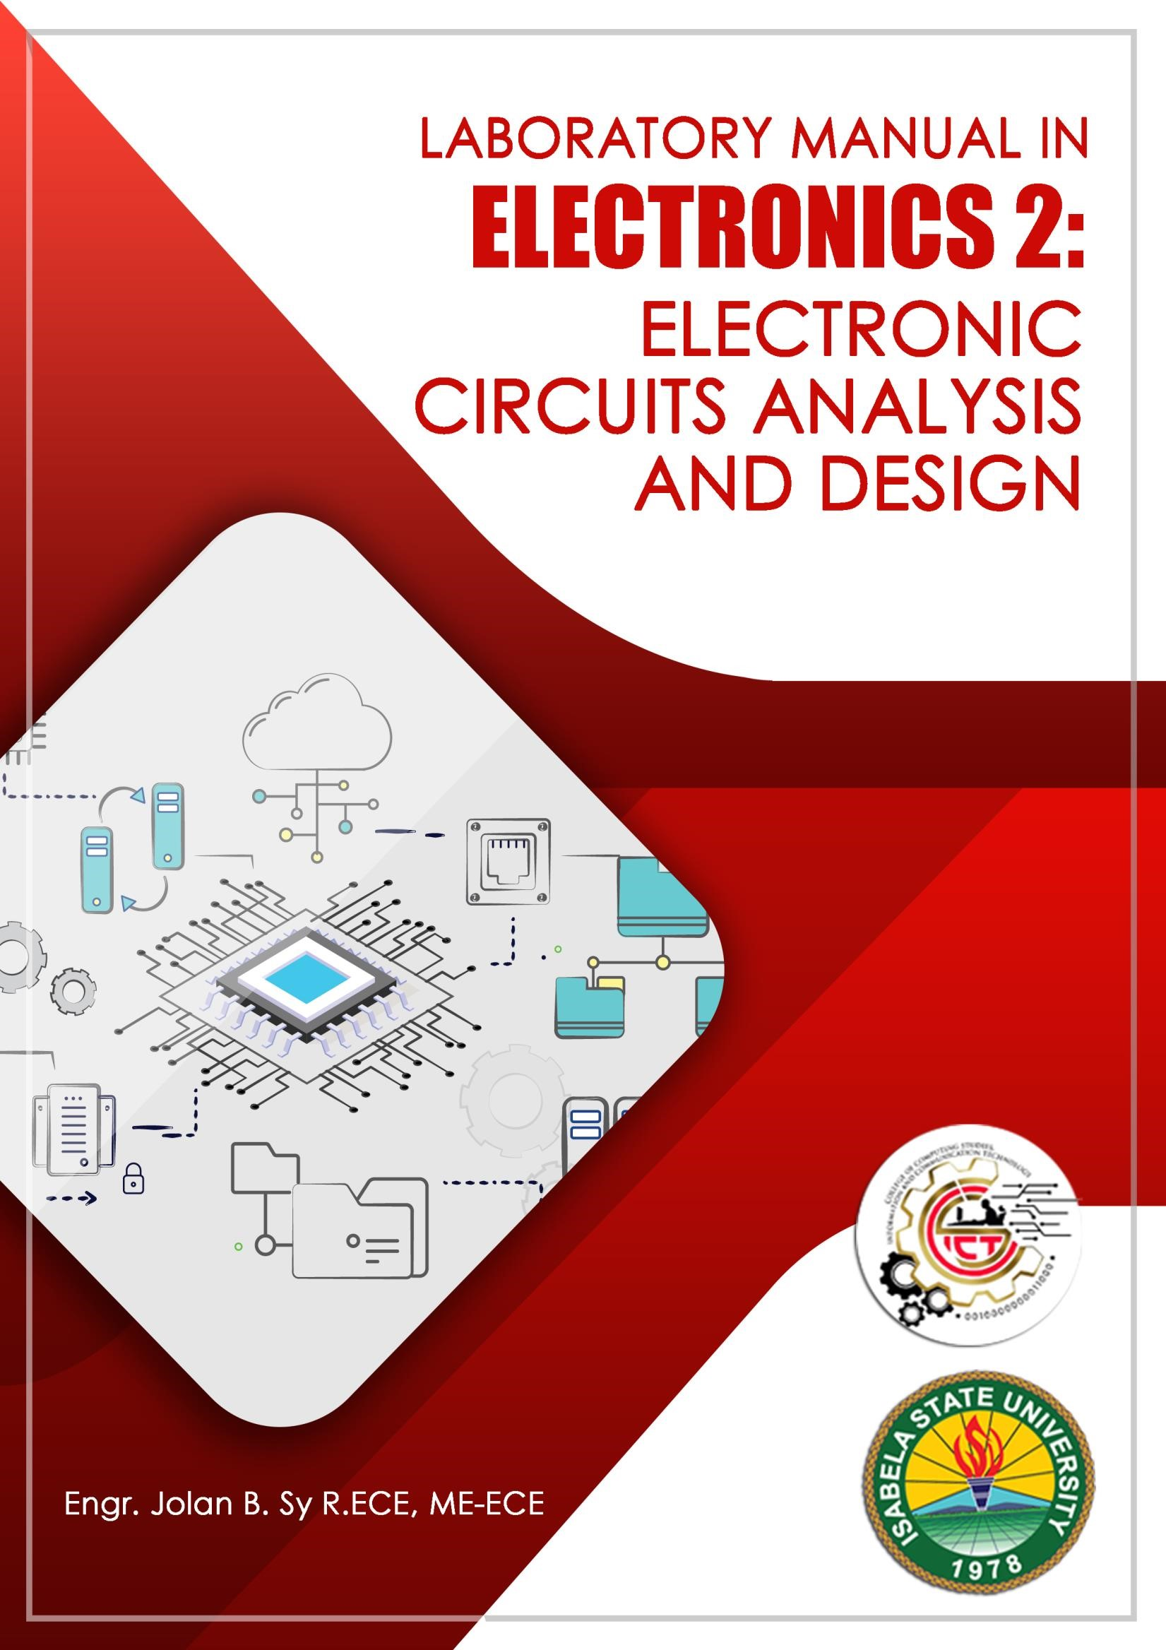

SAFETY

Safety in the electrical laboratory, as everywhere else, is a matter of the knowledge of potential hazards, following safety precautions, and common sense. Observing safety precautions is important due to pronounced hazards in any electrical/computer engineering laboratory. Death is usually certain when 0.1 ampere or more flows through the head or upper thorax and have been fatal to persons with coronary conditions. The current depends on body resistance, the resistance between body and ground, and the voltage source. If the skin is wet, the heart is weak, the body contact with ground is large and direct, then 40 volts could be fatal. Therefore, never take a chance on "low" voltage. When working in a laboratory, injuries such as burns, broken bones, sprains, or damage to eyes are possible and precautions must be taken to avoid these as well as the much less common fatal electrical shock. Make sure that you have handy emergency phone numbers to call for assistance if necessary. If any safety questions arise, consult the lab demonstrator or technical assistant/technician for guidance and instructions. Observing proper safety precautions is important when working in the laboratory to prevent harm to yourself or others. The most common hazard is the electric shock which can be fatal if one is not careful.

Acquaint yourself with the location of the following safety items within the lab.

- fire extinguisher
- first aid kit
- telephone and emergency numbers

Electric shock
Shock is caused by passing an electric current through the human body. The severity depends mainly on the amount of current and is less function of the applied voltage. The threshold of electric shock is about 1 mA which usually gives an unpleasant tingling. For currents above 10 mA, severe muscle pain occurs and the victim can't let go of the conductor due to muscle spasm. Current between 100 mA and 200 mA (50 Hz AC) causes ventricular fibrillation of the heart and is most likely to be lethal.

What is the voltage required for a fatal current to flow? This depends on the skin resistance. Wet skin can have a resistance as low as 150 Ohm and dry skin may have a resistance of 15 kOhm. Arms and legs have a resistance of about 100 Ohm and the trunk 200 Ohm. This implies that 240 V can cause about 500 mA to flow in the body if the skin is wet and thus be fatal. In addition skin resistance falls quickly at the point of contact, so it is important to break the contact as quickly as possible to prevent the current from rising to lethal levels.

Equipment grounding
Grounding is very important. Improper grounding can be the source of errors, noise and a lot of trouble. Here we will focus on equipment grounding as a protection against electrical shocks. Electric instruments and appliances have equipments casings that are electrically insulated from the wires that carry the power. The isolation is provided by the insulation of the wires as shown in the figure a below. However, if the wire insulation gets damaged and makes contact to the casing, the casing will be at the high voltage supplied by the wires. If the user touches the instrument he or she will feel the high voltage. If, while standing on a wet floor, a user simultaneously comes in contact with the instrument case and a pipe or faucet connected to ground, a sizable current can flow through him or her, as shown in Figure b. However, if the case is connected to the ground by use of a third (ground) wire, the current will flow from the hot wire directly to the ground and bypass the user as illustrated in figure c.
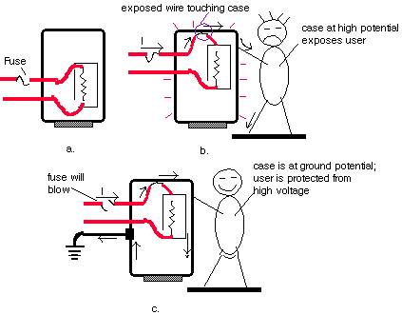
Equipments with a three wire cord is thus much safer to use. The ground wire (3rd wire) which is connected to metal case is also connected to the earth ground (usually a pipe or bar in the ground) through the wall plug outlet.

Always observe the following safety precautions when working in the laboratory:

- Do not work alone while working with high voltages or on energized electrical equipment or electrically operated machinery like a drill.

- Power must be switched off whenever an experiment or project is being assembled, disassembled, or modified. Discharge any high voltage points to grounds with a well insulated jumper. Remember that capacitors can store dangerous quantities of energy.

- Make measurements on live circuits or discharge capacitors with well insulated probes keeping one hand behind your back or in your pocket. Do not allow any part of your body to contact any part of the circuit or equipment connected to the circuit.

- After switching power off, discharge any capacitors that were in the circuit. Do not trust supposedly discharged capacitors. Certain types of capacitors can build up a residual charge after being discharged. Use a shorting bar across the capacitor, and keep it connected until ready for use. If you use electrolytic capacitors, do not :
  - put excessive voltage across them
  - put ac across them
  - connect them in reverse polarity

- Take extreme care when using tools that can cause short circuits if accidental contact is made to other circuit elements. Only tools with insulated handles should be used.

- If a person comes in contact with a high voltage, immediately shut off power. Do not attempt to remove a person in contact with a high voltage unless you are insulated from them. If the victim is not breathing, apply CPR immediately continuing until he/she is revived, and have someone dial emergency numbers for assistance.

- Check wire current carrying capacity if you will be using high currents. Also make sure your leads are rated to withstand the voltages you are using. This includes instrument leads.

- Avoid simultaneous touching of any metal chassis used as an enclosure for your circuits and any pipes in the laboratory that may make contact with the earth, such as a water pipe. Use a floating voltmeter to measure the voltage from ground to the chassis to see if a hazardous potential difference exists.

- Make sure that the lab instruments are at ground potential by using the ground terminal supplied on the instrument. Never handle wet, damp, or ungrounded electrical equipment.

- Never touch electrical equipment while standing on a damp or metal floor.

- Wearing a ring or watch can be hazardous in an electrical lab since such items make good electrodes for the human body.

- When using rotating machinery, place neckties or necklaces inside your shirt or, better yet, remove them.

- Never open field circuits of D-C motors because the resulting dangerously high speeds may cause a "mechanical explosion".

- Keep your eyes away from arcing points. High intensity arcs may seriously impair your vision or a shower of molten copper may cause permanent eye injury.

- Never operate the black circuit breakers on the main and branch circuit panels.

- In an emergency all power in the laboratory can be switched off by depressing the large red button on the main breaker panel. Locate it. It is to be used for emergencies only.

- Chairs and stools should be kept under benches when not in use. Sit upright on chairs or stools keeping the feet on the floor. Be alert for wet floors near the stools.

- Horseplay, running, or practical jokes must not occur in the laboratory.

- Never use water on an electrical fire. If possible switch power off, then use CO₂ or a dry type fire extinguisher. Locate extinguishers and read operating instructions before an emergency occurs.

- Never plunge for a falling part of a live circuit such as leads or measuring equipment.

- Never touch even one wire of a circuit; it may be hot.

- Avoid heat dissipating surfaces of high wattage resistors and loads because they can cause severe burns.

- Keep clear of rotating machinery.

Precautionary Steps Before Starting an Experiment so as Not to Waste Time Allocated

- Read materials related to experiment before hand as preparation for pre-lab quiz and experimental calculation.

- Make sure that apparatus to be used are in good condition. Seek help from technicians or the lab demonstrator in charge should any problem arises.
  - Power supply is working properly i.e. I_{max} (maximum current) LED indicator is disable. Maximum current will retard the dial movement and eventually damage the equipment. Two factors that will light up the LED indicator are short circuit and insufficient supply of current by the equipment itself. To monitor and maintain a constant power supply, the equipment must be connected to circuit during voltage measurement. DMM are not to be used simultaneously with oscilloscope to avert wrong results.
  - Digital multimeter (DMM) with low battery indicated is not to be used. By proper connection, check fuses functionality (especially important for current measurement). Comprehend the use of DMM for various functions. Verify measurements obtained with theoretical values calculated as it is quite often where 2 decimal point reading and 3 decimal point reading are very much deviated.
  - The functionality of voltage waveform generators are to be understood. Make sure that frequency desired is displayed by selecting appropriate multiplier knob. Improper settings (ie selected knob is not set at minimum (in direction of CAL – calibrate) at the bottom of knob) might result in misleading values and hence incorrect results. Avoid connecting oscilloscope together with DMM as this will lead to erroneous result.
  - Make sure both analog and digital oscilloscopes are properly calibrated by positioning sweep variables for VOLT / DIV in direction of CAL. Calibration can also be achieved by stand alone operation where coaxial cable connects CH1 to bottom left hand terminal of oscilloscope. This procedure also verifies coaxial cable continuity.

- Internal circuitry configuration of breadboard or Vero board should be at students’ fingertips (i.e. holes are connected horizontally not vertically for the main part with engravings disconnecting in-line holes).
- Students should be rest assured that measured values (theoretical values) of discrete components retrieved i.e. resistor, capacitor and inductor are in accordance the required ones.

- Continuity check of connecter or wire using DMM should be performed prior to proceeding an experiment. Minimize wires usage to avert mistakes.

- It is unethical and wrong for students to falsify results as to make them appear exactly consistent with theoretical calculations.

Safety Instructions for the Electronics 2

Agreement

I have read and agree to follow all of the safety rules. I realize that I must obey these rules to insure my own safety, and that of my fellow students, instructors and teaching assistants. I will cooperate to the fullest extent with my instructor and fellow students to maintain a safe lab environment. I will also closely follow the oral and written instructions provided by the instructor. I am aware that any violation of these rules that result in unsafe conduct in the laboratory or misbehavior on my part, may result in being removed from the laboratory, receiving a failing grade, and/or dismissal from the course.

Complete Name: __________________________________________________

Course : _______________________________Date:_______________________

Signature : __________________________

Rubrics

Criteria | Unsatisfac tory (1-3) | Satisfa ctory  (4-6) | Good  (7-9) | Excellent  (10)
Completion  (20%) | - less than 50% of the requirement has been completed | - between 50-65% of the requirement has been  completed | - between 65-95% of the requirement has been  completed | - between 100% of the requirement has been completed
Presentation and  Organization  (10%) | - no name, date, or requirement  title included  - poor use of materials  - disorganized and messy | - name, date, requirement title included  - use of materials that is easy to read  - organized work | - name, date, requirement title included  - good use of materials  - organized work | - name, date, requirement title included  - excellent use of materials  - effective use of materials  - creatively organized work
Correctness  (30%) | - Circuit does not execute due to  errors  - no error checking code included  - no testing has been completed | - Circuit  executes without errors  - Circuit handles some special cases  - some  testing has been completed | - Circuit  executes without errors  - Circuit  handles most special cases  - thorough  testing has been completed | - Circuit executes without errors  - Circuit handles all special cases  - thorough and organized testing has been completed and output from test cases is  included
Creativity  (30%) | - Circuit uses a difficult and  inefficient solution  - designer has not considered alternate solutions | - Circuit uses a logical solution that is easy to follow but it is not the most efficient  - designer has considered  alternate solutions | - Circuit  uses an efficient and easy to follow solution (i.e. no  confusing tricks)  - designer  has considered alternate solution and has chosen  the most efficient | - Circuit uses solution that is easy to understand and maintain  - designer has analyzed many alternate solutions and has chosen the most efficient  - designer has included the reasons for the solution chosen
Documentation  (10%) | - no documentation included | - basic documentation has been completed | - program has been clearly  documented | - clearly and effectively documented

ELECTRONICS 2

- Basic Guidelines
- Lab Instructions
- Lab Reports
- Grading
- Schedule and Experiment No. (Title)

1. Basic Guidelines

All experiments in this manual have been tried and proven and should give you little trouble in normal laboratory circumstances. However, a few guidelines will help you conduct the experiments quickly and successfully.
- Each experiment has been written so that you follow a structured logical sequence meant to lead you to a specific set of conclusions. Be sure to follow the procedural steps in the order which they are written.
- Read the entire experiment and research any required theory beforehand. Many times an experiment takes longer that one class period simply because a student is not well prepared.
- Once the circuit is connected, if it appears “dead’’ spend few moments checking for obvious faults. Some common simple errors are: power not applied, switch off, faulty components, lose connection, etc. Generally the problems are with the operator and not the equipment.
- When making measurements, check for their sensibility.
- It’s unethical to “fiddle” or alter your results to make them appear exactly consistent with theoretical calculations.

2. Lab Instructions

- Each student group consists of a maximum of 5 students. Each group is responsible in submitting 1 lab report upon completion of each experiment.
- Students are to wear proper attire i.e. shoe or sandal instead of slipper. Excessive jewelries are not advisable as they might cause electrical shock.
- Personal belongings i.e. bags, etc are to be put at the racks provided. Student groups are required to wire up their circuits in accordance with the diagram given in each experiment.
- A permanent record in ink of observations as well as results should be maintained by each student and enclosed with the report.
- The recorded data and observations from the lab manual need to be approved and signed by the lab instructor upon completion of each experiment.
- Before beginning connecting up, it is essential to check that all sources of supply at the bench are switched off.
- Starts connecting up the experiment circuit by wiring up the main circuit path, then add the parallel branches as indicated in the circuit diagram.
- After the circuit has been connected correctly, remove all unused leads from the experiment area, set the voltage supplies at the minimum value, and check the meters are set for the intended mode of operation.
- The students may ask the lab instructor to check the correctness of their circuit before switching on.
- When the experiment has been satisfactory completed and the results approved by the instructor, the students may disconnect the circuit and return the components and instruments to the counter tidily. Chairs are to be slid in properly.

3. Lab Reports

a. Report format and Evaluation:

The following format should be adhered to by the students in all their laboratory reports:
- Objective
- Brief Theory
- Results
- Workbench
(v) Discussion and Conclusion

Of those listed above each section included in a report should be clearly nominated with the appropriate heading. The information to be given in each section is set out below:

(i) Objective
This should state clearly the objective of the experiment. It may be the verification of law, a theory or the observation of particular phenomena. Writing out the objective of the experiment is important to the student as it emphasizes the purpose for which the experiment is conducted.

(ii) Brief Theory
In this section, the related theory of the experiment must be discussed briefly. This section is important to assist student in making conclusion by comparing the experimental results to the theory.

(iii) Results
All experimental results which have been approved by the lab instructor (including graphs) must be attached in the report.

(iv) Workbench
LTSPICE/Multisim or Proteus Simulation output (as instructed in the lab manual) must be attached in the report to show the comparison of simulation results and experimental results.

(vi) Discussion & Conclusion
Once the analysis of the results is complete, the student must forms some deductions on the results of his analysis. Usually this involves deducing whether the final results show that the aim of the experiment has been achieved or not, and if they verify some law or theory presented to the student during the lectures. Comments and comparison asked in the lab manual must be discussed in this section. In making a decision on the former point, the student should reread the aim; and on the latter, the text book should be referred to, to ascertain whether there is theoretical agreement or not.

The student should give considerable thought to the material that he intends to submit in this section. It is here that he is able to express his own ideas on the experiment results and how they were obtained. It is the best indication to his teacher of whether he has understood the experiment and of how well he has been able to analyze the results and make deductions from them.

It is recommended that the conclusion should be taken up by the student’s clear and concise explanation of his reasoning, based on the experimental results, that led to the deductions from which he was able to make the two statements with which he began the conclusion.

It is very rare for an experiment to have results which are entirely without some discrepancy. The student should explain what factors, in his opinion, may be the possible causes of these discrepancies. Similarly, results of an unexpected nature should form the basis for a discussion of their possible nature and cause.
The student should not be reluctant to give his opinions even though they may not be correct. He should regard his discussion as an opportunity to demonstrate his reasoning ability.

Should the results obtained be incompatible with the aim or with the theory underlying the experiment, then an acceptable report may be written suggesting reasons for the unsatisfactory results. It is expected that the student should make some suggestions as to how similar erroneous results for this experiment might be avoided in the future. The student must not form the opinion that an unsatisfactory set of results makes a report unacceptable.

b. Presentation of Lab Reports:

All students are required to present their reports in accordance with the following instructions.

- Reports have to be handwritten for submission.

- Writing should appear on one side of each sheet only.

- The students’ name & matric number, section number, lab session and the lecturer’s name must be printed in block letters at the top left-hand corner of the first sheet of the report. This must be followed in the middle of the sheet by:
  - The course code
  - The experiment number
  - The title of the experiment
  - The date on which the student carried out the experiment.

- All sections such as objective, brief theory and so on, should be titled on the left hand side of the working space of the page.

(v)
- Each type of calculation pertaining to the experiment should be preceded by a brief statement indicating its objective.
- All calculations are to be shown in sufficient details to enable the reader to follow their procedure.
- All formulas used are to be written in correct symbols prior to the substitution of the known quantities.

- All graphs are to be drawn on graph paper in blue or black ink. Other colors may be used for identification. The abscissa and ordinate are to be drawn in all times and scaled with the value clearly indicated at each major division. The quantity at each axis represents and the unit in which it is calibrated should be clearly indicated. Each graph is to be titled so as to indicate clearly what it represents.

- The report submitted by each student should contain a conclusion and discussion of more than 300 words.

- The cover of the report must be as follows:

4
. Grading

The work in the Electronics related lab carries
4
0
% of total marks for the subjec
t
. The distribution of
marks for Electronics Lab is as follows:

Midterm Exam Hands
-
On

%
25

Final Exam Hands
-
On

25
%

Lab Report

25
%

Project ( Simulation and
Hardware)

25
%

Total

100
%

Group members, Matric No.

Section number

Lab Session (Day, Time)

Lecturer’s name

Experiment No.

Title of experiment

Date

Table of Contents

Exercise Title

  - Transistor Bias
  - Coupling Bypass Capacitors
  - AC Emitter Resistance
  - The CE Amplifier
  - Cascaded CE Stages
  - Transistor as Switch
  - Class Amplifier
  - Emitter Follower
  - Class B Push-Pull Amplifier
  - Inverting Operational Amplifier
  - Non Inverting Operational Amplifier
  - Summing Amplifier -Adder
  - Subtractor Amplifier
  - Differentiator
  - Integrator
  - Differential Amplifier
  - DAC Using Operational Amplifier
  - Logarithmic Amplifier
  - Monostable Multivibrator -IC 555 timer
  - Astable Multivibrator -IC 555 timer
  - Non-Liner Operational Amplifier Experiment 1
Transistor Bias

Introduction

The experiment on "Transistor Bias" is a fundamental and essential study in the field of electronics and electrical engineering, focusing on the operation and application of transistors. Transistor biasing is the process of setting a transistor's operating point by applying external voltages to its base, collector, and emitter terminals. The operating point, also known as quiescent point or Q-point, is crucial for the transistor's stability and functionality, especially in amplification applications. Proper biasing ensures that the transistor operates efficiently and within its safe operating area, avoiding issues like signal distortion or transistor burnout.

This experiment typically involves setting up circuits with bipolar junction transistors (BJTs) or fieldeffect transistors (FETs), and adjusting the biasing voltages to achieve desired operation points. Through practical experience, students learn about different biasing techniques and their impact on transistor performance and circuit behavior.

Learning Objectives

- Understanding Transistor Operation: Develop a comprehensive understanding of how transistors work, including their construction, types (BJT, FET), and basic operation principles.

- Knowledge of Transistor Biasing Techniques: Gain knowledge of various transistor biasing techniques, such as fixed bias, voltage-divider bias, and emitter stabilization, and understand the advantages and disadvantages of each method.

- Circuit Construction and Biasing: Learn to construct transistor circuits and apply different biasing techniques to set the Q-point.

- Measurement and Analysis of Operating Point: Develop skills in measuring key parameters like base, collector, and emitter voltages and currents, and analyze how these values affect the transistor's operating point.

- Understanding the Impact of Temperature and Stability: Study the impact of temperature on transistor biasing and explore methods to ensure stability of the transistor's operating point.

- Application in Amplifier Circuits: Understand how biasing affects the performance of transistorbased amplifier circuits, including considerations for linearity and efficiency.

- Safety in Handling Electronic Components: Emphasize the importance of safe practices while handling electronic components and circuits.

- Problem-Solving and Critical Thinking: Enhance problem-solving and critical-thinking skills by troubleshooting biasing issues and optimizing circuit performance.

- Real-World Application and Relevance: Recognize the relevance of transistor biasing in practical applications such as audio amplifiers, radio transmitters, and other electronic devices.

By mastering these objectives, students will not only learn the theoretical aspects of transistor biasing but will also acquire practical skills essential for designing and analyzing electronic circuits that utilize transistors effectively.

Before we can use transistor to amplify an AC signal, we have to set up a quiescent (Q) point of operation, typically near the middle of the Dc load line. Then, the incoming AC signal can produce fluctuations above and below this Q point. The three most primitive forms of bias are base bias, emitter bias, and collector feedback bias. As you know, these are not the best ways a transistor if you want a stable Q point. Nevertheless, you may occasionally see these biasing methods used with small signal amplifiers. In this experiment you will connect all the three types of bias to verify the operation as discussed in the lecture.

Formulas

Ic = hfe Ib

Ie = Ic + Ib

Vc = Vce + Ve

Where Ve = 0 (for base bias fixed bias) and collector-feedback bias

Equipments

1 power supply: 15V
1 transistor: 2N3904 (or equivalent)
7 ½ watt resistors 100, 800, 820, 1k, 270k, 470k
1 VOM

Base Bias

- Refer to the data sheet of a 2N3904. Notice that the DC current gain hfe has minimum value of 100 and a maximum value of 300 for an Ic of 10 mA. The typical value is not listed. For this experiment we will assume the typical value is 200.
- In Fig. 1-1, use the typical hfe to calculate Ib, Ic, and Vc. Record your answers in table 1-1
- Connect the circuit of fig. 1-1. Measure and record the quantities listed in table 1-1

Emitter- feedback bias
- In fig. 1-2, use the typical hfe to calculate Ic, Vc, and Ve. Record your answers in table 1-1
- Connect the emitter-feedback bias of fig. 1-2. measure and record the quantities of table 1-1

Collector-feedback bias
- In fig 1-3, use the typical hfe to calculate and record the quantities of
Table 1-1.
- Connect the circuit of fig 1-3. measure all quantities listed in Table 1-1.

Troubleshooting
- In figure 1-3, assume the base resistor is open. Estimate and record the collector voltage (Vc) in table 1-4
- repeat step 8 for the other troubles listed in Table 1-4
Table 1-1
 | Calculated |  |  | Measured
Bias type | Ic | Ib | Ie | Ic | Ib | Ie
Base bias

Emitter feedback
Collector feedback
Table 1-2 Troubleshooting
Trouble | Estimated | Measured
Open 200k
Shorted 200k
Open 1k
Shorted 1k

Fig 1-1 Fig 1-2 Fig 1-3
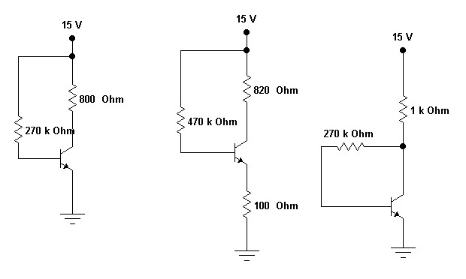

Experiment 2
Coupling and Bypass Capacitors

Introduction

The experiment on "Coupling and Bypass Capacitors" delves into an important aspect of circuit design in electrical engineering and electronics. Coupling capacitors (also known as blocking or decoupling capacitors) are used to connect two circuits so that only the AC signal passes from one to the other, blocking any DC components. Bypass capacitors, on the other hand, are used to provide an AC ground path for a DC bias point, effectively stabilizing DC operating conditions and reducing noise.

This experiment is pivotal for understanding how capacitors influence the behavior of electronic circuits, particularly in signal processing, amplification, and power supply applications. Students will engage in building and analyzing circuits that incorporate these capacitors, observing how they affect signal integrity and circuit performance.

Learning Objectives

- Understanding the Role of Capacitors in Circuits: Gain a thorough understanding of how coupling and bypass capacitors function in electronic circuits and their purposes.

- Circuit Construction and Analysis: Learn to construct circuits using coupling and bypass capacitors, focusing on how they influence signal paths and stability in various circuit configurations.

- Observing Signal Behavior with Coupling Capacitors: Develop skills in analyzing how coupling capacitors allow AC signals to pass while blocking DC components, and understand their impact on signal coupling between stages of a circuit.

- Studying the Effects of Bypass Capacitors: Understand how bypass capacitors provide a lowimpedance path to AC signals, thereby stabilizing the DC operating points and reducing noise.

- Measurement and Interpretation: Gain hands-on experience in measuring and interpreting the changes in signal amplitude, phase, and frequency response due to these capacitors in a circuit.

- Exploring Different Capacitor Values and Types: Experiment with different values and types of capacitors to observe how they affect the overall performance of the circuit.

- Safety in Circuit Experiments: Emphasize safety practices in handling electronic components and instruments during experimentation.

- Critical Thinking and Problem-Solving: Enhance critical thinking and problem-solving skills by troubleshooting circuits and optimizing capacitor choices for specific applications.

- Real-World Applications: Understand the practical applications of coupling and bypass capacitors in real-world electronic devices, such as amplifiers, radio receivers, and power supply units.

By completing this experiment, students will not only learn the theoretical principles behind coupling and bypass capacitors but will also gain practical skills in their application, essential for designing and troubleshooting advanced electronic circuits and systems.
Capacitive reactance decreases as frequency increases. Because of this, a capacitor has large impedance at low frequencies and a small impedance at high frequencies. As an approximation, we can say that a capacitor is a DC open and an AC short. When used in amplifiers, capacitors can couple the signal from one active node to another, or they can bypass the signal from an active node to ground.

Formulas

Critical Frequency, fc = 1 / (2 π RT C)

Where:
RT = R1 // RL for figure 2-1
RT = R1 // R2 for figure 2-2

Equipments

1 audio generator
4 ½ W resistors: two 22k-ohm, 68k-ohm, 100k-ohm
1 capacitor: 0.022 microfarad
1 oscilloscope
1 VOM

Procedure

- Calculate the critical frequency in figure 2-1a. fill the values of fc, 10 fc and 0.1 fc in table 2-1 under f.
- Connect the circuit of figure 2-1a
- Adjust the audio generator to get the frequency fc and an input voltage of 1Vp-p on the oscilloscope.
- Measure the output voltage and record in table 2-1
- Change the frequency to 10fc and readjust to get a Vin of 1 Vp-p. Measure and record Vout and record in table 2-1
- Change the frequency to 0.1fc and check that Vin is 1Vp-p. measure and record Vout.
- Calculate the critical frequency in figure 2-1a. fill the values of fc, 10 fc and 0.1 fc in table 2-2
- Connect the circuit of fig 2-1b withpout the capacitor. Adjust the frequency to fc.
- Set the signal level to 1Vp-p across the lower 22-k resistor.
- Connect the capacitor between point A to ground. Then measure and record VA.
- Remove the capacitor and change the frequency to 10fc. Then repeat steps 9 and 10.
- Remove the capacitor and change the frequency to 0.1fc. Then repeat steps 9 and 10.

Table 2-1 Coupling Capacitor

 | f | Vout
Fc
10fc
0.1 fc

Table 2-2 Bypass Capacitor

 | f | Vout
Fc
10fc
0.1 fc

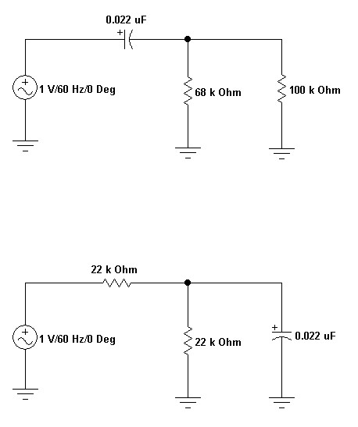
Fig 2
-
1
a

Fig 2-1b

Experiment 3
AC Emitter Resistance

Introduction

The experiment on "AC Emitter Resistance" is an advanced study in the field of electronics, focusing on understanding and analyzing the AC behavior of transistors, particularly in the common emitter configuration. This configuration is widely used in amplification circuits due to its high gain and versatility. The concept of AC emitter resistance, often represented as re, is crucial in determining the small-signal gain, input, and output impedances of a transistor amplifier. It is derived from the dynamic operation of the transistor and is key to understanding how the transistor's behavior changes with varying AC signals, as opposed to its DC characteristics.

The experiment typically involves setting up a transistor in a common emitter configuration, applying an AC signal, and measuring the resultant changes in voltages and currents to calculate the AC emitter resistance. This hands-on approach provides practical insights into transistor operation at different frequencies and signal levels, enhancing the understanding of transistor amplifiers in real-world applications.

Learning Objectives

- Understand AC Characteristics of Transistors: Develop a solid understanding of the AC behavior of transistors, especially in common emitter configurations, and how it differs from DC characteristics.

- Circuit Setup for AC Analysis: Learn to set up a transistor circuit in the common emitter configuration for AC analysis, including the correct implementation of signal sources and measurement instruments.

- Calculation of AC Emitter Resistance: Gain the ability to calculate the AC emitter resistance (r e ) from measured AC voltage and current values, and understand how it affects the amplifier's performance.

- Analyzing Amplifier Parameters: Understand how AC emitter resistance influences key amplifier parameters such as gain, input impedance, and output impedance.

- Frequency Response Analysis: Study the impact of frequency on AC emitter resistance and the overall frequency response of the amplifier.

- Measurement and Interpretation of Results: Develop skills in accurately measuring AC voltages and currents in a transistor amplifier and interpreting these measurements to draw conclusions about circuit behavior.

- Safety in AC Circuit Experiments: Emphasize the importance of safety when working with AC signals, particularly at higher frequencies and voltages.

- Critical Thinking and Problem-Solving: Enhance problem-solving skills by troubleshooting common issues in AC transistor circuits and optimizing circuit parameters for desired performance.

- Real-World Application and Relevance: Recognize the relevance of AC emitter resistance in practical applications, such as in audio amplifiers and signal processing equipment.

By mastering these objectives, students will not only comprehend the theoretical aspects of AC emitter resistance but will also acquire practical skills essential for designing and analyzing transistor amplifiers in various electronic applications.

The AC emitter resistance equals the change in base-emitter voltage divided by the change in emitter current. Because the graph of emitter current versus base-emitter voltage is exponential, it is possible to derive the following relation for the AC emitter resistance: re = 25 mV/Ie. In this experiment, you will connect a circuit that allows you to verify the foregoing relation.

Formulas

For the DC equivalent circuit:

Ie = Ve / Re
Re = 25 mV / Ie
Ve = - Vee – Vb

Equipment’s

- audio generator
- power supplies: 9 V and Adjustable from at least 1 to 12V
1 transistor: 2N3904
3 ½-W resistors, 1k-ohm, two 10 k-ohm
1 capacitor: 0.1 microfarad
1 oscilloscope
1 VOM

Procedure

- In fig. 3-1a shows a circuit that measures re. In the DC equivalent circuit of fig. 3-1b, the DC emitter equals the voltage across the 10k-ohm. Calculate the value of ie for each value of –Vee shown in table 3-1. record the value of Ie.
- Using the equations from the formulas, calculate and record the value of re for each Ie.
- Connect the circuit of fig 3-1a. set –Vee at –10.7V. Adjust the audio generator to 1kHz.with the Ac millivoltmeter in parallel with the audio generator, adjust the signal level to 1Vrms.
- once the audio generatorhas been set to 1Vrms, the approximate Ac equivalent circuit looks like Fig 3-1c. notice most of the 1V will be across the 10k-ohm resistance because re is very small by comparison (around 25 ohm). This is why the alternating currents i_{e} is approximately 0.1mA.
- Connect the AC millivoltmeter and the oscilloscope to measure Vbe, the AC voltage between the emitter and ground in fig. 3-1a.
- The oscilloscope should display a small sine wave. If so, read the value of Vbe on the AC millivoltmeter and record in table 3-2.
- Reduce the –Vee supply to -5.7V. the sine wave on the oscilloscope should increase. Read the new value of Vbe on the AC millivoltmeter and record in table 3-2.
- Reduce the –Vee supply to –3.2V. read the new value of Vbe and record
- In fig. 3-2c, re is much smaller than 10k-ohm. Therefore, almost all of the 1V is across the 10kohm. For this reason, the AC emitter current Ie is approximately equal to 0.1 mA. Now, you can calculate re by dividing each Vbe by 0.1 mA. Calculate and record the values in table 3-2.

Table 3-1 Calculations

-Vee | Ie | re
-10.7
-5.7
-3.2

Table 3-2 Measurements

-Vee | Ie | re
-10.7
-5.7
-3.2

Questions: (encircle the correct answer among the choices)

- In table 3-1, each time emitter current is cut in half, AC emitter resistance
a) goes down by a factor of 2 b) doubles
c) quadruples d) stays the same
- In Fig. 3-1a, the positive end of the –Vee supply is
a) grounded b) connected to 10 k-ohm resistor
c) Connected to the emitter d) none of the above
- When –Vee equals –10.7 V in 3-1b, Vce equals
a) 0.7V b) 1V c) 5V d) 8V
- The value of re equals
a) Vbe/ib b) Vbe/ie c) Vce/ie d) Vce/ib
- The value of re is only a small part of the resistance in fig 3-1c, the circuit driving re in approximately an ideal
a) Voltage source b) current source c) resistance d) capacitor
- According to table 3-1 and 3-2, the value of Vbe for aan Ie of 0.5mA is closest to
a) 2.5 mV b) 5 mV c) 50 mV d) 250 mV
- Table 3-2 confirms that re is
a) 25 b) equal to Vbe/ib
c) Inversely proportional to Vbe d) inversely proportional
7. in fig 3-1c, re is much smaller than
a) 25 ohm b) 50 ohm c) 100 ohm d) 10k-ohm

Fig 3-1a Fig 3-1b

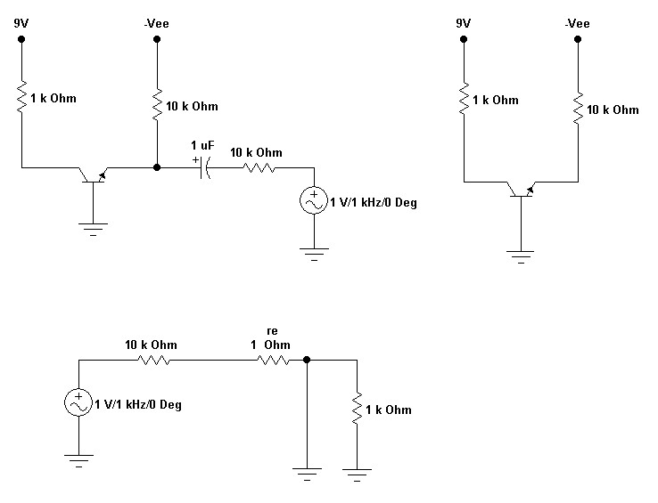
Fig 3-1c

Experiment 4
The CE Amplifier

Introduction

The experiment on the "Common Emitter (CE) Amplifier" is an integral part of electronics and electrical engineering education, focusing on a fundamental transistor amplifier configuration. The CE amplifier is widely used due to its favorable characteristics, including good voltage gain, moderate input impedance, and moderate output impedance. This configuration is a cornerstone in understanding amplifier design and operation.

In a CE amplifier, the input signal is applied to the base-emitter junction, and the output is taken from the collector-emitter circuit. The experiment typically involves constructing a CE amplifier circuit using a bipolar junction transistor (BJT), applying an input signal, and analyzing the amplified output. This practical approach helps students understand the principles of signal amplification, the role of biasing in amplifier performance, and the impact of various circuit components on the amplifier's behavior.

Learning Objectives

- Understanding CE Amplifier Configuration: Gain a comprehensive understanding of the common emitter amplifier, its circuit configuration, and operational principles.

- Circuit Construction and Biasing: Learn to construct a CE amplifier circuit, including proper biasing of the BJT for optimal operation.

- Signal Amplification Analysis: Develop skills in applying an input signal and analyzing the amplified output, understanding the amplifier's voltage gain, and how the signal is inverted.

- Measurement of Amplifier Parameters: Gain hands-on experience in measuring key amplifier parameters such as voltage gain, input impedance, output impedance, and bandwidth.

- Impact of Component Variations: Understand how variations in circuit components (like resistors, capacitors) affect the performance of the amplifier.

- Frequency Response Characteristics: Study the frequency response of the CE amplifier and understand how it behaves across different frequencies.

- Safety in Electronic Experiments: Emphasize the importance of safety practices when constructing and testing electronic circuits.

- Data Analysis and Interpretation: Enhance the ability to interpret experimental data, compare it with theoretical expectations, and understand the practical limitations and non-idealities in amplifier circuits.

- Real-World Applications: Recognize the practical applications of CE amplifiers in various electronic devices and systems, highlighting their importance in the electronics industry.

By completing this experiment, students will not only learn the theoretical aspects of common emitter amplifiers but also acquire practical skills essential for designing and analyzing various types of electronic amplifiers.

After the transistor of a CE amplifier has been biased with its Q point near the middle of the DC load line, you can couple a small signal into the base. This produces an amplifier AC signal at the collector. In this experiment you will build a CE amplifier and measure its voltage gain, as well as looking at the AC waveforms throughout the circuit

Formulas

For DC analysis  Vb = R2 Vcc  R1 + R2  Vbe = Vb – Ve  Ie = Ve / Ie | For AC analysis  Re = 26 mV  Ie  Av = Vout / Vpp or Rc / re  Vb = Vin pp  Ve = ie re

Equipment’s

1 audio generator
1 power supply
1 transistor : 2N3904
4 ½-W resistors: 1 k-ohm, 2.2 k-ohm, 3.6 k-ohm, 10 k-ohm
2 capacitors: 1 μF, 470 μF ( 10V rating or better)
1 oscilloscope

Procedure

DC and AC voltages
- in fig 4-1, calculate the DC voltage at the base, emitter, and the collector. Record your answer in table 4-1. let the typical value of hfe be equal to 200.
- calculate and record the peak-to-peak Ac voltages at the base, emitter, and collector
- connect the circuit. Adjust the signal generator to get an input signal of 10 mV peak-to-peak at 1 kHz.
- look at the base, emitter, and collector. At each point, use the oscilloscope on Dc input to measure Dc voltage and on AC input to measure the Ac peak-to-peak voltage. Record all voltages in table 4-1
- with the oscilloscope on the DC input, you should investigate the output waveform
Phase inversion
- if you are using a dual-trace or dual beam oscilloscope, look at the base signal with one input and the collector signal with the other input. Also use the collector signal to drive the external trigger of the oscilloscope. (if no doubt about how to use the external trigger ask the instructor.) Notice that the collector signal is 180 degree out of phase with the base signal.
- if you are using a single trace oscilloscope externally trigger the oscilloscope with the collector signal. Look first at the base signal, then at the collector signal. Notice that the signals are 180 degrees out of phase

Voltage gain
- in fig 4-1, use the formulas provided. Calculate the ideal emitter resistance re. Also calculate the voltage gain A. record your answer in table 4-2

Troubleshooting
- in fig 4-1, assume that C1 is open. Estimate the peak-to-peak AC voltage at the base, emitter and collector. Record in table 4-3
- repeat step 9 for each trouble listed in table 4-3
- connect the circuit with each trouble. Measure and record the AC voltages.

Table 4-1 CE Amplifier

 | Calculated |  |  | Measured
 | B | E | C | B | E | C
DC
AC

Table 4-2 Voltage Gain

Transistor | Calculated |  | Measured |  | Experimental
 | re | A | Vin | Vout | A | re
2N3904

Table 4-3 troubleshooting

 | Estimated |  |  | Measured
Trouble | Vb | Ve | Vc | Vb | Ve | Vc
Open C1
Open R2
Open Re

Fig 4-1
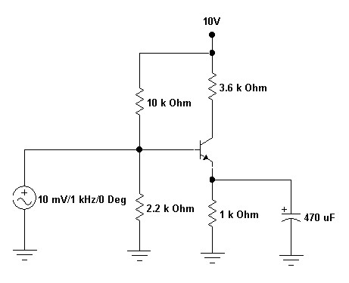
Experiment 5
Cascaded CE Stages

Introduction

The experiment on "Cascaded Common Emitter (CE) Stages" is an advanced and insightful study in electronics and electrical engineering, focusing on the concept of cascading multiple amplifier stages to enhance performance characteristics. Cascading refers to connecting two or more amplifier stages in sequence, where the output of one stage serves as the input to the next. This setup is common in applications requiring high gain or specific amplification characteristics, such as in audio amplifiers, radio frequency (RF) amplifiers, and signal processing equipment.

In this experiment, students explore the dynamics of combining multiple CE amplifier stages, examining how the characteristics of one stage affect the next. The cascaded arrangement presents a complex interaction between stages, including impedance matching, gain calculations, bandwidth considerations, and the potential for increased distortion or instability.

Learning Objectives

- Understanding Cascaded Amplifier Principles: Develop a comprehensive understanding of the principles behind cascading amplifier stages, including the benefits and challenges of such configurations.

- Circuit Construction of Cascaded CE Stages: Learn to construct and configure cascaded CE amplifier stages, ensuring proper coupling and biasing between stages.

- Analysis of Gain and Bandwidth: Gain skills in analyzing the overall gain of the cascaded system, understanding how individual stage gains combine, and how bandwidth is affected by cascading.

- Impedance Matching Between Stages: Understand the importance of impedance matching between stages for maximum power transfer and reduced signal loss.

- Measurement of Individual and Overall Stage Parameters: Develop expertise in measuring and analyzing parameters like voltage gain, input and output impedances, and frequency response of each stage and the overall system.

- Exploring the Effects of Loading: Study how the loading effect of one stage on another influences the performance of the entire cascaded arrangement.

- Safety in Complex Circuit Experiments: Emphasize the importance of safety practices when dealing with complex electronic circuits, particularly those with multiple stages.

- Critical Thinking and Problem-Solving: Enhance critical thinking and problem-solving skills by troubleshooting issues in cascaded configurations, such as instability and distortion.

- Real-World Applications: Recognize the practical applications and significance of cascaded CE stages in various electronic devices and signal processing systems.

By mastering these objectives, students will not only gain an in-depth understanding of cascaded common emitter stages but also acquire practical skills essential for designing and analyzing complex amplification systems in various electronic applications.

The amplified signal out of a CE stage can be used at the input to another CE stage. In this way, we can build a multistage amplifier with very large voltage gain. Because a CE stage has input impedance, there is a loading effect on the preceding stage. In other words, the loaded voltage gain is less than the unloaded voltage gain. In this experiment you will build a two stage amplifier using swamped stages to stabilize the overall voltage gain.

Formulas

For DC stages  Vb = R2 Vcc  R1 + R2  Vbe = Vb – Ve  Ie = Ve / re  Vc = Vcc - IcRc | For AC analysis  Re = 25 mV / Ie  Vb = Vin pp  Av = Vout pp / Vin pp  = Rc / re ( without load)  Av = Rc // R_{L} ( with load)

Vin = Ve = ie re

Vout = ie Rc

Equipment’s

1 audio generator
- power supply
- transistor (2N3904)
12 ½ –W resistors: two 68Ω, three 1k Ω, one 1.2kΩ, two 2.2 kΩ, two 3.6k Ω, two10k Ω
5 capacitors: three 1 μF, two 47 μF (10V rating or higher)
1 oscilloscope
1 VOM

Calculations
- In fig 5-1, calculate the DC voltage at the base, emitter and collector of each stage. Record your answer in table 5-1.
- Let the typical hfe value equal to 200
- calculate the peak-to-peak AC voltage at the base, emitter and the collector of each stage using hfe of stage 2. record all voltages in table 5-2
Tests
- connect the two-stage amplifier of fig 5-1
- measure the DC voltage at the base, emitter, and collector of each stage. Record the data in table 5-1. within the tolerance of the resistors being used, the measured voltages should agree with your calculated voltages.
- measure the peak-to-peak AC voltages at the base, emitter and the collector of each stage. Record your data in table 5-2. These measured AC voltages should agree with your calculated values

Loading Effects
- open the coupling capacitor between the first and the second stage. Look at the AC voltage on the first collector. Reconnect the coupling capacitor and notice that the AC signal decreases significantly. Do not continue until you understand and can explain why the signal decreases.
- open the coupling capacitor between the second stage and the load resistor. Look at the AC voltage on the second collector. Reconnect the coupling capacitor and notice the decrease in signal strength. Once more, you should be able to explain why this happens

Table 5-1 DC voltages

 | calculated |  |  | Measured
Stage | Vb | Ve | Vc | Vb | Ve | Vc
1
2

Table 5-2 AC voltage
Hfe = _________

 | calculated |  |  | Measured
Stage | Vb | Ve | Vc | Vb | Ve | Vc
1
2

Fig 5-1

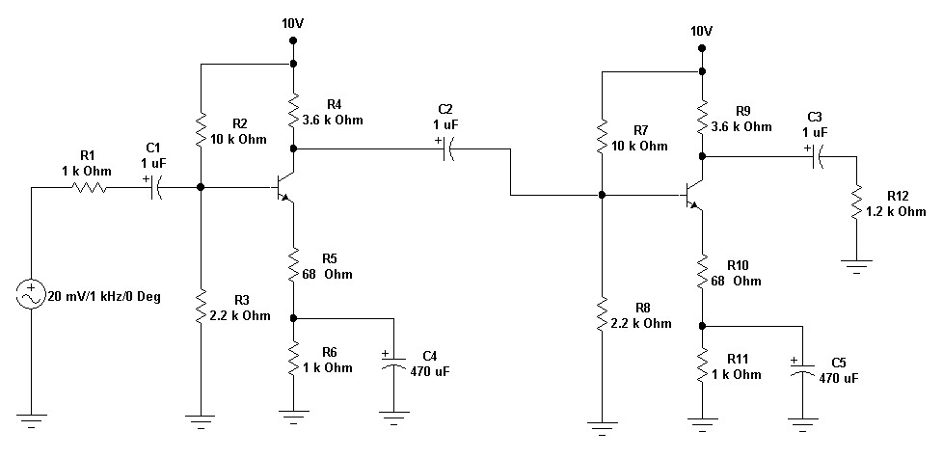

Experiment 6
Transistor as a Switch

Introduction

The experiment on "Transistor as a Switch" is a fundamental study in electronics and electrical engineering, focusing on the use of transistors as switching devices. Transistors, which are the building blocks of modern electronic devices, can operate in two primary modes: amplification and switching. In the switching mode, a transistor switches current on or off in a circuit, functioning as a binary device. This ability makes transistors crucial components in digital electronics, including logic gates, microprocessors, and various types of digital circuits.

This experiment typically involves using a transistor (either Bipolar Junction Transistor - BJT or Field Effect Transistor - FET) to control the flow of current in a simple circuit, such as lighting up an LED or activating a relay. Students learn about the operation of transistors in their active, cut-off, and saturation regions, which correspond to their switching characteristics.

Learning Objectives

- Understand the Working Principle of Transistors as Switches: Gain a clear understanding of how transistors operate in different regions (active, cut-off, saturation) and how these regions are used for switching applications.

- Circuit Construction and Analysis: Learn to construct basic transistor switch circuits and analyze their operation, including understanding the role of base, collector, and emitter in BJTs or gate, drain, and source in FETs.

- Control Signal Application: Develop skills in applying control signals to the transistor’s base or gate to activate/deactivate the switch and control a load.

- Exploring Different Transistor Types: Experiment with different types of transistors (NPN, PNP, N-channel, P-channel) to understand their unique switching characteristics and applications.

- Measurement of Key Parameters: Measure and analyze key parameters like base/gate voltage, collector/drain current, and emitter/source voltage to understand the transistor's behavior in a switching context.

- Safety in Electronic Experiments: Emphasize the importance of safety when constructing and testing transistor circuits.

- Problem-Solving and Practical Application: Enhance problem-solving skills by troubleshooting common issues in transistor switch circuits and optimizing their performance.

- Real-World Applications of Transistor Switches: Understand the practical applications of transistor switches in various electronic devices, particularly in digital logic and control systems.

- Data Analysis and Interpretation: Develop the ability to interpret experimental data and understand how it correlates with the theoretical operation of transistors as switches.

By mastering these objectives, students will not only learn the fundamental principles of using transistors as switches but also acquire practical skills crucial for designing and implementing transistor-based control systems in various electronic applications.

The application of transistor is not limited solely to the amplification of signals. Through proper design it can be used as a switch for control applications. Using the saturation and cut-off level of a transistor is important in switching operation thus calling it as a switching transistors used mainly as drivers. In this experiment we will use switching theories in creating transistor-transistor combination to create basic logic operations.

Equipments

- power supply
- transistor (2N3904)
- ½ W resistors; one 400 ohm, two 1k ohm
1 Light Emitting Diode

Procedure

Inverter (NOT)

- Connect the circuit as given in Figure 6-1
- Turn-on the power supply. After turning-on notice what happens to the LED.
- Apply 5V on the input side of the circuit. Note what happens to the LED
- Record the outputs in Table 6-1

AND

- Connect the circuit in figure 6-2. Notice that is now in series with collector resistor.
- Turn-on the power supply and apply the input combination. Again observe the output in each combination.
- Record the outputs in Table 6-2

OR

- Knowing the basic theories of transistor discrete operation with the NOT and the AND logic operation. Design a transistor-transistor logic gates that will satisfy the conditions for an OR gate operation
- Draw your circuit diagram and present it to your instructor for approval
- Test your circuit and observe the output response. Record the outputs in
Table 6-3

Experiment 7
Class A Amplifiers

Introduction

The experiment on "Class A Amplifiers" is a crucial aspect of learning in electrical engineering and electronics, focusing on a specific type of amplifier known for its simplicity and high-quality audio output. Class A amplifiers operate with their output transistors conducting electrical current at all times, even when there is no incoming audio signal. This continuous operation means the transistors never turn off, which reduces distortion but leads to inefficiency in terms of power consumption and heat generation.

This type of amplifier is often used in high-fidelity audio applications where sound quality is paramount. The experiment typically involves constructing a basic Class A amplifier circuit, using components such as transistors, resistors, and capacitors, and then analyzing its performance in terms of gain, fidelity, efficiency, and heat dissipation.

Learning Objectives

- Understanding Class A Amplifier Operation: Gain a comprehensive understanding of how Class A amplifiers work, including their design principles and operating characteristics.

- Circuit Construction and Design: Learn to design and construct a basic Class A amplifier circuit, including component selection and understanding the role of each component in the circuit.

- Analysis of Amplifier Performance: Develop skills in analyzing the performance of Class A amplifiers, focusing on parameters such as gain, frequency response, distortion, and efficiency.

- Measurement of Key Parameters: Gain hands-on experience in measuring and interpreting key parameters like voltage gain, input and output impedance, and harmonic distortion.

- Heat Management and Efficiency Considerations: Understand the challenges associated with heat generation in Class A amplifiers and explore methods for heat dissipation and efficiency improvement.

- Safety in Electronic Experiments: Emphasize the importance of safety, particularly in handling circuits that may generate significant heat.

- Problem-Solving and Troubleshooting: Enhance problem-solving and troubleshooting skills by diagnosing and rectifying issues in Class A amplifier circuits.

- Real-World Applications: Recognize the applications of Class A amplifiers in real-world scenarios, particularly in high-fidelity audio systems.

Comparative Analysis with Other Amplifier Classes: Understand the differences between Class A amplifiers and other classes of amplifiers (like Class B, AB, and D) in terms of operation, efficiency, and application.

By mastering these objectives, students will not only learn the theoretical aspects of Class A amplifiers but will also gain practical skills essential for designing, analyzing, and troubleshooting high-fidelity audio amplification systems.

In a Class A amplifier, the transistor operates in the active region throughout the AC cycle. This is equivalent to saying the signal does not drive the transistor into either or cut-off on the AC load line. With a CE amplifier, MPP is the smaller of 2I_{CQ}r_{C} OR 2V_{CEQ}. Some of the important quantities in a class A amplifier are the current drain, the maximum transistor power dissipation, the maximum unclipped load power, and the stage efficiency. In this experiment you will calculate and measure the voltages, current and powers of a Class A amplifier.

Formulas

Q point  I_{CQ} = Ic(sat) / 2 = Vcc / Rc  V_{CEQ} = VCE(off) / 2  Where VCE(off) = Vcc  PQ = power dissipation = Pi(DC) - Po(DC)  Po(DC) , maximum unclipped load power  = VCerms x ICrms | MPP = [VCE(off) - VCEQ] x 2  Where MPP is the maximum peak to peak voltage swing  Icc, Current drain = Ic + Iv-d  Where: Iv-d (current through the base voltage divider) = Vcc / (R1 + R2)

Pi(DC), DC input power = Vcc ICQ

% efficiency = Po(ac) / Pi(DC) x 100

Equipments

1 audio generator
- power supply
- transistor (2N3904)
7 ½ –W resistors: 1k Ω, 220 Ω, 1.5k Ω, 1.8k Ω, 2.2k Ω, 3.6 k Ω, 10k Ω
3 capacitors: two 1 μF, 470 μF (16V rating or higher)
1 oscilloscope
1 VOM

Procedure

CE amplifier
- In fig 7-1, calculate the quiescent collector current and the quiescent collector-emitter voltage. Record your answer in table 7-1
- Calculate and record the MPP and the drain of the stage.
- Calculate the transistor power dissipation, maximum unclipped load power, DC input power to the stage, and stage efficiency. Record your answer on the theoretical column of table 7-2.
- Connect the circuit. Reduce the signal generator to zero. Use the VOM to measure ICQ and VCEQ. Record the data
- Use the oscilloscope to look at the load voltage. Adjust the signal generator until clipping starts on either half cycle. Notice how the waveform appears squashed on the upper half cycle and elongated on the lower half cycle. This nonlinear distortion is being caused by the large changes in re as the collector approaches cutoff and saturation
- reduce the signal generator until clipping starts. You have to estimate this as best you can because the clipping is soft as the operating point approaches cutoff. Back off enough from the clipping so that the upper peak appears rounded and smooth. Measure and record the peak-topeak AC voltage. (this measured value is a rough approximation of the MPP value)\measure and record the total current drain of the stage.
- calculate and record the experimental quantities listed in table 7-2 using the measured data of table 7-1
- adjust the signal generator to get a peak-to-peak load voltage of 2V. notice how much nonlinear distortion there is
- insert a swamping of 220 Ω. Adjust the signal generator to get a load voltage of 2V pp and noticed how the load signal appears less distorted than before. You should know why this improvement occurs.

Table 7-1 CE Amplifier

 | Calculated | Measured
ICQ
VCEQ
MPP
Is

Table 7-2 power and efficiency

 | Theoretical | Experimental
PDmax
PLmax
Ps

Fig 7-1
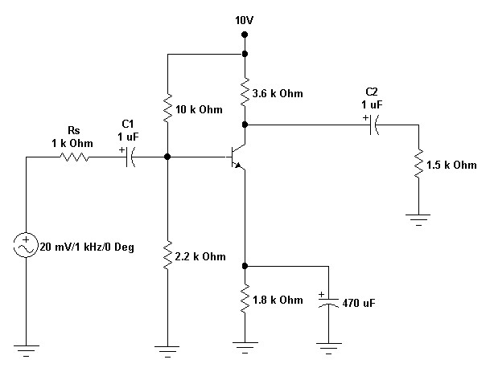

Experiment 8
The Emitter Follower
Introduction

The experiment on "The Emitter Follower," also known as a common collector amplifier, is a fundamental study in electronics and electrical engineering. This configuration is widely appreciated for its ability to provide high input impedance, low output impedance, and unity voltage gain, making it an ideal buffer stage in many circuit applications. An emitter follower does not amplify the voltage of a signal but instead is used to increase the current capability while preserving the voltage level, thus allowing a small input signal to drive a larger load.

This experiment typically involves constructing an emitter follower circuit using a bipolar junction transistor (BJT) and analyzing its characteristics. Students explore how the emitter follower responds to input signals and how it affects the loading of the preceding stage and the driving of the subsequent stage. Practical aspects such as biasing, stability, and impedance matching are also integral parts of the learning experience.

Learning Objectives

- Understanding Emitter Follower Configuration: Gain a solid understanding of the emitter follower circuit, its design, and operational principles, including its place within the broader category of amplifier configurations.

- Circuit Construction and Biasing: Learn to construct an emitter follower circuit, focusing on correct transistor biasing and component selection for optimal performance.

- Analyzing Impedance Characteristics: Develop skills in analyzing the high input and low output impedance characteristics of the emitter follower, and understanding its implications for circuit integration.

- Measuring Voltage Gain and Frequency Response: Measure and understand the unity voltage gain and frequency response of the emitter follower, noting its behavior across different signal frequencies.

- Load Driving Capability: Experiment with and analyze the emitter follower's ability to drive various loads, observing how it sources and sinks current.

- Stability and Biasing Considerations: Study the stability of the emitter follower under different operating conditions, including the effects of temperature and biasing variations.

- Safety in Circuit Experiments: Emphasize the importance of safe practices when handling electronic components and testing circuits.

- Real-World Application Scenarios: Understand the practical applications of emitter followers in electronic circuits, such as in signal buffering, impedance matching, and as a driver for lowimpedance loads.

- Problem-Solving and Critical Thinking: Enhance problem-solving skills by troubleshooting emitter follower circuits and making adjustments to improve performance and stability.

By mastering these objectives, students will gain a comprehensive understanding of the emitter follower configuration and its practical applications in electronic circuit design, enhancing their skills in building and analyzing complex electronic systems.

An emitter follower has a high input impedance, low output impedance, and low nonlinear distortion. It is often used as a buffer stage between a high input impedance source and a low resistance load. In this experiment you will build an emitter follower to verify its high impedance and low output impedance.

Formulas

DC analysis  Vb = R2 Vcc  R1 + R2  Ve = Vb – Vbe  Vce = Vcc – Ve  Vc = Vce + Ve | AC analysis  Re = 25 mV / Ie  Vout = Ve = i_{e}r_{L}  Where r_{L} = R_{L} // RE  Vin = ie (re + r_{L} ) or Vin = Vb  Av = Vout pp / Vin pp = 1  = Rc / re ( without load)

Ai = i_{e} / i_{b} = beta

i_{e} = ic thus Vc = ic (re + r_{L} )

Equipments

1 audio generator
1 power supply
1 transistor (2N3904)
5 ½ –W resistors: 51 Ω, 3.6k Ω, 4.3k Ω,two 10k Ω
2 capacitors: 1 μF, 470 μF (10V rating or higher)
1 oscilloscope
1 VOM

Procedure

Emitter follower
- In fig 8.1, calculate the DC voltage at the base, emitter and collector. Record your answer in table 8-1.
- Refer to the data sheet of 2N3904 to determine the typical hfe. Record this value in table 8-1
- Calculate and record the peak to peak AC voltage at the base, emitter and collector.
- Connect the circuit. Measure and record the DC Voltage at the base, emitter and collector.
- Adjust the signal generator to get the source signal of 1Vp-p at 10 kHz (Measure this between the left end of the source resistor and ground)
- Measure and record the peak to peak AC voltage at the base, emitter and collector.

Output Impedance
- Calculate the theoretical output impedance for the circuit of fig 8-1. record your answer in table 8-2.
- Reduce the peak to peak source from 1V to 100 mV..
- Measure and record the peak to peak output voltage (unloaded)
- Connect a load resistance of 52 ohm across the output.
- Measure the loaded output voltage
- Calculate the output impedance of the emitter follower with the data of steps 9 and 11. Record your experimental answer at table 8-1

Table 8-1 Emitter follower: hfe = ____________

 | Calculated |  |  | Measured
 | B | E | C | B | E | C
DC
AC

Table 8-3 Output Impedance

Calculated r_{out}
Unloaded v_{out}
Loaded v_{out}
Experimental r_{out}

Fig 8-1

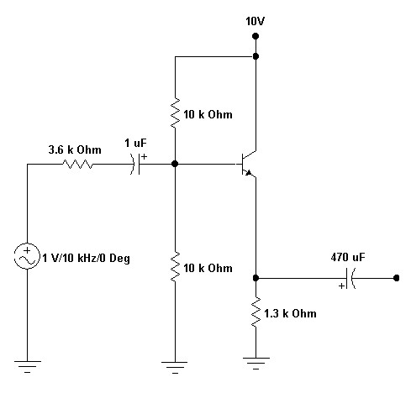

Experiment 9
Class B Push-Pull Amplifier

Introduction

The experiment on the "Class B Push-Pull Amplifier" is a significant study in advanced electronics and electrical engineering, focusing on a widely used amplifier design known for its efficiency and effectiveness in power amplification. Class B amplifiers operate with each transistor conducting for exactly half (180 degrees) of the input signal cycle. In a push-pull arrangement, two transistors are used, where one amplifies the positive half of the waveform and the other amplifies the negative half. This design significantly reduces power wastage and heat generation compared to Class A amplifiers, making it suitable for high-power applications like audio amplifiers.

This experiment involves constructing a Class B push-pull amplifier circuit, typically using a pair of complementary transistors (NPN and PNP) or MOSFETs. Students explore the intricacies of biasing in Class B operation, the functioning of the push-pull mechanism, and the ways to minimize distortions such as crossover distortion.

Learning Objectives

- Understanding Class B Amplifier Principles: Develop a thorough understanding of Class B amplifiers, including their operational mechanism and efficiency advantages over other classes.

- Circuit Construction and Biasing: Learn to construct a Class B push-pull amplifier, focusing on the correct implementation of complementary transistor pairs and the importance of biasing for minimizing crossover distortion.

- Analyzing Amplifier Performance: Develop skills in analyzing the performance of Class B amplifiers, including their efficiency, power output, and distortion characteristics.

- Measurement of Amplifier Parameters: Gain hands-on experience in measuring key parameters such as output power, efficiency, and harmonic distortion.

- Understanding Crossover Distortion: Study the phenomenon of crossover distortion inherent in Class B amplifiers, its causes, and methods to mitigate it.

- Design Considerations for Real-world Applications: Learn about design considerations for practical applications, including load handling, heat dissipation, and the use of heat sinks.

- Safety in Electronic Experiments: Emphasize the importance of safety, especially when dealing with high-power circuits.

- Problem-Solving and Innovation: Enhance problem-solving skills by diagnosing and rectifying issues in the amplifier circuit, and exploring innovative designs to improve performance.

- Real-World Applications: Understand the applications of Class B push-pull amplifiers in real-world scenarios, particularly in audio amplification systems.

By mastering these objectives, students will not only learn the theoretical aspects of Class B pushpull amplifiers but will also acquire practical skills essential for designing and analyzing efficient and high-power amplification systems.

EQUIPMENT REQUIRED:
APPARATUS REQUIRED:
Power supply 0-30V- 1 No.
CRO 20MHz - 1 No.
Digital multimeter - 1 No.
Signal generator 1Hz - 1MHz - 1 No.
COMPONNTS REQUIRED:
Resistors 10KΩ - 1N0
1KΩ - 1NO
220Ω -1NO
Capacitors 0.47uf -1NO
22uf - 2NO
TRANSFORMER -2NO

CIRCUIT
DIAGRAM:
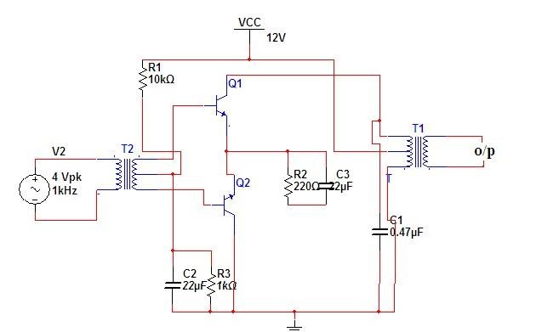

THEORY:
An amplifying system consists of several stages in cascade. The input and the intermediate stages amplify small signal excitations to a value large enough to drive the final device .The out put stage feeds the final device .The output stage feeds a transducer such as a CRO,loudspeaker or servomotor. Thus the final stage must be capable of delivering a large voltage or current or appreciable amount of power. This requires an amplifier which is referred as a power amplifier In class B complimentary symmetry class _B amplifier one np-n and p-n-p is used. Hence the circuit is called class-B complimentary symmetry amplifier. This circuit ifis transformer less circuit .But with common emitter configuration it becomes power transfer without output impedance for maximum power transfer without an output transformers. Hence the matched pair of complementary transistors are used in common collector configuration This is because in common collector configuration has lowest output impedance and hence the impedance matching is possible.
PROCEDURE:
1.conncet the circuit s per the circuit diagram
2.apply 4v p-p with 1KHZ frequency using function generator
3.observe the output in CRO .
4.note the cross over distortion in output.(outputVp-p)
5.remove the collector connection and put ammeter.
6.note the Idc value in the ammeter.
7.using Pdc and Pac formulas find the efficiency.

OBSERVATION:
VO =

VCC =

RL =

EFFICIENCY: Pac/PDC = Vmx II /4 X VCC =
Vm = V pp/2
MODEL GRAPHS: I/P
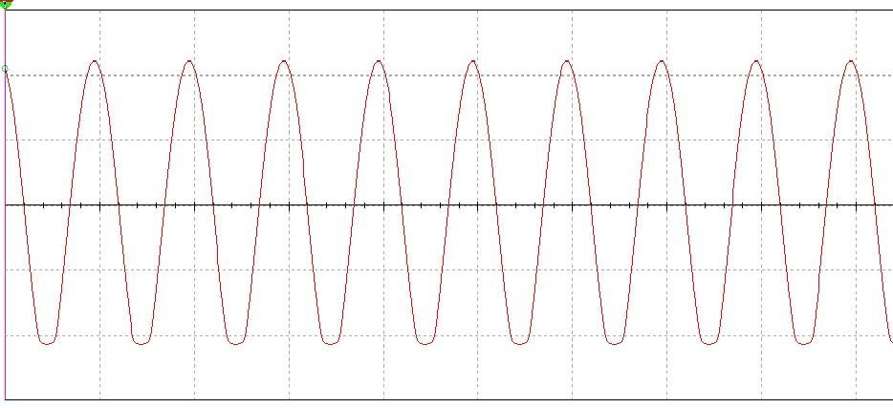

O/P
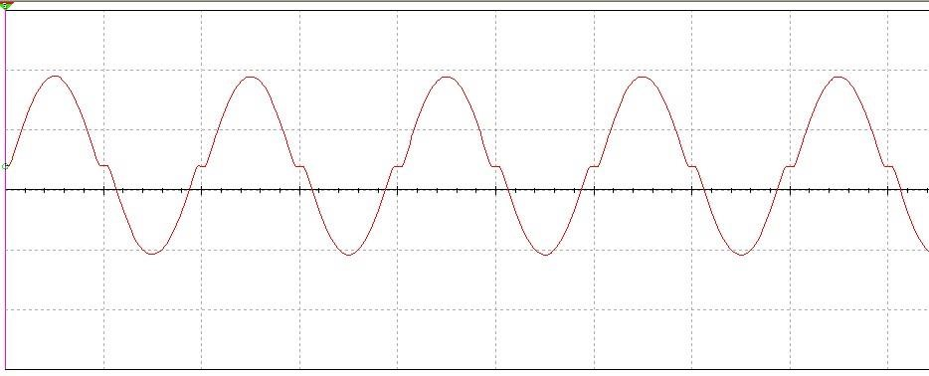
RESULT: The efficiency of class B complimentary symmetry power amplifier is obtained.

EFFICIENCY: Pac/PDC = Vmx II /4 X VCC =
VIVA QUESTIONS:
1.In classB power amplifiers why crossover distortion will be occurred?
2.what are he different methods to eliminate distortion?
3..howmuch efficiency will b obtained in classs-B power amplifier?
4.where is the location of operating point in class-B power amplifier?

Experiment 10
Inverting Amplifier

Introduction

The experiment on the "Inverting Amplifier" is a fundamental aspect of learning in electronics and electrical engineering, focusing on a common operational amplifier (op-amp) configuration. In an inverting amplifier, the input signal is applied to the inverting input of the op-amp while the non-inverting input is typically grounded. This configuration is known for providing a phase-shifted output, where the output signal is inverted relative to the input signal, and for its ability to amplify with a stable, predictable gain determined by the resistor values in the circuit.

This experiment typically involves constructing an inverting amplifier circuit using an op-amp, applying input signals, and analyzing the output. Students learn about key concepts such as gain, bandwidth, input and output impedance, and phase inversion. The practical application of this experiment enhances understanding of op-amp behavior, linear amplification, and feedback in electronic circuits.

Learning Objectives

- Understanding Inverting Amplifier Principles: Gain a solid understanding of the operational principles of inverting amplifiers, including their configuration and the role of feedback.

- Circuit Construction and Design: Learn to construct and design an inverting amplifier circuit using operational amplifiers, focusing on the selection of appropriate resistor values to set the desired gain.

- Analysis of Gain and Bandwidth: Develop skills in calculating and measuring the gain of the inverting amplifier and understanding how bandwidth limitations of the op-amp affect the circuit.

- Phase Shift Analysis: Understand and demonstrate the phase inversion characteristic of the inverting amplifier, where the output signal is 180 degrees out of phase with the input.

- Measurement of Input and Output Impedance: Gain hands-on experience in measuring and analyzing the input and output impedance of the inverting amplifier.

- Exploring the Effects of Different Component Values: Experiment with different resistor and capacitor values to observe how they affect the amplifier’s performance, including gain, bandwidth, and stability.

- Safety in Circuit Experiments: Emphasize the importance of safety when constructing and testing electronic circuits.

- Real-World Application Scenarios: Understand the practical applications of inverting amplifiers in signal processing, audio electronics, and other electronic systems.

- Problem-Solving and Critical Thinking: Enhance problem-solving skills by troubleshooting issues in the amplifier circuit and making adjustments to improve performance and stability.

By completing this experiment, students will not only learn the theoretical aspects of inverting amplifiers but will also acquire practical skills essential for designing and analyzing circuits using operational amplifiers in various electronic applications.APPARATUS:
- Operational Amplifier mA 741 IC –1No.
- Resistors 1KOhm and 10KOhm
- Dual Power supply( 0-20V)
- Regulated Power Supply.(0-20V)
- Multimeter
- CRO and Probes
- Funtion Signal Generator.
- Bread board
9.Connecting wires

THEORY:
INVERTING AMPLIFIER:
An op-amp connected as an inverting amplifier with a controlled amount of voltage gain is shown in fig.
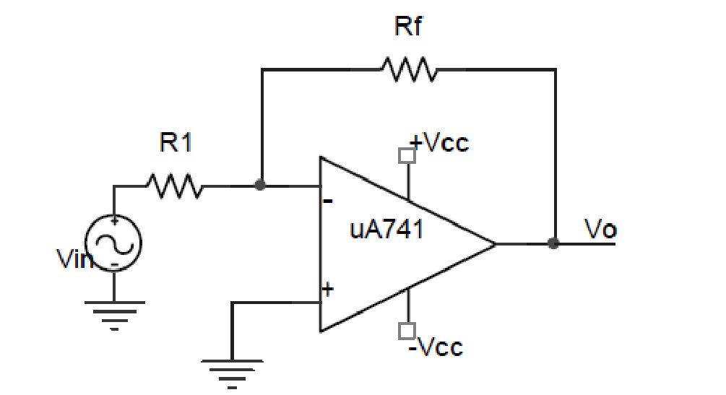

Fig: Inverting amplifier configuration of op-amp

The input signal is applied through a series input resistor R1 to the inverting input. The Non inverting input terminal is grounded. Also, the output is fed back through Rf to the same input. The noninverting input is grounded. Rf and R1 together sets the gain of the amplifier. An expression for the output voltage of the inverting amplifier is written as
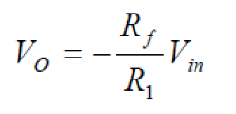
The –ve sign indicates inversion and the output voltage is 180⁰ out of phase with respect to the input and amplified by gain A. The closed-loop gain of the inverting amplifier is, thus
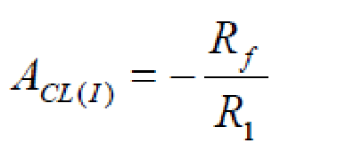
Assuming Rf is a 5k ohm resistor and R1 is a 1k ohm resistor, and Vin is +/- 1 volt triangle input, then Av would be -5 and Vout would be +/- 5volts triangle wave that is 180° out of phase compared to the input as shown in Expected Graph. Note how the output signal is 5 times larger than the input signal. For the special case, when Rf = R1 , Vout = - Vin a 180° phase shifted version of the input.
The interesting item about the inverting amplifier is that the gain is only a function of the ratio of the two resistors of R1 and R2.

CIRCUIT DIAGRAM:

10Kohm
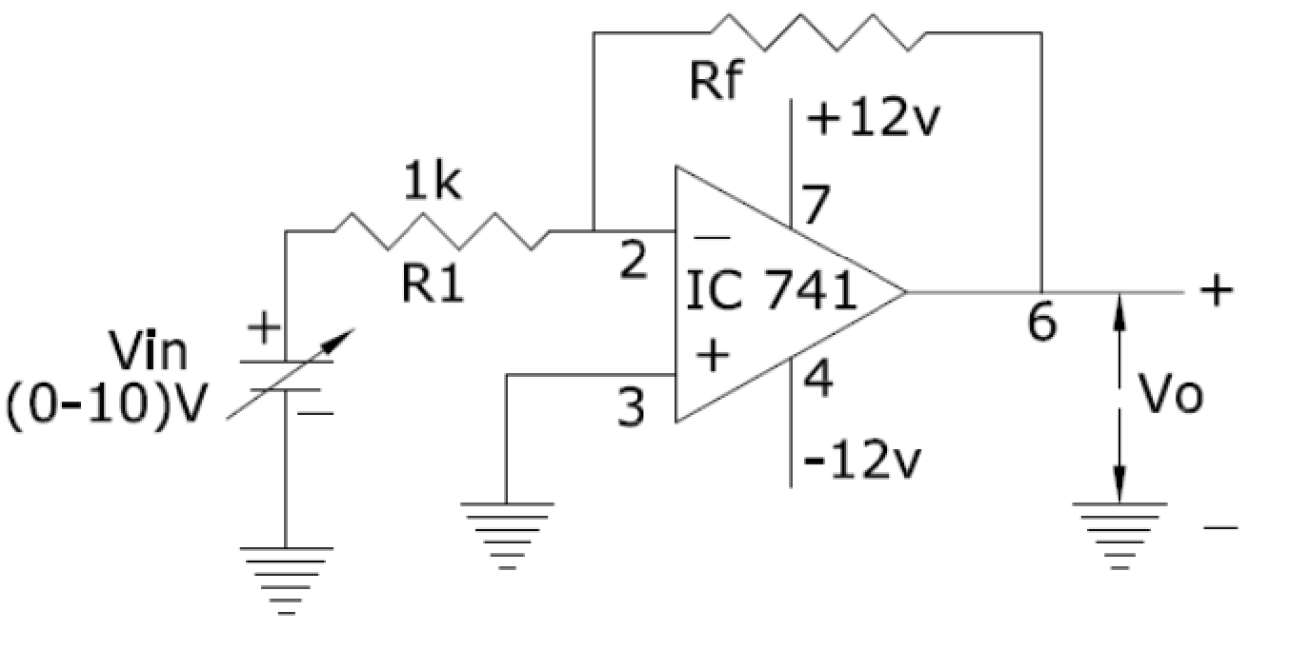

PROCEDURE:

1.Initially set +Vcc = 12 volts and -Vcc to -12 volts.
2.Measure all resistors that are used in the amplifier circuits using the multimeter and record these values
3. As shown in the circuit diagram connect the circuit for Inverting amplifier on a breadboard
4.Before turning any power on, double check the wiring to make sure that it is correct. Make sure that the power supply to the op-amp is correctly wired as not to apply the incorrect polarity to the op-amp.
- Input may be AC or DC voltages from function generator or DC power supply.

- For DC input apply a 1-volt DC input to inverting input terminal of IC741 for Vin from the dc supply and check the output voltage Vo at the output terminal using the multimeter.

7.Compare practical Vo with the theoretical output voltage Vo = (-Rf /R1) Vin

8.For AC input connect the inverting input terminal of IC741 op-amp to function generator and output terminal to CRO.

- Feed input from function generator and observe the output on CRO.

- Draw the input and output waveforms on graph paper.
- Compare the phase between the input and output waveforms.

TABULAR COLUMN:

S.NO | Vin | Vo = (-Rf /R1) Vin |  | Gain = Vo/Vin
 |  | Theoretical | Practical

EXPECTED GRAPH:
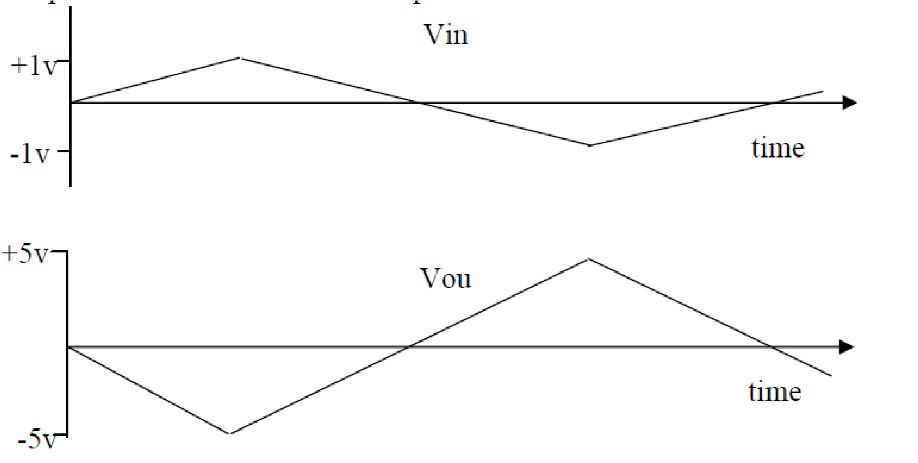

Fig: Output for -5 Gain Inverting Amplifier with a +/- 1 volt triangle wave input. R1=1k & R2=5k

WORKSHEET:

Input Waveform:
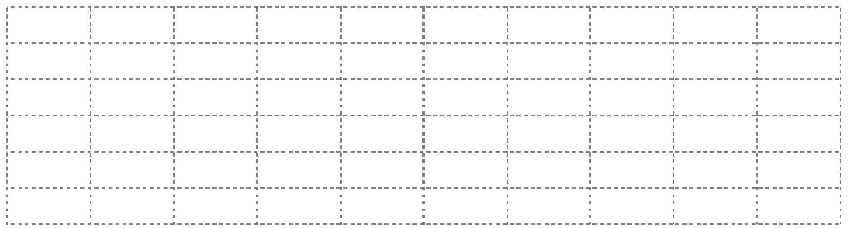
Output Waveform:

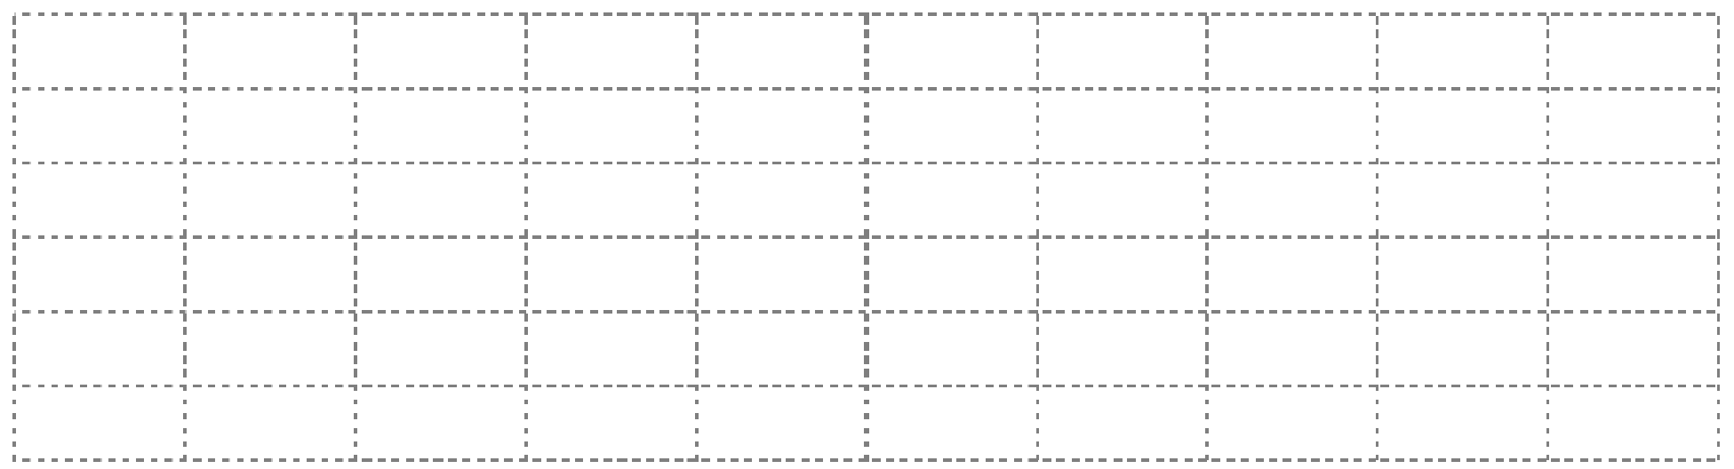

RESULT:

The Practical Values of V_{o} observed are equal to the Theoritical values. From this we can conclude that the Inverting Amplifier using 741 OP-AMP is satisfying its function properly. And it is also noticed that gain is depending on R₂ or R_{f} feedback Resistor.

Experiment 11

Non Inverting Amplifier

Introduction

The experiment on the "Non-Inverting Amplifier" is a crucial part of electronics and electrical engineering education, focusing on a key operational amplifier (op-amp) configuration. In a noninverting amplifier, the input signal is applied to the non-inverting input of the op-amp, resulting in an output signal that is in phase with the input. This configuration is renowned for its high input impedance and ability to amplify signals without inverting their phase. Non-inverting amplifiers are extensively used in applications where signal integrity, particularly phase preservation, is important.

This experiment typically involves constructing a non-inverting amplifier circuit using an op-amp, calculating and setting the desired voltage gain, and analyzing the amplifier's performance in terms of gain, bandwidth, input and output impedance. The hands-on approach in this experiment aids in comprehending the principles of linear amplification, feedback stabilization, and the operational characteristics of non-inverting amplifiers.

Learning Objectives

- Understanding Non-Inverting Amplifier Principles: Develop a comprehensive understanding of the operational principles of non-inverting amplifiers, including their circuit configuration and feedback mechanisms.

- Circuit Construction and Gain Calculation: Learn to construct a non-inverting amplifier circuit using op-amps and calculate the desired gain based on resistor values.

- Analysis of Amplifier Performance: Gain expertise in analyzing the amplifier’s performance, focusing on parameters such as voltage gain, bandwidth, and phase response.

- Measurement of Input and Output Impedance: Develop skills in measuring the high input impedance and low output impedance characteristics of the non-inverting amplifier.

- Exploring the Impact of Component Values: Experiment with different component values to observe their effects on the amplifier's performance, including stability and frequency response.

- Safety in Electronic Circuit Experiments: Emphasize the importance of safety practices when handling and testing electronic circuits.

- Real-World Application Insights: Understand the practical applications of non-inverting amplifiers in various electronic devices and systems, particularly where phase preservation and high input impedance are required.

- Problem-Solving and Critical Thinking: Enhance problem-solving skills by diagnosing and rectifying issues in the non-inverting amplifier circuit and optimizing it for specific applications.

- Data Analysis and Interpretation: Cultivate the ability to interpret experimental data, compare it with theoretical expectations, and understand the implications of circuit non-idealities.

By completing this experiment, students will not only learn the theoretical aspects of non-inverting amplifiers but will also acquire practical skills essential for designing and analyzing circuits using operational amplifiers in a wide range of electronic applications.

APPARATUS:
- Operational Amplifier mA 741 IC –1No.

- Resistors 1KOhm and 10KOhm
- Dual Power supply( 0-20V)
- Regulated Power Supply.(0-20V)
- Multimeter
- CRO and Probes
- Funtion Signal Generator.
- Bread board
9.Connecting wires

THEORY:
NON - INVERTING AMPLIFIER:
An op-amp connected in a closed-loop configuration as a non-inverting amplifier with a controlled amount of voltage gain is shown in Fig

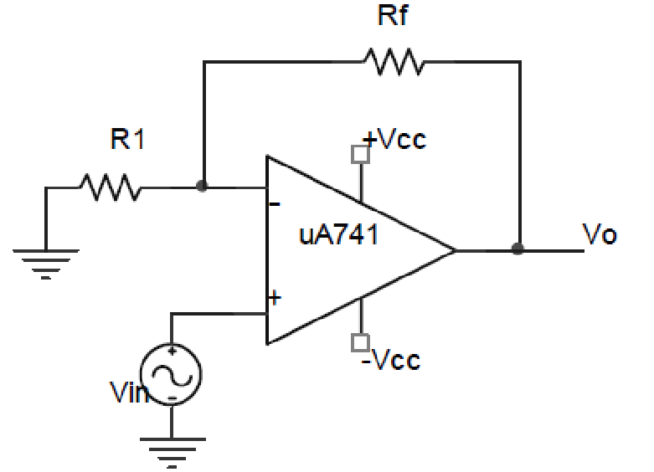
Fig: Non-inverting amplifier configuration of op-amp

The input signal is applied to the non-inverting (+) input. The output is applied back to the inverting(-) input through the feedback circuit (closed loop) formed by the input resistor R1 and the feedback resistor Rf. This creates –ve feedback as follows. Resistors R1 & Rf form a voltage-divider circuit, which reduces V_{O} and connects the reduced voltage V_{f} to the inverting input. The feedback is expressed as
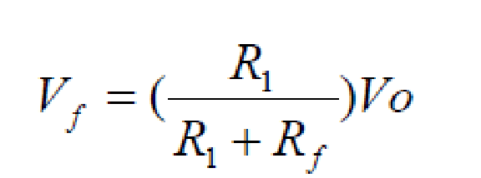
The difference of the input voltage, V_{in} and the feedback voltage, V_{f} is the differential input of the opamp. This differential voltage is amplified by the gain of the op-amp and produces an output voltage expressed as
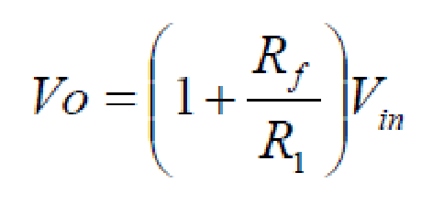
The closed-loop gain of the non-inverting amplifier is, thus

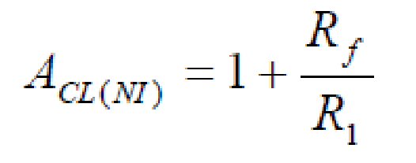

Notice that the closed loop gain is
- Independent of open-loop gain of op-amp
- Set by selecting values of R1 and Rf

CIRCUIT DIAGRAM:
10k
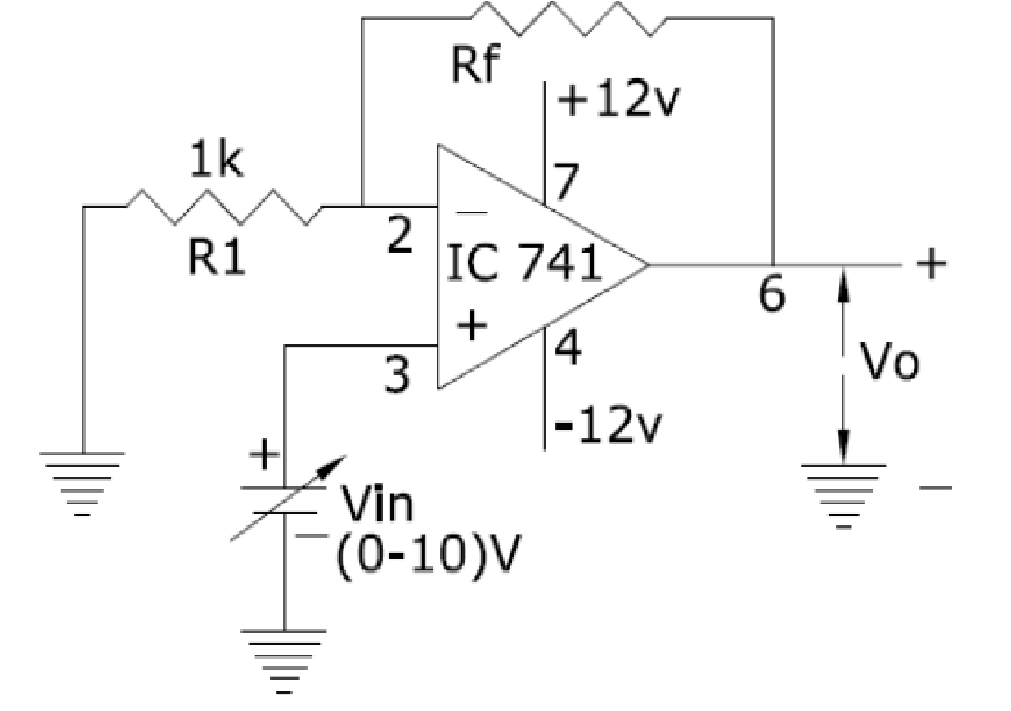

PROCEDURE:
1.Initially set +Vcc = 12 volts and -Vcc to -12 volts.
2.Measure all resistors that are used in the amplifier circuits using the multimeter and record these values
3. As shown in the circuit diagram connect the circuit for Non-Inverting amplifier on a breadboard
4.Before turning any power on, double check the wiring to make sure that it is correct. Make sure that the power supply to the op-amp is correctly wired as not to apply the incorrect polarity to the op-amp.

5.For DC input apply a 1-volt DC input to non-inverting input terminal of IC741 for Vin from the dc supply and check the output voltage Vo at the output terminal using the multimeter.

6.Compare practical Vo with the theoretical output voltage Vo = Vin (1+ R_{f} / R1)

7.For AC input connect the non-inverting input terminal of IC741 op-amp to function generator and output terminal to CRO.

- Feed input from function generator and observe the output on CRO.

- Draw the input and output waveforms on graph paper.
- Compare the phase between the input and output waveforms.

TABULAR COLUMN:

S.NO | Vin | Vo = Vin (1+ Rf /R1) |  | Gain = Vo/Vin
 |  | Theoretical | Practical

EXPECTED GRAPH:

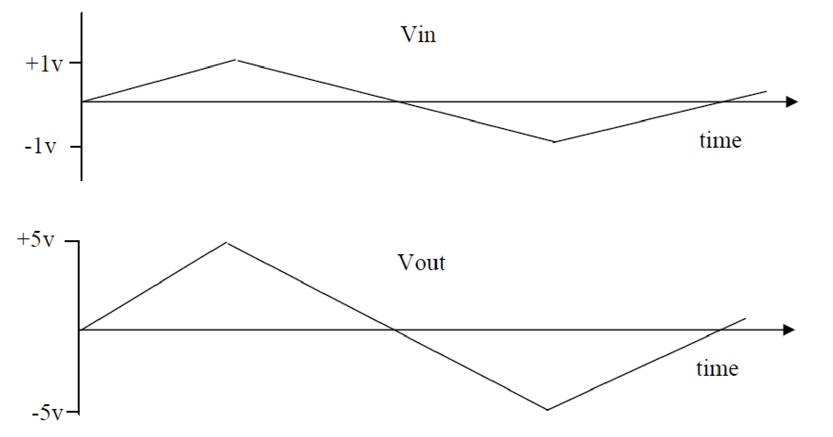

Fig: Output for +5 Gain Non-Inverting Amplifier with a +/- 1 volt triangle wave input. R1=1k & R2=4k

WORKSHEET:

Input Waveform:
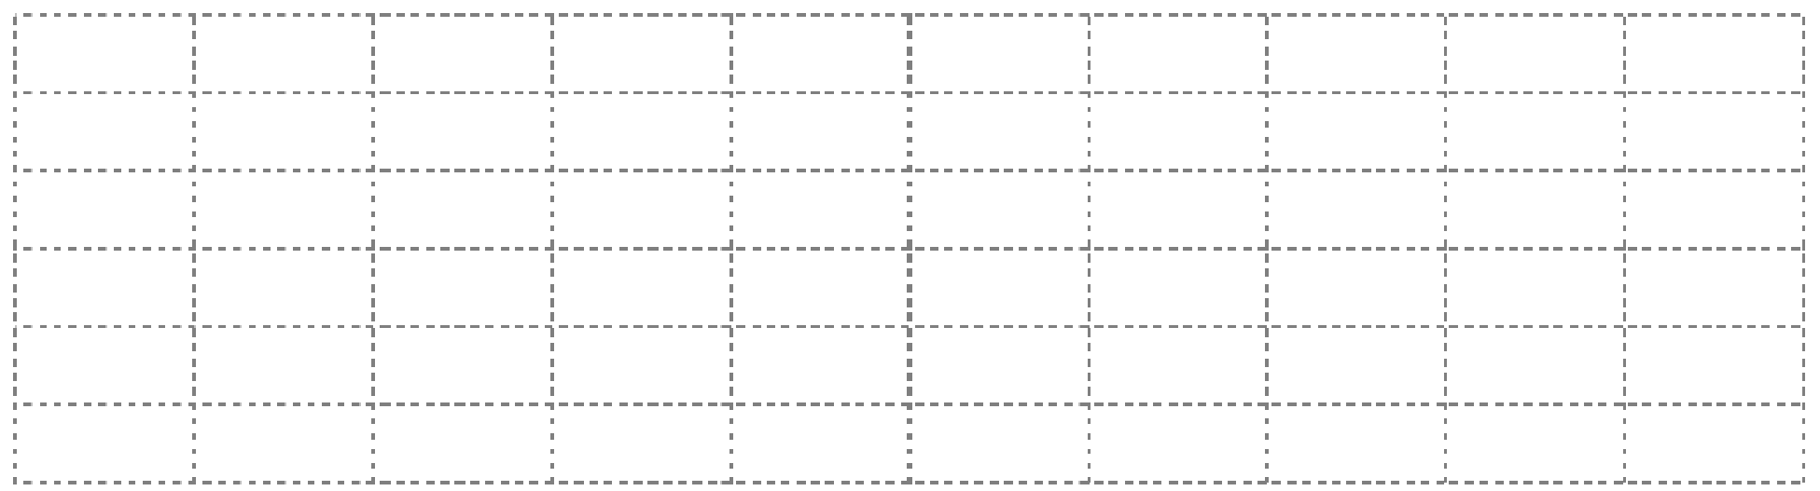

Output Waveform:

RESULT:

The Practical Values of V_{o} observed are equal to the Theoritical values. From this we can conclude that the Non Inverting Amplifier using 741 OP-AMP is satisfying its function properly. And it is also noticed that gain is depending on R₂ or R_{f} feedback Resistor.

Experiment 12

Summing Amplifier

Introduction

The experiment on the "Summing Amplifier" is an essential component of learning in the field of electronics and electrical engineering, focusing on a versatile operational amplifier (op-amp) configuration. A summing amplifier, often also referred to as an adder, is an op-amp circuit that can produce an output equal to the weighted sum of multiple input signals. This functionality makes it extremely useful in applications like audio mixing, signal processing, and data acquisition systems, where combining multiple signals into a single output is required.

In this experiment, students will construct a summing amplifier circuit using an op-amp and resistors, and explore how it combines multiple input signals, either inverting or non-inverting configurations. The practical experience gained from this experiment helps in understanding the principles of superposition and linear operation in op-amp circuits.

Learning Objectives

- Understanding Summing Amplifier Principles: Gain a comprehensive understanding of the operational principles of summing amplifiers, including the concepts of superposition and linear amplification.

- Circuit Construction and Design: Learn to construct and design both inverting and non-inverting summing amplifier circuits, focusing on the selection of appropriate resistor values for desired scaling of input signals.

- Analysis of Circuit Behavior: Develop skills in analyzing the behavior of summing amplifiers, particularly how they combine multiple input signals and the impact of scaling factors.

- Measurement and Interpretation of Output: Gain hands-on experience in applying multiple input signals, measuring the combined output, and interpreting the results in terms of input contributions.

- Exploring the Effects of Different Component Values: Experiment with different resistor values and configurations to understand their effect on the amplifier’s linearity, gain, and bandwidth.

- Understanding Practical Limitations and Non-Idealities: Recognize and analyze the practical limitations and non-idealities of op-amp summing amplifiers, such as input offset voltage and bandwidth limitations.

- Safety in Electrical Circuit Experiments: Emphasize the importance of safe practices when handling and testing electronic circuits.

- Real-World Applications: Understand the practical applications of summing amplifiers in various electronic systems, including audio mixers, analog computers, and signal processing units.

- Problem-Solving and Critical Thinking: Enhance problem-solving skills by troubleshooting issues in the summing amplifier circuit and making adjustments for optimal performance.

By mastering these objectives, students will not only learn the theoretical concepts of summing amplifiers but will also acquire practical skills essential for designing and analyzing circuits in various electronic applications involving signal combination and processing.

APPARATUS:
- Operational Amplifier mA 741 IC
- Resistors 1KOhm
- Dual Power supply( 0-20V)
- Regulated Power Supply.(0-20V)
- Multimeter
- Bread board
7.Connecting wires

THEORY:

Op-amp can be used to design a circuit whose output is the sum of several input signals. Such a circuit is called a summing amplifier or an adder. Summing amplifier can be classified as inverting & noninverting summer depending on the input applied to inverting & non-inverting terminals respectively. The summing amplifier has two or more inputs, and its output voltage is proportional to the algebraic sum of its input voltages. Below figure shows a two-input inverting summing amplifier.
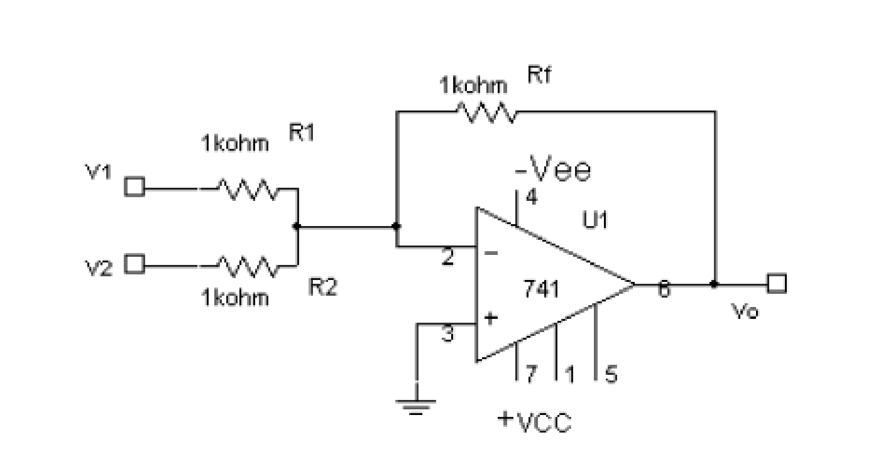
If all the three resistors are equal (R1=R2=Rf=R) then V_{O} = - (Vinl + Vin2)
The above equation shows that the output voltage has the same magnitude as the sum of two input voltages but with a –ve sign indicating inversion. If we connect the inputs to non inverting terminal then the adder is non inverting adder.

CIRCUIT DIAGRAM:

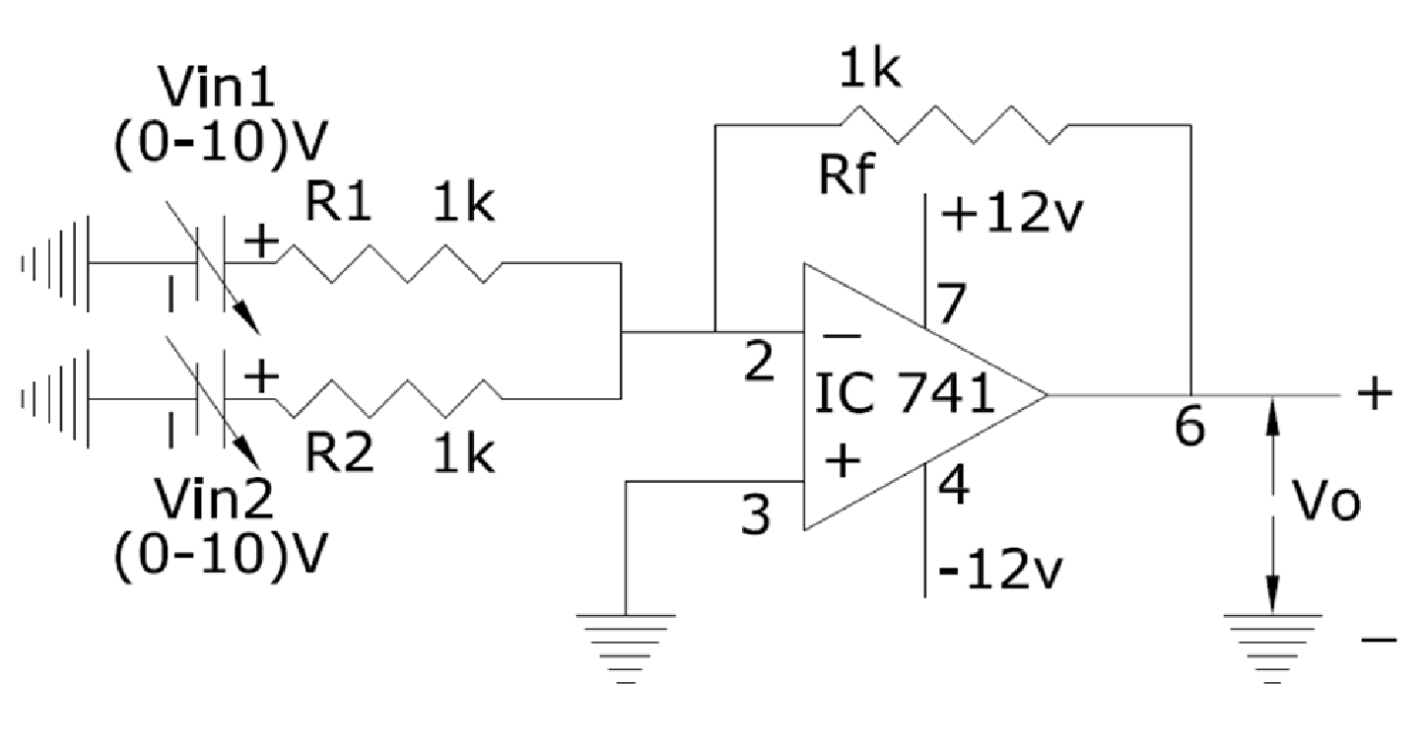

PROCEDURE:
1.Initially set +Vcc = 12 volts and -Vcc to -12 volts.
2.Measure all resistors that are used in the amplifier circuits using the multimeter and record these values
3. As shown in the circuit diagram connect the circuit for Summing amplifier on a breadboard
4.Before turning any power on, double check the wiring to make sure that it is correct. Make sure that the power supply to the op-amp is correctly wired as not to apply the incorrect polarity to the op-amp.

5.Apply dc voltages at each input terminal for V1 and V2 from the dc supply and check the output voltage Vo at the output terminal using the multimeter.

6. Tabulate 3 different sets of readings by repeating the above step.

7.Compare practical Vo with the theoretical output voltage VO = - (Vinl + Vin2)

TABULAR COLUMN:

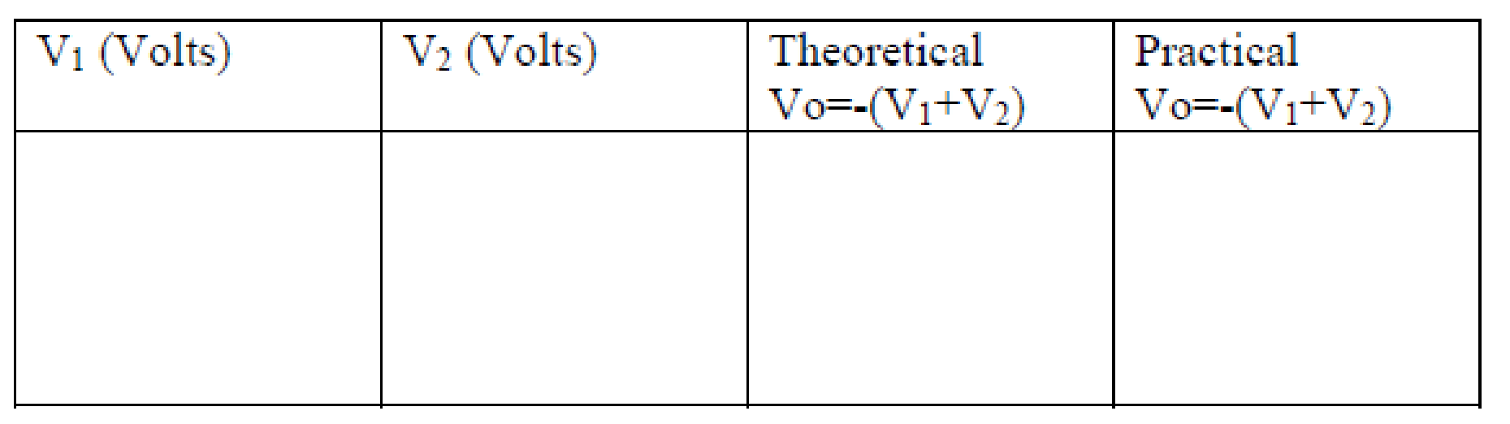

RESULT:

The Practical Values of V_{o} observed are equal to the theoritical values and output is a true replica of addition of two input values. From this we can conclude that the Summing Amplifier or Adder using 741 OP-AMP is satisfying its function properly.

Experiment 13

Differentce Amplifier-Subtractor

Introduction

The experiment on the "Difference Amplifier," also known as a Subtractor, is an important aspect of study in electronics and electrical engineering. This type of circuit, typically constructed using operational amplifiers (op-amps), is designed to amplify the difference between two input signals. The difference amplifier is a fundamental tool in signal processing and is widely used in applications such as sensor signal conditioning, data acquisition systems, and as part of more complex circuits like analogto-digital converters.

This experiment involves the construction of a difference amplifier circuit using op-amps and precision resistors to achieve accurate amplification of the differential signal. Students will explore the principles of differential amplification, learn about common-mode rejection ratio (CMRR), and understand the importance of matching resistor values for optimal circuit performance.

Learning Objectives

- Understanding Difference Amplifier Principles: Develop a solid understanding of how difference amplifiers work, including their basic circuit configuration and the principle of differential amplification.

- Circuit Construction and Design: Learn to construct and design a difference amplifier circuit, focusing on component selection, particularly precision resistors, to ensure accurate amplification of the differential signal.

- Analyzing Amplifier Performance: Gain expertise in analyzing the performance of difference amplifiers, focusing on parameters like gain for differential and common-mode signals, input impedance, and CMRR.

- Measurement of Key Parameters: Develop skills in measuring key parameters such as input and output voltages, gain, and CMRR, and understanding how these parameters affect the performance of the amplifier.

- Exploring the Impact of Component Mismatch: Understand the impact of mismatched components on the circuit's performance, particularly in terms of gain accuracy and CMRR.

- Practical Application Considerations: Learn about the practical considerations and applications of difference amplifiers in electronic systems, including noise rejection and signal conditioning.

- Safety in Electronic Circuit Experiments: Emphasize the importance of safety when handling and testing electronic circuits.

- Problem-Solving and Critical Thinking: Enhance problem-solving skills by diagnosing and rectifying issues in the difference amplifier circuit and optimizing its performance for specific applications.

- Data Analysis and Interpretation: Cultivate the ability to interpret experimental data, compare it with theoretical expectations, and understand the implications of circuit non-idealities.
By completing this experiment, students will not only learn the theoretical aspects of difference amplifiers but will also acquire practical skills essential for designing and analyzing circuits used in advanced electronic signal processing applications.

APPARATUS:
- Operational Amplifier mA 741 IC
- Resistors 10KOhm
- Dual Power supply( 0-20V)
- Regulated Power Supply.(0-20V)
- Multimeter
- Bread board
7.Connecting wires

THEORY:
Op-amp can be used to design a circuit whose output is proportional to or equal to the difference of two input signals. Such a circuit is called a difference amplifier or a subtractor. Below figure shows circuit of a subtractor.
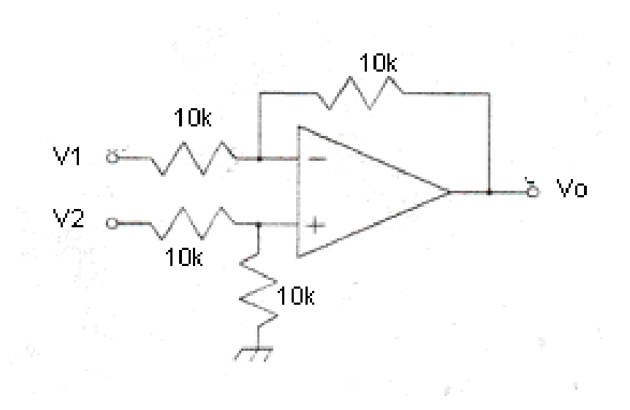
By connecting one input voltage V1 to inverting terminal and another input voltage V2 to the non – inverting terminal, we get the resulting circuit as the Subtractor. If all external resistance are equal in value, so the gain of the amplifier is equal to 1. The output voltages of the differential amplifier with a gain of unity is,

VO = (V2- V1)
Thus the output voltage Vo is equal to the voltage V2 applied to the non – inverting terminal minus the voltage V1 applied to the inverting terminal. Hence the circuit is called a Subtractor.
CIRCUIT DIAGRAM:

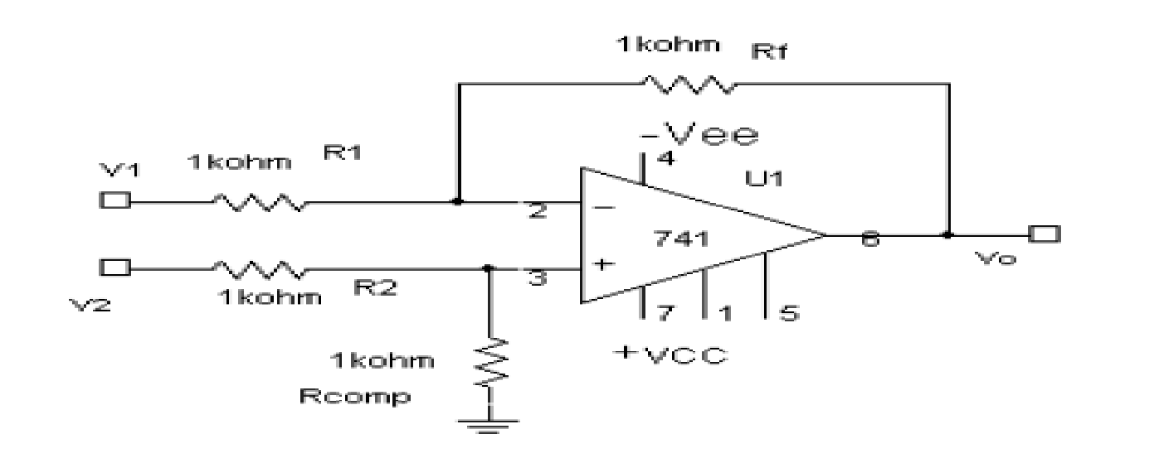

PROCEDURE:
1.Initially set +Vcc = 12 volts and -Vcc to -12 volts.
2.Measure all resistors that are used in the amplifier circuits using the multimeter and record these values
3. As shown in the circuit diagram connect the circuit for Subtractor on a breadboard
4.Before turning any power on, double check the wiring to make sure that it is correct. Make sure that the power supply to the op-amp is correctly wired as not to apply the incorrect polarity to the op-amp.

5.Apply dc voltages at each input terminal for V1 and V2 from the dc supply and check the output voltage Vo at the output terminal using the multimeter.

6. Tabulate 3 different sets of readings by repeating the above step.

7.Compare practical Vo with the theoretical output voltage VO = (V2- V1)

TABULAR COLUMN:

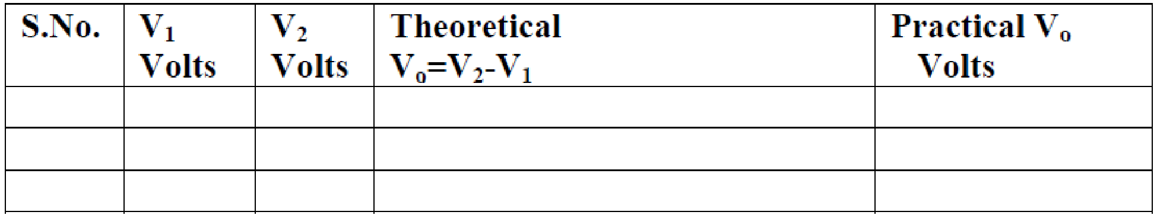

RESULT:

The Practical Values of V_{o} observed are equal to the theoritical values and output is a true replica of the subtraction values of the two inputs .
From this we can conclude that the Difference Amplifier or Subtractor using 741 OP-AMP is satisfying its function properly.

Experiment 14
INTEGRATOR

Introduction

The experiment on the "Integrator Amplifier" is a vital component of electronics and electrical engineering education, focusing on an operational amplifier (op-amp) circuit that performs the mathematical operation of integration. An integrator amplifier outputs a voltage that is proportional to the integral of its input voltage over time. This type of circuit is fundamental in analog signal processing and finds applications in various fields, including control systems, analog computing, and waveform generation.

In this experiment, students construct an integrator circuit using an op-amp, resistors, and capacitors. They explore how the circuit integrates a time-varying input signal, observing the resulting output waveforms. The practical experience of building and analyzing an integrator amplifier deepens the understanding of integral calculus in a real-world application and provides insight into the behavior of capacitive reactance in AC circuits.

Learning Objectives

- Understanding Integrator Amplifier Principles: Develop a comprehensive understanding of the operational principles of integrator amplifiers, including their design and the mathematical concept of integration in signal processing.

- Circuit Construction and Analysis: Learn to construct an integrator amplifier circuit using an opamp, resistors, and capacitors, focusing on understanding the role of each component.

- Observation and Measurement of Waveforms: Gain hands-on experience in applying different input signals (such as square, triangular, and sine waves) and observing the corresponding integrated output waveforms.

- Analysis of Frequency Response: Understand the frequency response of the integrator circuit, including the effects of the capacitor and the operational bandwidth of the op-amp.

- Exploring the Impact of Component Values: Experiment with different values of resistors and capacitors to observe their effects on the integration time constant and the output waveform.

- Safety in Circuit Experiments: Emphasize the importance of safe practices when handling electronic components and instruments.

- Real-World Application Scenarios: Understand the practical applications of integrator amplifiers in electronic devices and systems, such as in signal filtering, waveform generation, and control systems.

- Problem-Solving and Critical Thinking: Enhance problem-solving skills by troubleshooting issues in the integrator amplifier circuit and making adjustments for optimal performance.

- Data Analysis and Interpretation: Develop the ability to analyze and interpret experimental data, understanding how it correlates with the theoretical operation of integration.

By mastering these objectives, students will not only learn the theoretical concepts of integrator amplifiers but will also acquire practical skills essential for designing and analyzing circuits in various electronic applications involving signal processing and control.

APPARATUS:
- Operational Amplifier mA 741 IC –1No.
- Resistors 1KOhm and 10KOhm
- Capacitor 0.1μf
- Dual Power supply( 0-20V)
- Regulated Power Supply.(0-20V)
- Multimeter
- CRO and Probes
- Funtion Signal Generator.
- Bread board
10.Connecting wires

THEORY:
Integrator or the integration amplifier is a circuit in which “the output voltage waveform is the integral of the input voltage waveform” .Such a circuit is obtained by using a basic inverting amplifier configuration, if the feedback resistor R_{f} is replaced by a capacitor C_{f}.

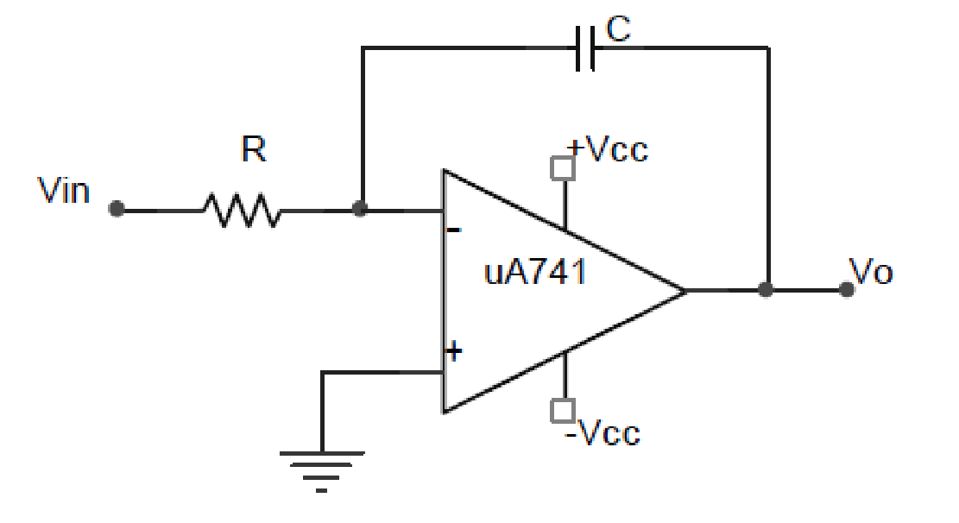

Figure: Basic Op-Amp Integrator

The output voltage is given by

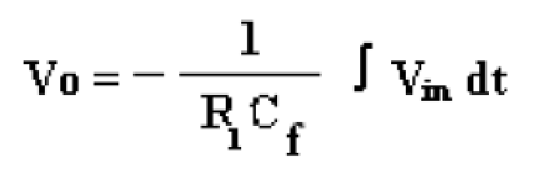
Thus, the output voltage is directly proportional to the negative integral of the input voltage and inversely proportional to the time constant R C_{f}.
If the input to the integrator is a square wave, the output will be a triangular wave, or if the input is a sine wave, the output will be a cosine wave.
For proper integration, RC has to be much greater than the time period of the input signal i.e,. RC _{f} ≥ T.
Integrator has wide applications in
1.Analog computers used for solving differential equations in simulation arrangements. 2. A/D Converters
- Signal wave shaping
- Function Generators

CIRCUIT DIAGRAM:

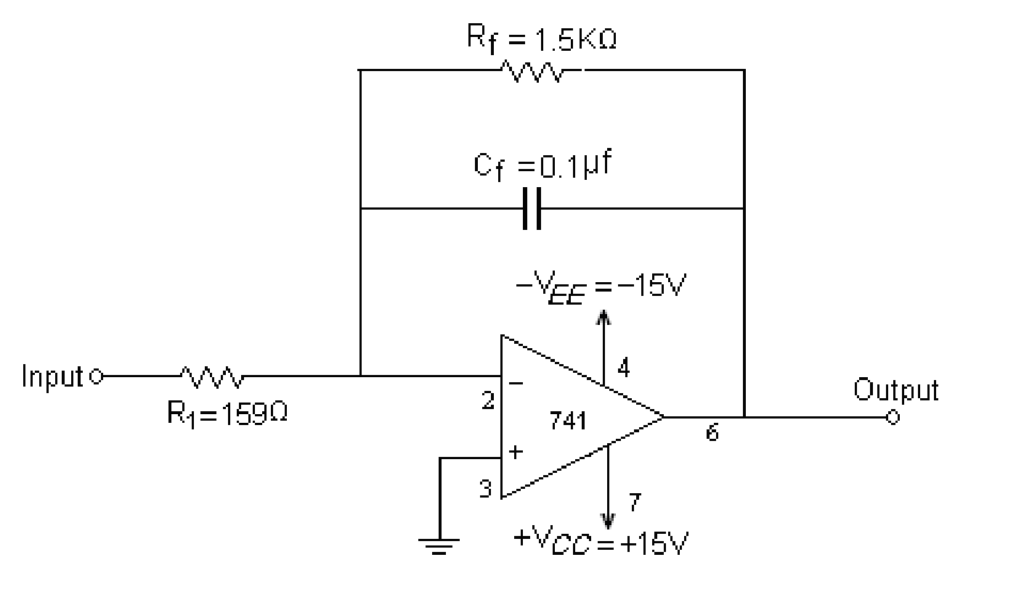

PROCEDURE:
- Initially set +Vcc = 12 volts and -Vcc to -12 volts.
- Measure all resistors that are used in the amplifier circuits using the multimeter and record these values
3.As shown in the circuit diagram connect the circuit for Integrator on a breadboard
4.Before turning any power on, double check the wiring to make sure that it is correct. Make sure that the power supply to the op-amp is correctly wired as not to apply the incorrect polarity to the op-amp.

- Apply square wave at the input terminals of the circuit using function Generator.

- Connect channel-1 of CRO at the input terminals and channel-2 at the output terminals.

- Observe the output of the circuit on the CRO which is a triangular wave and note down the position, the amplitude and the time period of Vin & Vo.

- Now apply the sine wave as input signal.

- Observe the output of the circuit on the CRO which is a cosine wave (90º phase shifted from the sine wave input) and note down the position, the amplitude and the time period of Vin & Vo.

- Plot the output voltages corresponding to square and sine wave inputs.

TABULAR COLUMN:
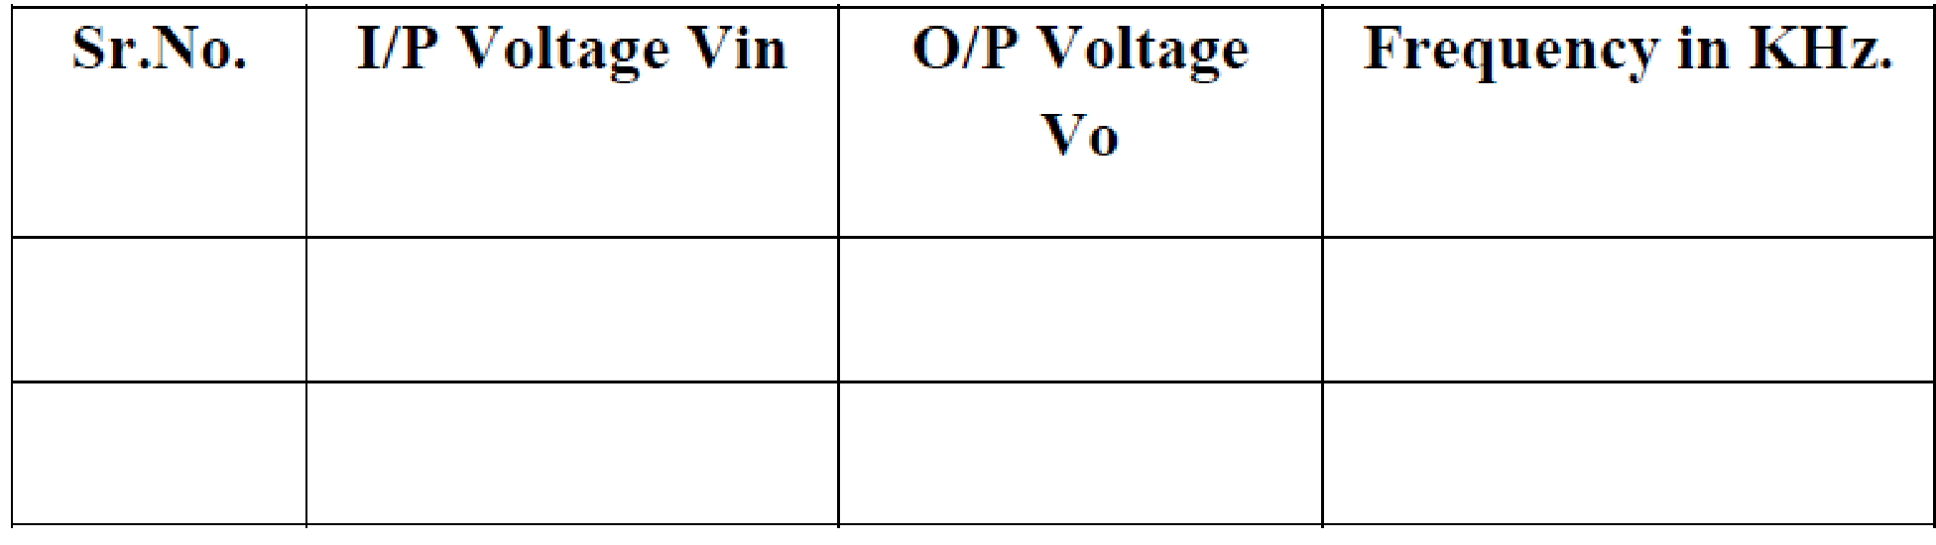
EXPECTED WAVEFORMS:

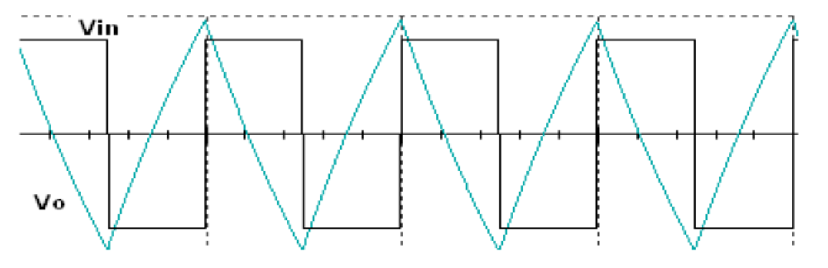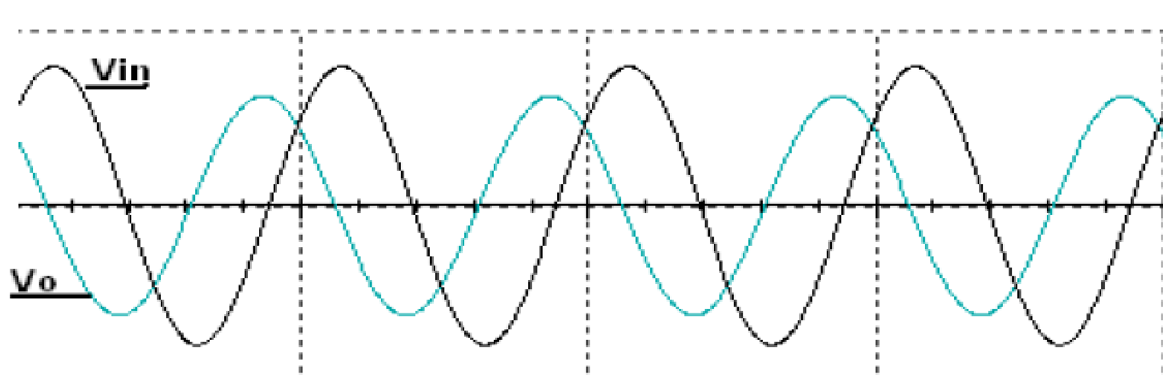

WORKSHEET:
Input waveform:
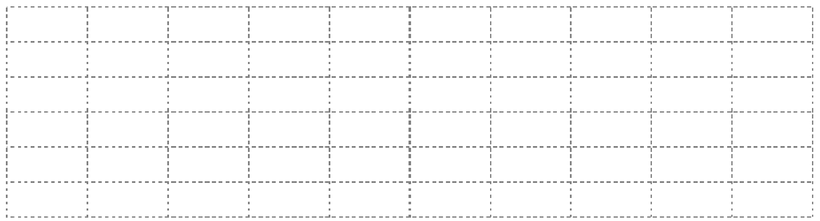
Output Waveform:


RESULT:

Hence an op-amp integrator simulates mathematical integration which is basically a summing process that determines the total area under the curve of a function ie., the integrator does integration of the input voltage waveform.Output of an integrator using op-amp 741 for a given input signal is observed and plotted From this we can conclude that the Integrator using IC 741 OP-AMP is satisfying its function properly.

Experiment 15

Differentiator

Introduction

The experiment on the "Differentiator Amplifier" is an integral part of electronics and electrical engineering curricula, focusing on an operational amplifier (op-amp) circuit that performs the mathematical operation of differentiation. A differentiator amplifier produces an output voltage that is proportional to the rate of change of its input voltage. This circuit is essential in signal processing applications, particularly in areas like waveform shaping, edge detection in digital signal processors, and as a component in analog computers.

In this experiment, students will construct a differentiator circuit using an op-amp, resistors, and capacitors. They will explore how the circuit responds to various input waveforms, such as square, triangular, and sine waves, and observe the corresponding differentiated output waveforms. This hands-on approach enhances understanding of the practical application of differential calculus in electronics and the behavior of reactive components like capacitors and resistors in AC circuits.

Learning Objectives

- Understanding Differentiator Amplifier Principles: Gain a thorough understanding of the operational principles of differentiator amplifiers, including their design and the mathematical concept of differentiation in signal processing.

- Circuit Construction and Analysis: Learn to construct a differentiator amplifier circuit using an op-amp, capacitors, and resistors, focusing on the role of each component in the circuit.

- Observation and Measurement of Waveforms: Develop hands-on experience in applying different input signals and observing the corresponding output waveforms, which represent the derivative of the input.

- Frequency Response Analysis: Understand the frequency response of the differentiator circuit, including the effects of the capacitor and resistor values on the circuit's performance.

- Exploring the Impact of Component Values: Experiment with changing resistor and capacitor values to observe how they affect the differentiation time constant and the shape of the output waveform.

- Safety in Electronic Circuit Experiments: Emphasize the importance of safety when constructing and testing electronic circuits.

- Real-World Application Insights: Understand the practical applications of differentiator amplifiers in signal processing and control systems, such as in motion detection, rate-ofchange sensors, and waveform generation.

- Problem-Solving and Critical Thinking: Enhance problem-solving skills by troubleshooting issues in the differentiator amplifier circuit and making adjustments to improve its performance.

- Data Analysis and Interpretation: Cultivate the ability to interpret experimental data, understanding how it correlates with the theoretical operation of differentiation.

By completing this experiment, students will not only grasp the theoretical concepts of differentiator amplifiers but will also acquire practical skills essential for designing and analyzing circuits in various electronic applications involving advanced signal processing.

APPARATUS:
- Operational Amplifier mA 741 IC –1No.
- Resistors 1KOhm and 10KOhm
- Capacitor 0.1μf
- Dual Power supply( 0-20V)
- Regulated Power Supply.(0-20V)
- Multimeter
- CRO and Probes
- Funtion Signal Generator.
- Bread board
10.Connecting wires

THEORY:

Differentiator performs the reverse of integration function. Differentiator circuits as its name implies, performs the mathematical operation of differentiator, that is, the output waveform is the derivative of the input. The differentiator may be constructed from a basic inverting amplifier when an input resistor R1 is replaced by a capacitor C, An ideal differentiation is shown in below figure.

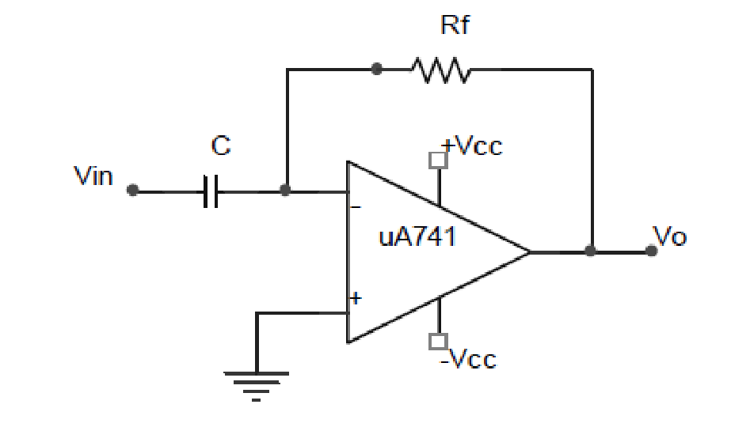

Figure: Basic Op-Amp Differentiator

The output voltage is given by

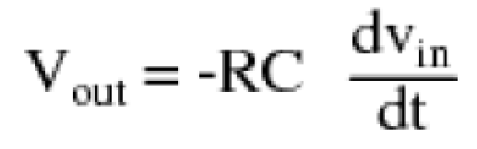
Thus, the output Vo is equal to the R_{f} C times the negative instantaneous rate of change of the input voltage Vin with time.. A linear, positive rate of input voltage change will result in a steady negative voltage at the output of the op-amp. Conversely, a linear, negative rate of input voltage change will result in a steady positive voltage at the output of the op-amp. This polarity inversion from input to output is due to the fact that the input signal is being sent (essentially) to the inverting input of the opamp, so it acts like the inverting amplifier

Since the differentiator performs the reverse of the integrators function, triangular wave input will produce a Square wave output ,or a cosine wave input will produce a sine wave output. If we apply square wave as input signal output is a spike wave .

The input signal will be differentiated properly if the time period T of the input signal is larger than or equal to R_{f}C1. That is, T ≥ R_{f} C1 Differentiator has wide applications in
- Monostable Multivibrator
- Signal wave shaping
- Function Generators.
CIRCUIT DIAGRAM:

Rf =10K
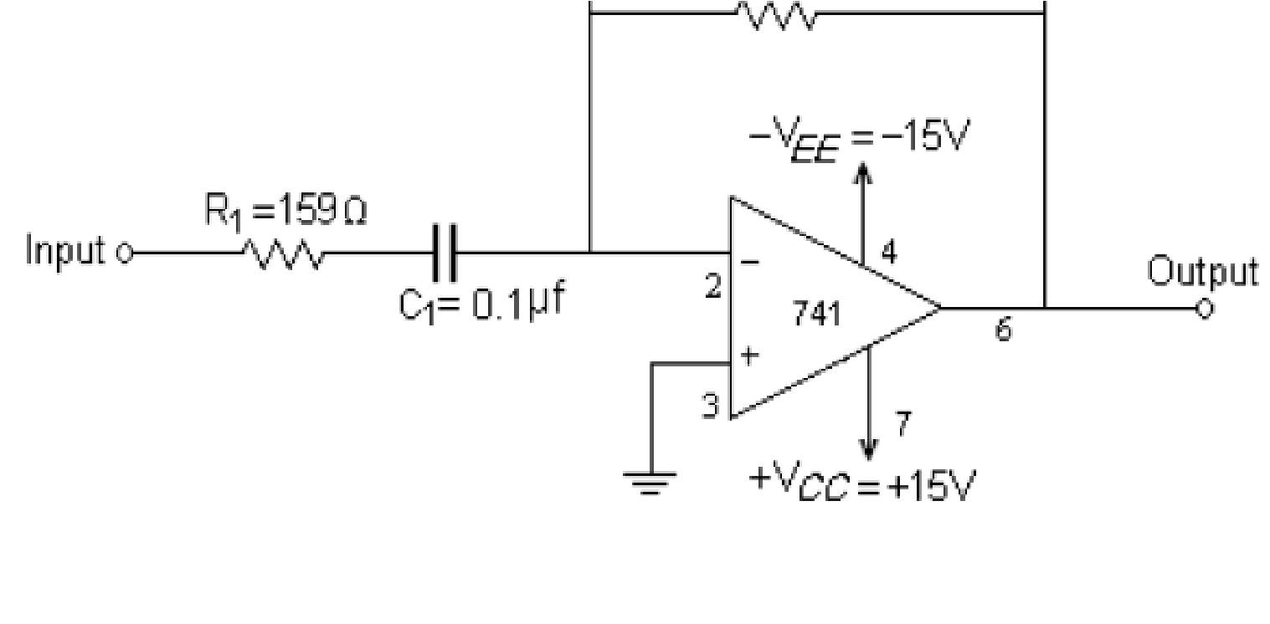
PROCEDURE:

1.Initially set +Vcc = 12 volts and -Vcc to -12 volts.
2.Measure all resistors that are used in the amplifier circuits using the multimeter and record these values
3. As shown in the circuit diagram connect the circuit for differentiator on a breadboard
4.Before turning any power on, double check the wiring to make sure that it is correct. Make sure that the power supply to the op-amp is correctly wired as not to apply the incorrect polarity to the op-amp.

- Apply sine wave at the input terminals of the circuit using function Generator.

- Connect channel-1 of CRO at the input terminals and channel-2 at the output terminals.

- Observe the output of the circuit on the CRO which is a cosine wave (90º phase shifted from the sine wave input) and note down the position, the amplitude and the time period of Vin & Vo.

- Now apply the square wave as input signal.

- Observe the output of the circuit on the CRO which is a spike wave and note down the position, the amplitude and the time period of Vin & Vo.

- Plot the output voltages corresponding to square and sine wave inputs.

TABULAR COLUMN:
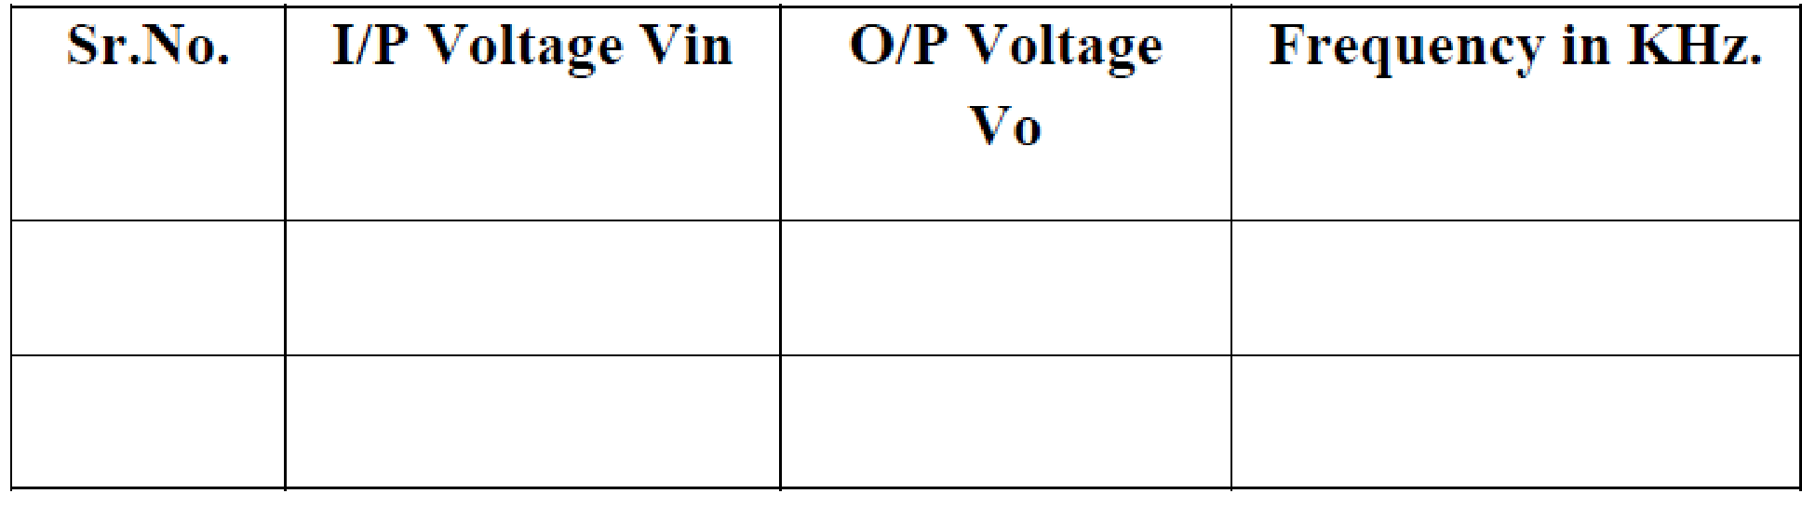
EXPECTED WAVEFORMS:

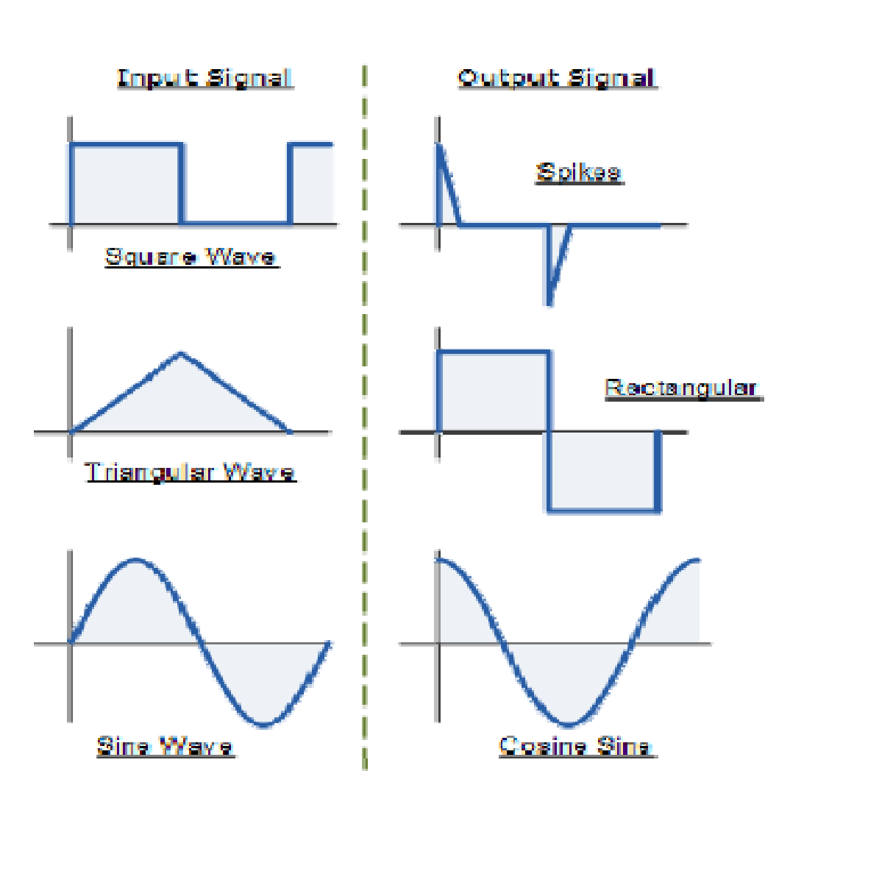

WORKSHEET:
Input Waveform:
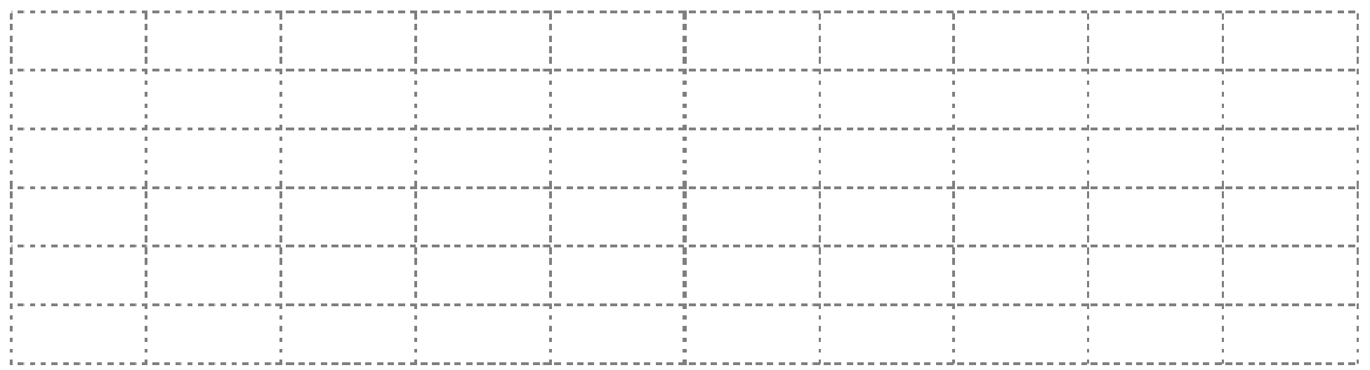
Output Waveform:


RESULT:

Hence an op-amp differentiator simulates mathematical differentiation of the input voltage waveform. Output of an differentiator using op-amp 741 for a given input signal is observed and plotted .From this we can conclude that the differentiator using IC 741 OP-AMP is satisfying its function properly.

Experiment 16
VOLTAGE FOLLOWER

Introduction

The experiment on the "Voltage Follower" is a fundamental and practical study in the field of electronics and electrical engineering. A voltage follower, also known as a buffer amplifier or unity-gain amplifier, is an operational amplifier (op-amp) configuration that provides a high input impedance, low output impedance, and a gain of approximately one. This means the output voltage closely follows (mirrors) the input voltage. The primary purpose of a voltage follower is not to amplify the signal but to improve the circuit's impedance characteristics, making it an essential tool in various applications such as signal isolation, buffering, and driving heavy loads without distorting the signal.

In this experiment, students will construct a voltage follower circuit using an op-amp and analyze its characteristics. The hands-on approach helps in understanding the operational principles of the voltage follower, its effect on loading, and its role in complex electronic systems.

Learning Objectives

- Understanding Voltage Follower Principles: Gain a comprehensive understanding of the operational principles of voltage followers, including their configuration and the role of unitygain amplification.

- Circuit Construction and Analysis: Learn to construct a voltage follower circuit using an op-amp and analyze its characteristics, focusing on the high input impedance and low output impedance aspects.

- Exploring Impedance Characteristics: Develop skills in understanding the importance of impedance matching in electronic circuits and how the voltage follower assists in this.

- Measurement of Circuit Parameters: Gain hands-on experience in measuring key parameters like input and output voltages, input and output impedances, and verifying the unity-gain characteristic.

- Exploring the Impact on Signal Integrity: Understand the significance of the voltage follower in preserving signal integrity, particularly in circuits with high impedance sources or when driving capacitive loads.

- Safety in Electronic Circuit Experiments: Emphasize the importance of safety when constructing and testing electronic circuits.

- Real-World Application Scenarios: Recognize the practical applications of voltage followers in various electronic devices and systems, such as in sensor interfaces, audio equipment, and signal processing units.

- Problem-Solving and Critical Thinking: Enhance problem-solving skills by troubleshooting issues in the voltage follower circuit and optimizing its performance for specific applications.

- Data Analysis and Interpretation: Develop the ability to analyze and interpret experimental data, understanding how it correlates with the theoretical operation of voltage followers.

By mastering these objectives, students will not only learn the theoretical aspects of voltage followers but will also acquire practical skills essential for designing and analyzing circuits in a wide range of electronic applications.

APPARATUS:
- Operational Amplifier mA 741 IC –1No.

- Resistors 1KOhm
- Dual Power supply( 0-20V)
- Regulated Power Supply.(0-20V)
- Multimeter
- CRO and Probes
- Funtion Signal Generator.
- Bread board
9.Connecting wires

THEORY:
Voltage follower is basically a non-inverting amplifier with RF=0 & R1= infinity. Here the output voltage is as same as that of the input voltage. Hence, the amplifier output is related to the input as,
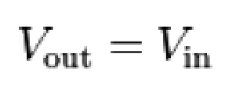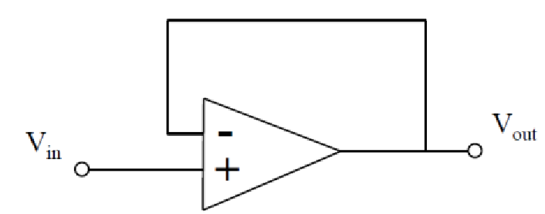

Fig: Voltage follower configuration of op-amp

Gain = 1 + ( Rf / Rin) Here Rf is zero,
Gain = 1 + ( 0 / Rin)
Gain = 1 + 0
Gain = 1
The name ‘’follower’’ is due to the fact that the output voltage follows the input. Voltage followers are widely used to provide buffering between high internal resistance soures and a load.

CIRCUIT DIAGRAM:

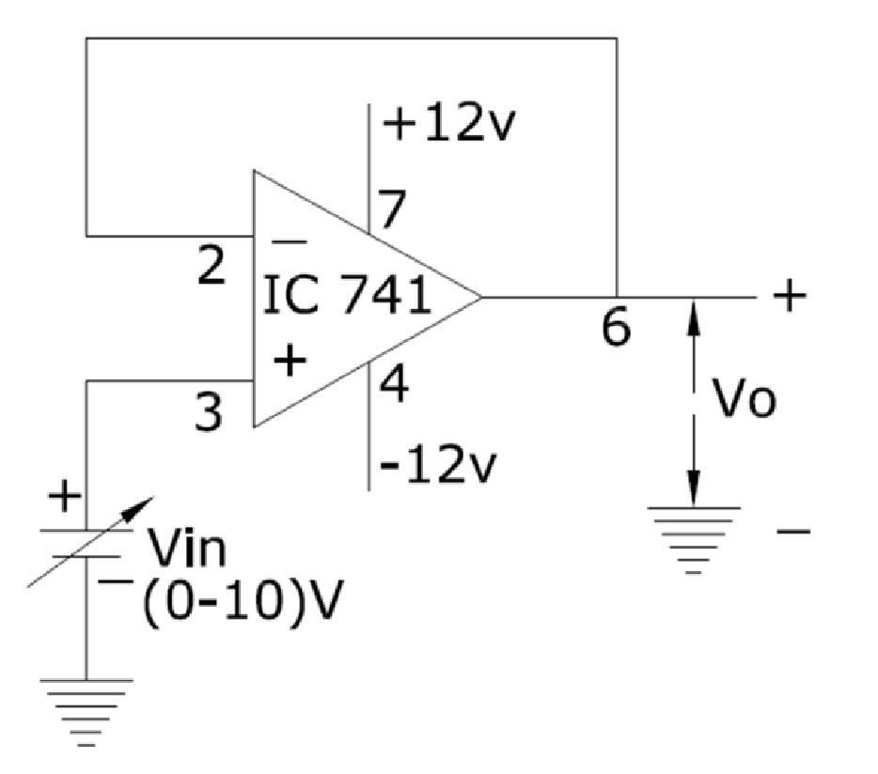

PROCEDURE:
1.Initially set +Vcc = 12 volts and -Vcc to -12 volts.
2.Measure all resistors that are used in the amplifier circuits using the multimeter and record these values
3. As shown in the circuit diagram connect the circuit for Voltage Follower on a breadboard
4.Before turning any power on, double check the wiring to make sure that it is correct. Make sure that the power supply to the op-amp is correctly wired as not to apply the incorrect polarity to the op-amp.

5.For DC input apply a 1-volt DC input to non-inverting input terminal of IC741 for Vin from the dc supply and check the output voltage Vo at the output terminal using the multimeter.

6.Compare practical Vo with the theoretical output voltage Vo = Vin

- For AC input connect the non-inverting input terminal of IC741 op-amp to function generator and output terminal to CRO.

- Feed input from function generator and observe the output on CRO.

- Draw the input and output waveforms on graph paper.
- Compare the input and output waveforms.

TABULAR COLUMN:

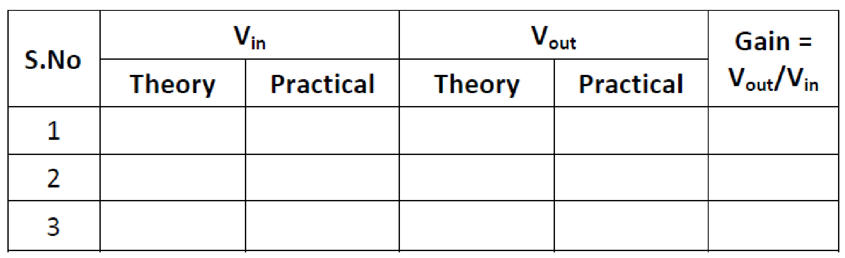

EXPECTED GRAPH:

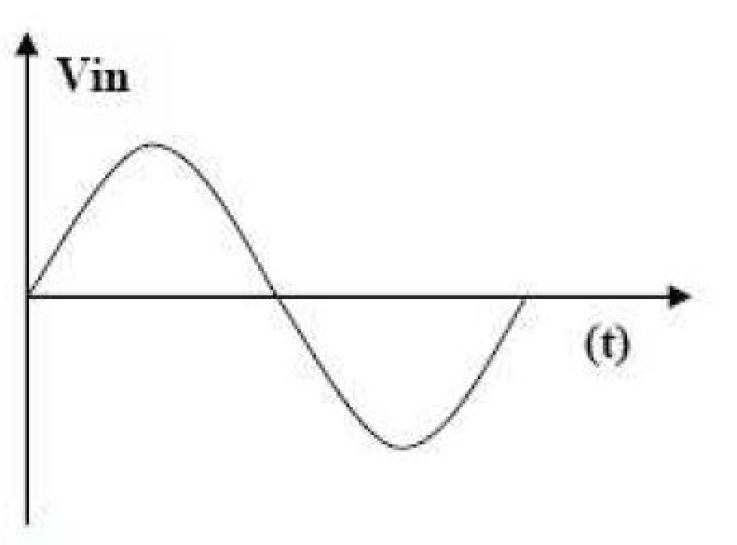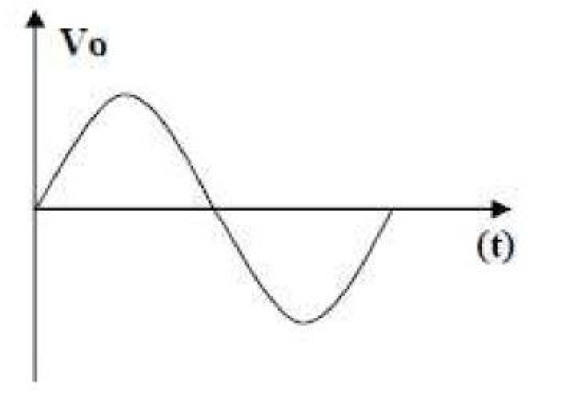

WORKSHEET:

Input Waveform:


Output Waveform:


RESULT:

The Practical Values of V_{o} observed are equal to the Theoritical values. From this we can conclude that the Non Inverting Amplifier using 741 OP-AMP is satisfying its function properly. And it is also noticed that gain is depending on R₂ or R_{f} feedback Resistor.

Experiment .No.17
DIFFERENTIAL AMPLIFIER

Introduction

The experiment on the "Differential Amplifier" is a key educational component in the fields of electronics and electrical engineering, focusing on an operational amplifier (op-amp) configuration used for amplifying the difference between two input voltages while rejecting any voltages that are common to both inputs. Differential amplifiers are fundamental in various applications, including audio processing, instrumentation, and as part of more complex integrated circuits like analog-to-digital converters.

This experiment involves constructing a differential amplifier using op-amps and precision resistors to ensure accurate amplification of the differential signal. Students explore how the circuit responds to different input signals, and they learn about key concepts such as common-mode rejection ratio (CMRR), differential gain, and input impedance. Practical experiments with differential amplifiers provide valuable insights into how electronic devices process and amplify signals.

Learning Objectives

- Understanding Differential Amplifier Principles: Develop a comprehensive understanding of the operational principles of differential amplifiers, including their circuit configuration and the role of each component.

- Circuit Construction and Analysis: Learn to construct a differential amplifier circuit using opamps and resistors, focusing on achieving precise differential amplification.

- Measurement and Analysis of Differential Gain and CMRR: Gain hands-on experience in measuring differential gain and the CMRR, understanding their significance in amplifier performance.

- Exploring Input Impedance and Signal Handling: Understand the importance of input impedance in differential amplifiers and how the amplifier handles various input signal types.

- Safety in Electronic Circuit Experiments: Emphasize the importance of safety when constructing and testing electronic circuits.

- Real-World Application Insights: Recognize the practical applications of differential amplifiers in various electronic systems, including their role in noise reduction and signal fidelity.

- Problem-Solving and Critical Thinking: Enhance problem-solving skills by troubleshooting issues in the differential amplifier circuit and making adjustments for optimal performance.

- Data Analysis and Interpretation: Develop the ability to interpret experimental data, compare it with theoretical expectations, and understand the implications of circuit non-idealities.

By completing this experiment, students will not only learn the theoretical aspects of differential amplifiers but will also acquire practical skills essential for designing and analyzing circuits used in advanced signal processing and electronic applications.

APPARATUS:
- Operational Amplifier mA 741 IC –1No.
- Resistors 1KOhm and 10KOhm
- Dual Power supply( 0-20V)
- Regulated Power Supply.(0-20V)
- Multimeter
- CRO and Probes
- Funtion Signal Generator.
- Bread board 9.Connecting wires THEORY:
INVERTING AMPLIFIER:
Differential amplifier: The differential amplifier is designed to amplify the difference of the two inputs. The simplest configuration is shown in Fig.
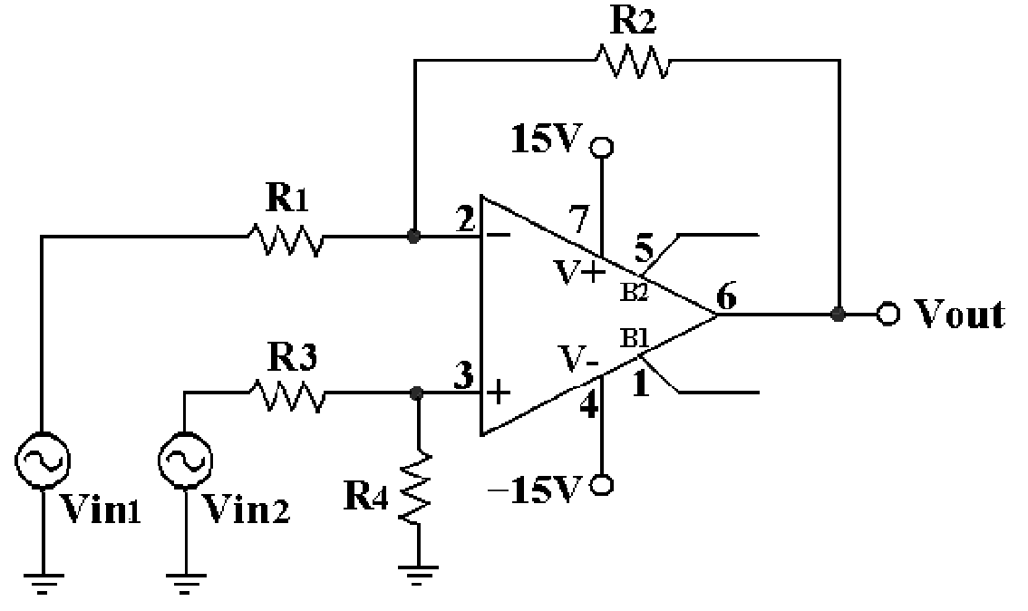
Fig: Differential Amplifier with R1=R3 and R2=R4

If the resistor values are chosen such that R2/R1=R4/R3, then the output of the amplifier is given by:

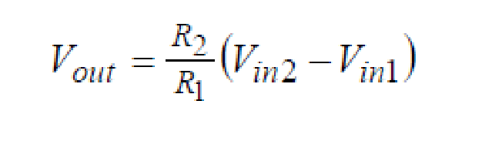
This expression shows that the amplifier amplifies the difference between the two input signals vin1vin2 and rejects the common mode input signals; Vout = 0 if vin1=vin2. Therefore, the differential amplifier is used in very noisy environment to reject common noise that appears at both inputs. Such a circuit is very useful in detecting very small differences in signals. Since the gain can be chosen to be very large. For example, if R2=100R1, then a small difference V1-V2 is amplified 100 times.

CIRCUIT DIAGRAM:
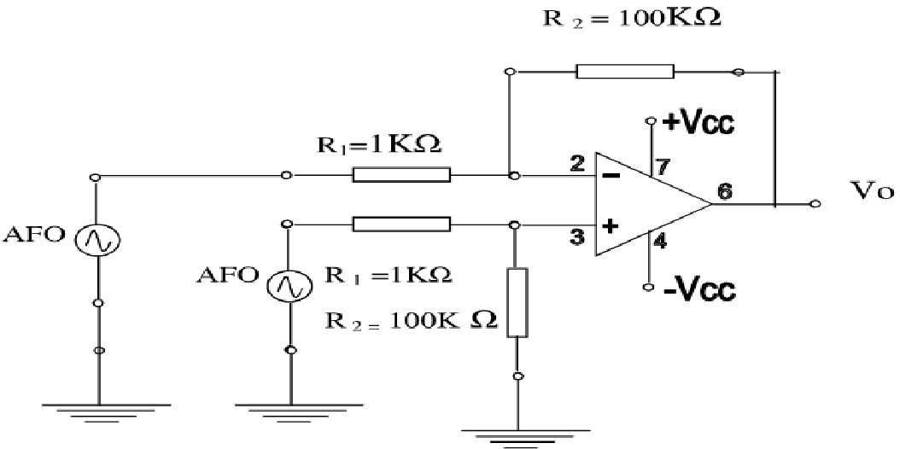

PROCEDURE:
1.Initially set +Vcc = 12 volts and -Vcc to -12 volts.
2.Measure all resistors that are used in the amplifier circuits using the multimeter and record these values
3. As shown in the circuit diagram connect the circuit for differential amplifier on a breadboard
4.Before turning any power on, double check the wiring to make sure that it is correct. Make sure that the power supply to the op-amp is correctly wired as not to apply the incorrect polarity to the op-amp.

5. Inputs may be AC or DC voltages from function generator or DC power supply.

6.Apply DC inputs to both the input terminals of IC741 from the dc supply and check the output voltage Vo at the output terminal using the multimeter.

7. Readings are tabulated and gain is calculated .Compare practical Vo with the theoretical output voltage Vo = Rf /R1 (Vin2-Vin1)

TABULAR COLUMN:

S.NO | Vin  Vin1 Vin2 | Vo = Rf /R1 (Vin2-Vin1) |  | Gain = Rf /R1
 |  | Theoretical | Practical

RESULT:

The Practical Values of V_{o} observed are equal to the Theoritical values. From this we can conclude that the Differential Amplifier using 741 OP-AMP is satisfying its function properly.

Experiment No.18
DAC Using Operational Amplifier

Introduction

The experiment on "DAC (Digital-to-Analog Converter) Using Operational Amplifier" is a crucial study in the fields of electronics and electrical engineering, focusing on the conversion of digital signals into analog form using operational amplifiers. DACs are fundamental components in modern electronic systems, allowing digital devices to interact with the analog world. This includes applications in audio processing, instrumentation, and control systems.

In this experiment, students will construct a DAC using operational amplifiers and resistors, typically employing techniques such as the R-2R ladder network or weighted resistor methods. The practical experience of building a DAC circuit provides an understanding of how digital values can be translated into corresponding analog voltages, the importance of precision in component values, and the operational principles of op-amps in these applications.

Learning Objectives

- Understanding DAC Fundamentals: Develop a comprehensive understanding of the principles of digital-to-analog conversion and the role of DACs in electronic systems.

- DAC Circuit Construction and Design: Learn to construct a DAC using operational amplifiers and resistors, focusing on the design considerations for accurate and efficient conversion.

- Analyzing DAC Performance: Gain expertise in analyzing the performance of the constructed DAC, including its resolution, accuracy, and linearity.

- Exploring Different DAC Configurations: Understand and implement different DAC configurations, such as the R-2R ladder and weighted resistor methods, and compare their advantages and limitations.

- Measurement of Output Analog Signals: Develop skills in measuring and interpreting the analog output corresponding to various digital input signals, using tools like oscilloscopes and multimeters.

- Understanding the Importance of Precision Components: Recognize the significance of using precision resistors and stable op-amps in DAC circuits to ensure accurate analog output.

- Safety in Electronic Circuit Experiments: Emphasize the importance of safety when handling and testing electronic circuits.

- Real-World Application Scenarios: Understand the practical applications of DACs in various electronic devices and systems, such as audio equipment, data acquisition systems, and control systems.

- Problem-Solving and Critical Thinking: Enhance problem-solving skills by troubleshooting issues in the DAC circuit and making adjustments to improve its performance and accuracy.

By completing this experiment, students will not only learn the theoretical aspects of digital-to-analog conversion but will also acquire practical skills essential for designing and analyzing DACs in various electronic applications.

APPARATUS:
- Operational Amplifier mA 741 IC
- Resistors
- Dual Power supply( 0-20V)
- Regulated Power Supply.(0-20V)
- Multimeter
- Bread board
7.Connecting wires

THEORY:

Nowadays digital systems are used in many applications because of their increasingly efficient, reliable and economical operation. Since digital systems such as microcomputers use a binary system of ones and zeros, the data to be put into the microcomputer have to be converted from analog form to digital form. The circuit that performs this conversion and reverse conversion are called A/D and D/A converters respectively. D/A converter in its simplest form uses an op-amp and resistors either in the R-2R form or binary weighted form.

The fig. below shows D/A converter with resistors connected in R-2R form. It is so called as the resistors used here are R and 2R. The binary inputs are simulated by switches b0 to b3 and the output is proportional to the binary inputs. Binary inputs are either in high (+5V) or low (0V) state.

The analysis can be carried out with the help of Thevenin’s theorem. The output voltage corresponding to all possible combinations of binary inputs can be calculated as below.

V0 = - RF [ (b3/2R) + (b2/4R) + (b1/8R) + (b0/16R) ]

Where each inputs b3, b2, b1 and b0 may be high (+5V) or low (0V).

CIRCUIT DIAGRAM:
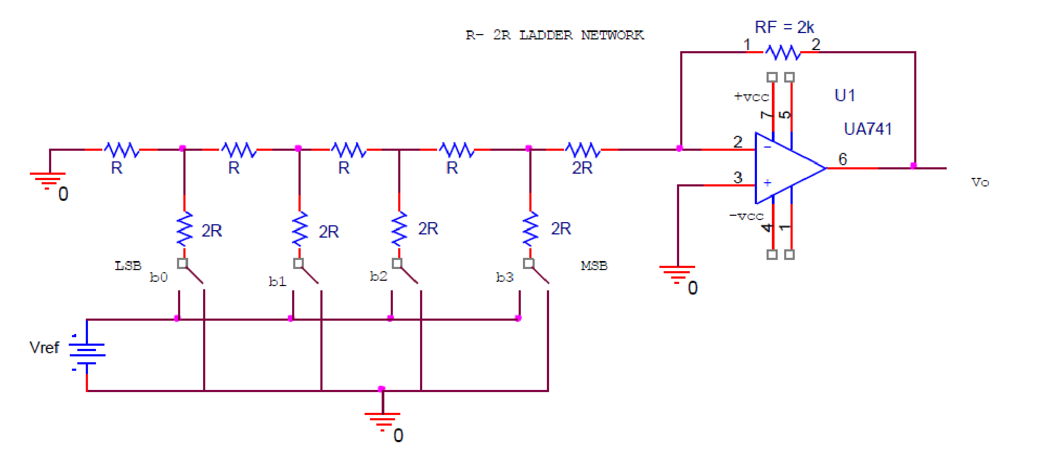

PROCEDURE:
- Initially set +Vcc = 12 volts and -Vcc to -12 volts.
- Measure all resistors that are used in the amplifier circuits using the multimeter and record these values.
- As shown in the circuit diagram connect the circuit for DAC on a breadboard
- Before turning any power on, double check the wiring to make sure that it is correct. Make sure that the power supply to the op-amp is correctly wired as not to apply the incorrect polarity to the op-amp.

- Apply different combination of binary inputs using switches from the dc supply and check the output voltage Vo at the output terminal using the multimeter. Where each inputs b3, b2, b1 and b0 may be high (+5V) or low (0V).

- Tabulate different sets of readings by repeating the above step.

- Compare practical Vo with the theoretical output voltage V_{O}.

TABULAR COLUMN:

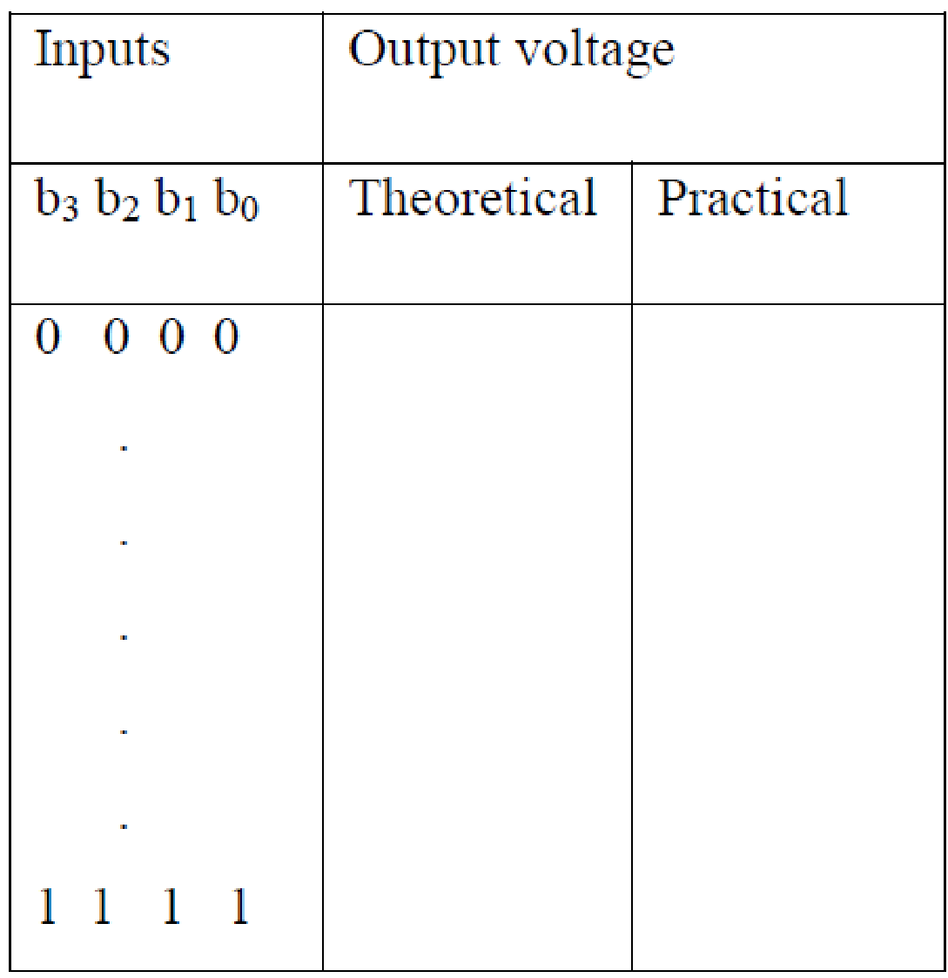

RESULT:

The Practical Values of V_{o} observed are equal to the theoretical values. From this we can conclude that the Digital to Analog converter using 741 OP-AMP is satisfying its function properly.

Experiment .No.19
Logarithmic Amplifier

Introduction

The experiment on the "Logarithmic Amplifier" is a vital component of advanced studies in electronics and electrical engineering, focusing on an operational amplifier (op-amp) configuration that produces an output voltage proportional to the logarithm of the input voltage. Logarithmic amplifiers are extensively used in applications requiring compression of wide-ranging signals into a smaller scale, such as in signal processing for audio and instrumentation, and for mathematical operations in analog computers.

In this experiment, students will construct a logarithmic amplifier using an op-amp and a diode, or a transistor acting as a diode. The diode or transistor in the feedback loop of the op-amp creates a nonlinear relationship between the input and output voltages, resulting in logarithmic amplification. Through this practical approach, students gain insights into the principles of logarithmic scaling, the operation of diodes and transistors in non-linear regions, and the application of these concepts in real-world scenarios.

Learning Objectives

- Understanding Logarithmic Amplification: Develop a comprehensive understanding of the principles of logarithmic amplification, including the non-linear characteristics of diodes and transistors used in these circuits.

- Circuit Construction and Design: Learn to construct and design a logarithmic amplifier circuit, focusing on the correct implementation of the op-amp and diode or transistor.

- Analyzing Circuit Performance: Gain skills in analyzing the performance of logarithmic amplifiers, particularly in understanding how input voltages are logarithmically scaled to output voltages.

- Measurement and Interpretation of Results: Develop the ability to measure and interpret the output of the logarithmic amplifier, understanding how it correlates with the logarithmic function of the input.

- Exploring the Impact of Component Variations: Experiment with different diodes, transistors, and op-amps to observe how variations in component characteristics affect the amplifier's performance.

- Understanding Practical Limitations and Applications: Recognize the practical limitations and ideal applications of logarithmic amplifiers, such as in dynamic range compression and signal processing.

- Safety in Electronic Circuit Experiments: Emphasize the importance of safety when constructing and testing electronic circuits.

- Problem-Solving and Critical Thinking: Enhance problem-solving skills by diagnosing and rectifying issues in the logarithmic amplifier circuit and optimizing its performance.

- Real-World Applications: Understand the practical applications of logarithmic amplifiers in various electronic systems, highlighting their importance in specialized signal processing tasks.

By mastering these objectives, students will not only learn the theoretical aspects of logarithmic amplifiers but will also acquire practical skills essential for designing and analyzing circuits for advanced electronic applications.

APPARATUS:
- Operational Amplifier mA 741 IC
- Resistor 1K Ohm
- Dual Power supply ( 0-20V)
- Regulated Power Supply (0-20V)
- Multimeter
- Bread board
7.Connecting wires

THEORY:

Op-amp can be used to design a circuit whose output is the logarithm of input signals. Such a circuit is called a logarithmic amplifier.

Logarithmic amplifier can be designed by incorporating a diode in feedback part. Recall that the I-V curve of a diode has an exponential form. We can use that to make a logarithmic amplifier, where the output voltage is proportional to the log of the input voltage. Build the circuit using a 1N914 diode and see how it works, driving it with the variable dc supply. Note that there are an unknown muliplicative constant and offset on the output, so you won’t simply observe Vout = log(Vin). Instead, measure Vout for a range of Vin and see if you observe a linear relationship on a semi-log graph. So Output Voltage of a logarithmic amplifier is given by the relation

Vout = - log₁₀ (Vin)

The reverse of logarithmic amplifier called Anti- logarithmic amplifier can be designed simply by interchanging diode and resistor. So if we place diode in place of resistor and a resistor in place of diode it acts like a Anti- logarithmic amplifier.

CIRCUIT DIAGRAM:

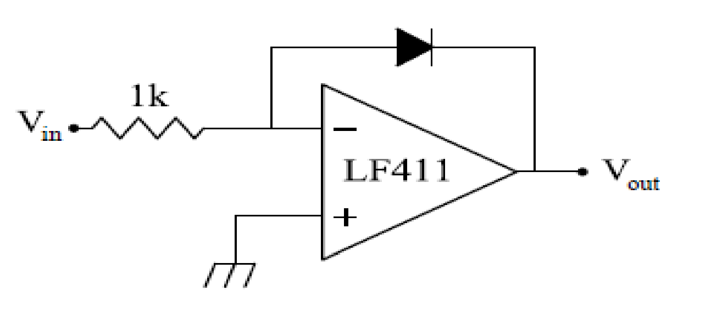

Fig: Logarithmic amplifier configuration of op-amp

PROCEDURE:
- Initially set +Vcc = 12 volts and -Vcc to -12 volts.
- Measure all resistors that are used in the amplifier circuits using the multimeter and record these values.
- As shown in the circuit diagram connect the circuit for logarithmic amplifier on a breadboard
- Before turning any power on, double check the wiring to make sure that it is correct. Make sure that the power supply to the op-amp is correctly wired as not to apply the incorrect polarity to the op-amp.

- Apply different inputs from the dc supply and check the output voltage Vo at the output terminal using the multimeter.

- Tabulate different sets of readings by repeating the above step.

- Compare practical Vo with the theoretical output voltage Vout = - log₁₀(Vin).

TABULAR COLUMN:

S.NO | Vin | Vout = - log₁₀ (Vin).
 |  | Theoretical | Practical

RESULT:

The Practical Values of V_{o} observed are equal to the theoretical values. From this we can conclude that the logarithmic amplifier using 741 OP-AMP is satisfying its function properly.

Experiment 20
Mono-Stable Multivbrator -IC 555 Timer

Introduction

The experiment on the "Monostable Multivibrator using IC 555 Timer" is a fundamental and practical exploration in the field of electronics and electrical engineering. The 555 timer IC is a versatile and widely used integrated circuit that can be configured in various modes, one of which is the monostable multivibrator, also known as a one-shot pulse generator. In this configuration, the 555 timer generates a single output pulse of a specific duration in response to a triggering input signal. This application is crucial in creating time delays, pulse generation, and as a part of more complex electronic systems for various applications like timers, pulse width modulation, and frequency measurement.

In this experiment, students will build a monostable circuit using the 555 timer IC and explore how the duration of the output pulse can be controlled by external resistors and capacitors. This hands-on approach will deepen the understanding of timing and pulse generation mechanisms in electronic circuits.

Learning Objectives

- Understanding Monostable Multivibrator Principles: Gain a comprehensive understanding of the monostable multivibrator configuration of the 555 timer, including its operational principles and timing characteristics.

- Circuit Construction and Design: Learn to construct and design a monostable circuit using the 555 timer, focusing on component selection (resistors and capacitors) to set the desired pulse duration.

- Exploration of Timing and Control Mechanisms: Understand how the time constant determined by external resistors and capacitors affects the pulse width and how to calculate this duration.

- Measurement and Analysis of Output Pulses: Develop skills in measuring and analyzing the output pulse in response to a triggering signal, using tools like oscilloscopes.

- Investigating Trigger Signal Characteristics: Study the characteristics of the trigger signal required to activate the monostable multivibrator and how different types of trigger signals affect the circuit's performance.

- Real-World Application Scenarios: Recognize the practical applications of a monostable multivibrator in electronic design, such as in creating time delays, switching, and pulse generation.

- Safety in Electronic Circuit Experiments: Emphasize the importance of safety when handling and testing electronic circuits.

- Problem-Solving and Critical Thinking: Enhance problem-solving skills by diagnosing and troubleshooting issues in the monostable circuit and optimizing its performance for specific applications.

- Data Analysis and Interpretation: Cultivate the ability to interpret experimental data and understand how it correlates with the theoretical operation of the monostable multivibrator.

By completing this experiment, students will not only learn the theoretical aspects of the 555 timer in a monostable configuration but also acquire practical skills essential for designing and analyzing timingrelated circuits in various electronic applications.

APPARATUS:
- IC555-Timer –1No.
- Resistors
- Capacitor
- Dual Power supply( 0-20V)
- Regulated Power Supply.(0-20V)
- Multimeter
- CRO and Probes
- Funtion Signal Generator.
- Bread board
10.Connecting wires

THEORY:

A Monostable Multivibrator, often called a one-shot Multivibrator, is a pulse-generating circuit in which the duration of the pulse is determined by the RC network connected externally to the 555 timer. In a stable or stand by mode the output of the circuit is approximately Zero or at logic-low level. When an external trigger pulse is obtained, the output is forced to go high (  V_{CC}). The time for which the output remains high is determined by the external RC network connected to the timer. At the end of the timing interval, the output automatically reverts back to its logic-low stable state. The output stays low until the trigger pulse is again applied. Then the cycle repeats. The Monostable circuit has only one stable state (output low), hence the name monostable. Normally the output of the Monostable
Multivibrator is low.

CIRCUIT DIAGRAM:
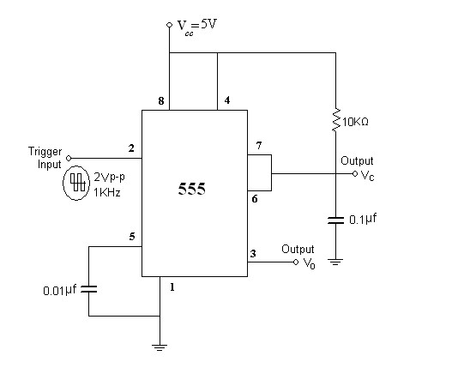
DESIGN:
Consider V_{CC} = 5V, for given t_{p}
Output pulse width t_{p} = 1.1 R_{A} C
Assume C in the order of microfarads & Find R_{A} Typical values:
If C=0.1 µF , R_{A} = 10k then t_{p} = 1.1 mSec
Trigger Voltage = 4 V

PROCEDURE:
- Initially set +Vcc = 5 volts.
- Measure all resistors that are used in the amplifier circuits using the multimeter and record these values
3.As shown in the circuit diagram connect the circuit for Monostable Multivibrator on a breadboard.
- Before turning any power on, double check the wiring to make sure that it is correct. Make sure that the power supply to the IC 555 is correctly wired as not to apply the incorrect polarity to the IC 555.

- Apply Negative triggering pulses at pin 2 of frequency 1 KHz.

- Observe the output waveform and measure the pulse duration.
- Theoretically calculate the pulse duration as T_{high}=1.1. R_{A}C
- Compare it with experimental values .
TABULAR COLUMN:

Trigger | Output wave | Capacitor output

EXPECTED GRAPH:

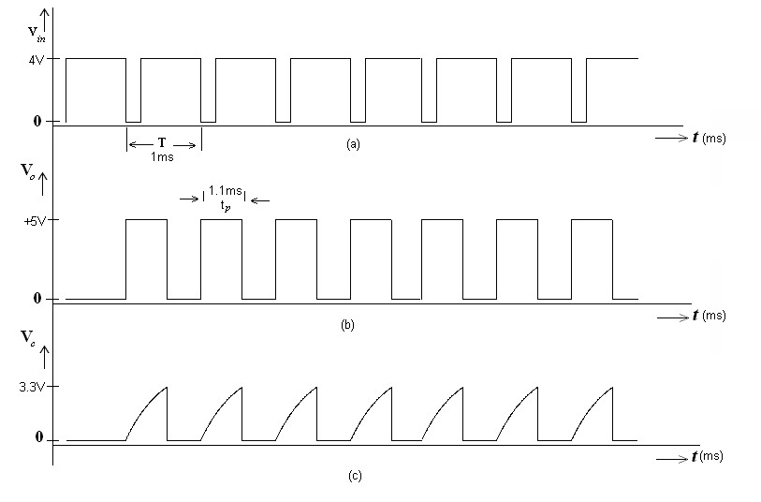
Fig: (a): Trigger signal (b): Output Voltage (c): Capacitor Voltage
WORKSHEET:
Trigger Waveform:


Output Waveform:

RESULT:

The Practical Values of V_{o} observed are equal to the Theoritical values. From this we can conclude that the Monostable Multivibrator using IC 555-Timer is satisfying its function properly.

Experiment 21

Astable Multivibrator -IC 555 Timer

Introduction

The experiment on the "Astable Multivibrator using IC 555 Timer" is a fundamental exploration in the field of electronics, focusing on a versatile and widely-used configuration of the 555 timer IC. An astable multivibrator, unlike a monostable multivibrator, does not have a stable state. In this mode, the 555 timer oscillates continuously between its two states, generating a square wave output without the need for any external triggering. This makes the astable multivibrator ideal for applications such as clock pulses generation, LED blinking, tone generation in buzzers, and in creating pulse width modulation (PWM) signals.

In this experiment, students will construct an astable circuit using the 555 timer IC and explore how the frequency and duty cycle of the output wave can be controlled through the choice of resistors and capacitors. This practical approach provides insights into the principles of waveform generation and timing control in electronic circuits.

Learning Objectives

- Understanding Astable Multivibrator Principles: Gain a comprehensive understanding of the astable multivibrator configuration of the 555 timer, including its operational principles and waveform characteristics.

- Circuit Construction and Design: Learn to construct and design an astable multivibrator circuit using the 555 timer, focusing on the selection and calculation of resistors and capacitors to achieve desired frequency and duty cycle.

- Analysis of Waveform Generation: Develop skills in analyzing the generated square wave, understanding how the frequency and duty cycle are affected by component values.

- Measurement and Interpretation of Output: Use tools like oscilloscopes to measure the output waveform, and learn to interpret these measurements in terms of frequency, period, and duty cycle.

- Exploring Frequency and Duty Cycle Control: Experiment with different resistor and capacitor values to observe how they influence the frequency and duty cycle of the output waveform.

- Real-World Application Scenarios: Recognize the practical applications of an astable multivibrator in electronic design, such as in signal generation, timing circuits, and PWM control.

- Safety in Electronic Circuit Experiments: Emphasize the importance of safety when constructing and testing electronic circuits.

- Problem-Solving and Critical Thinking: Enhance problem-solving skills by diagnosing and troubleshooting issues in the astable circuit and optimizing its performance for specific applications.

- Data Analysis and Interpretation: Cultivate the ability to analyze experimental data, understanding how it correlates with the theoretical operation of the astable multivibrator.

By completing this experiment, students will not only learn the theoretical concepts of the astable multivibrator using the 555 timer but will also acquire practical skills essential for designing and analyzing timing and waveform generation circuits in various electronic applications.

APPARATUS:
- IC555-Timer –1No.
- Resistors
- Capacitor
- Dual Power supply( 0-20V)
- Regulated Power Supply.(0-20V)
- Multimeter
- CRO and Probes
- Funtion Signal Generator.
- Bread board
10.Connecting wires

THEORY:

When the power supply V_{CC} is connected, the external timing capacitor ‘C” charges towards V_{CC} with a time constant (R_{A}+R_{B}) C. During this time, pin 3 is high (≈V_{CC}) as Reset R=0, Set S=1 and this

combination makes Q =0 which has unclamped the timing capacitor ‘C’.
When the capacitor voltage equals 2/3 V_{CC}, the upper comparator triggers the control flip flop

on that Q =1. It makes Q1 ON and capacitor ‘C’ starts discharging towards ground through R_{B} and transistor Q1 with a time constant R_{B}C. Current also flows into Q1 through R_{A}. Resistors R_{A} and R_{B} must be large enough to limit this current and prevent damage to the discharge transistor Q1. The minimum value of R_{A} is approximately equal to V_{CC}/0.2 where 0.2A is the maximum current through the ON transistor Q1.
During the discharge of the timing capacitor C, as it reaches V_{CC}/3, the lower comparator is

triggered and at this stage S=1, R=0 which turns Q =0. Now Q =0 unclamps the external timing capacitor C. The capacitor C is thus periodically charged and discharged between 2/3 V_{CC} and 1/3 V_{CC} respectively. The length of time that the output remains HIGH is the time for the capacitor to charge from 1/3 V_{CC} to 2/3 V_{CC}.
The capacitor voltage for a low pass RC circuit subjected to a step input of V_{CC} volts is given by V_{C} = V_{CC} [1- exp (-t/RC)]
Total time period T = 0.69 (R_{A} + 2 R_{B}) C
f= 1/T = 1.44/ (R_{A} + 2R_{B}) C

CIRCUIT DIAGRAM:

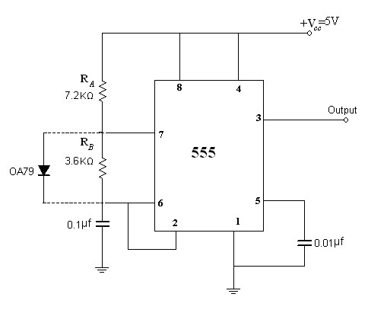

DESIGN:
Formulae: f= 1/T = 1.44/ (R_{A}+2R_{B}) C
Duty cycle (D) = t_{c}/T = R_{A} + R_{B}/(R_{A}+2R_{B}) MODEL CALCULATIONS:
Given f=1 KHz. Assuming c=0.1μF and D=0.25
1 KHz = 1.44/ (RA+2R_{B}) x 0.1x10⁻⁶ and 0.25 =( R_{A}+R_{B})/ (R_{A}+2R_{B})
Solving both the above equations, we obtain R_{A} = 7.2K Ω and R_{B} = 3.6K Ω
PROCEDURE:
- Initially set +Vcc = 5 volts.
- Measure all resistors that are used in the amplifier circuits using the multimeter and record these values
3.As shown in the circuit diagram connect the circuit for Astable Multivibrator on a breadboard.
4. Before turning any power on, double check the wiring to make sure that it is correct. Make sure that the power supply to the IC 555 is correctly wired as not to apply the incorrect polarity to the IC 555.

5.For Unsymmetrical Square wave Connect the circuit as per the circuit diagram shown without connecting the diode.

6.Observe and note down the waveform at pin 6 and across timing capacitor.

- Measure the frequency of oscillations and duty cycle and then compare with the given values.
- Sketch both the waveforms to the same time scale.
9.For Symmetrical Square wave Connect the circuit as per the circuit diagram shown by connecting the diode.
- Choose R_{a}=R_{b} = 10KΩ and C=0.1Μf.

- Observe the output waveform, measure frequency of oscillations and the duty cycle and then sketch the o/p waveform.

TABULAR COLUMN:

Parameter | Unsymmetrical | Symmetrical
Voltage V_{PP}
Time period T
Duty cycle

EXPECTED GRAPH:

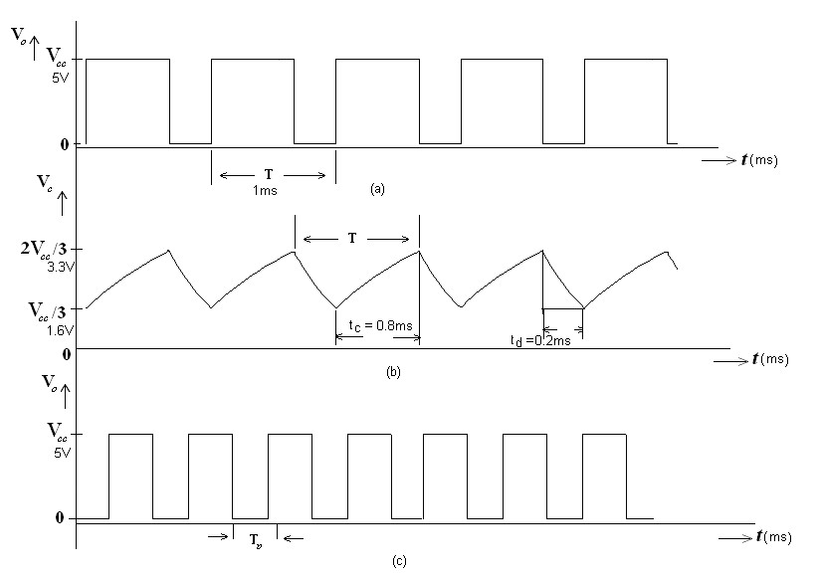
Fig (a): Unsymmetrical square wave output
(b): Capacitor voltage of Unsymmetrical square wave output
(c): Symmetrical square wave output
WORKSHEET:
Unsymmetrical square wave Output Waveform :


Capacitor voltage of Unsymmetrical square wave Output Waveform :


Symmetrical square wave Output Waveform :
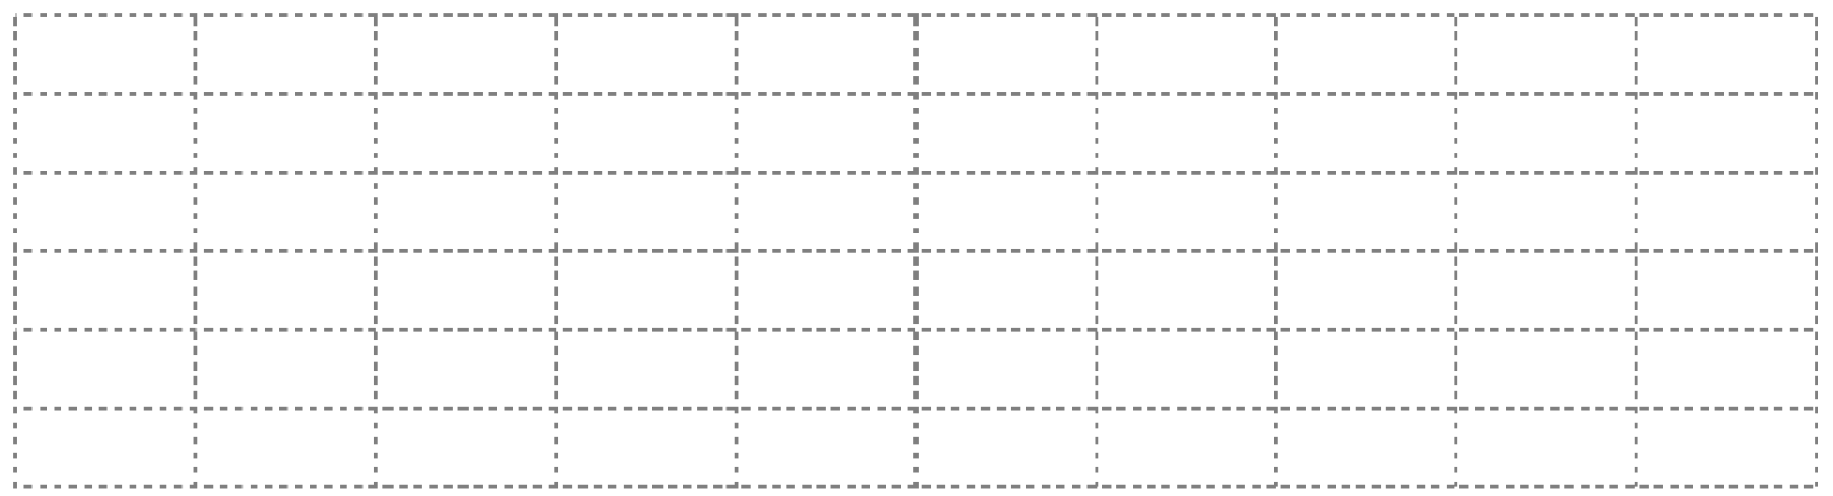

RESULT:

From this we can conclude that the Astable Multivibrator using IC 555-Timer is satisfying its function properly.

Experiment No.22
Liner Op-Amp Circuit
Introduction

The experiment on "Linear Op-Amp Circuits" is a fundamental and crucial aspect of electronics and electrical engineering education, focusing on the exploration of operational amplifiers (op-amps) in linear applications. Operational amplifiers are versatile components used in a wide range of electronic circuits. In linear mode, op-amps are used to perform various analog signal processing tasks such as amplification, filtering, summing, and integration. Understanding how to design and analyze linear opamp circuits is essential for anyone involved in electronic circuit design.

This experiment typically involves constructing various fundamental linear op-amp configurations, such as inverting and non-inverting amplifiers, summing amplifiers, and differential amplifiers. Students will learn to apply concepts like feedback, gain, bandwidth, and impedance, and understand how these factors influence the performance of op-amp circuits.

Learning Objectives

- Understanding Linear Op-Amp Principles: Gain a comprehensive understanding of operational amplifiers and their use in linear circuit configurations, including the principles of negative and positive feedback.

- Circuit Construction and Analysis: Learn to construct various linear op-amp circuits, such as inverting, non-inverting, summing, and differential amplifiers, and analyze their behavior.

- Exploring Gain and Bandwidth Relationships: Understand the relationship between gain and bandwidth in op-amp circuits, and how these parameters can be manipulated and optimized for different applications.

- Impedance Considerations in Op-Amp Circuits: Study the input and output impedance characteristics of different op-amp configurations and their implications for circuit design.

- Measurement and Interpretation of Circuit Performance: Use instruments like oscilloscopes and multimeters to measure key parameters in op-amp circuits, such as voltage gain, phase shift, and frequency response.

- Practical Application of Linear Op-Amp Circuits: Recognize the practical applications of linear op-amp circuits in real-world scenarios, including audio electronics, signal processing, and sensor interfacing.

- Safety in Electronic Circuit Experiments: Emphasize the importance of safety when handling and testing electronic circuits.

- Problem-Solving and Troubleshooting Skills: Enhance problem-solving and troubleshooting skills by identifying and rectifying common issues in linear op-amp circuits.

- Data Analysis and Critical Thinking: Develop the ability to analyze experimental data, compare it with theoretical predictions, and make informed decisions in circuit design and modifications.

By mastering these objectives, students will not only learn the fundamental concepts of linear op-amp circuits but also acquire the practical skills necessary for designing, analyzing, and troubleshooting a wide range of electronic applications.

APPARATUS:
- Operational Amplifier mA 741 IC
- Resistors
- Capacitors
- Diode
- Dual Power supply( 0-20V)
- Regulated Power Supply.(0-20V)
- Multimeter
- CRO and Probes
- Funtion Signal Generator.
- Bread board
11.Connecting wires

THEORY:
The use of op-amps can improve the performance of a wide variety of signal processing circuits. In rectifier circuits, the cut-in voltage drop that occurs with an ordinary semiconductor diode can be eliminated to give precision rectification waveforms can be limited and clamped at precise levels when op-amps are employed in clipping and clamping circuits. The error with peak detectors can also be minimized by the use of the op-amps.

Active half wave rectifier:

Op-amps can enhance the performance of diode circuits. For one thing, the op-amp can eliminate the effect of diode offset voltage, allowing us to rectify, peak-detect, clip, and clamp lowlevel signals (those with amplitudes smaller than the offset voltage). And because of their buffering action op-amps can eliminate the effects of source and load on diode circuits. Circuits that combine op-amps and diodes are called active diode circuits. Below figure shows active HWR.
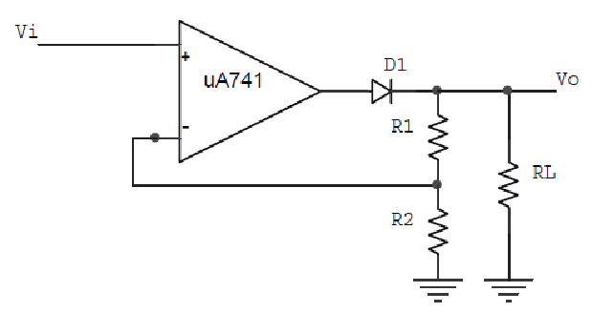
When the input signal goes positive, the op-amp goes positive and turns on the diode. The circuit then acts as a conventional non-inverting amplifier, and the positive half-cycle appears across the load resistor. On the other hand, when the input goes negative, the op-amp output goes negative and turns off the diode. Since the diode is open, no voltage appears across the load resistor. This is why the final output is almost a perfect half-wave signal.

Active clipper:

Clipper is a circuit that is used to clip off (remove) a certain portion of the input signal to obtain a desired output wave shape. In op-amp clipper circuits, a rectified diode may be used to clip off certain parts of the input signal. Below figure shows an active positive clipper, a circuit that removes positive parts of the input signal. The clipping level is determined by the reference voltage Vref.

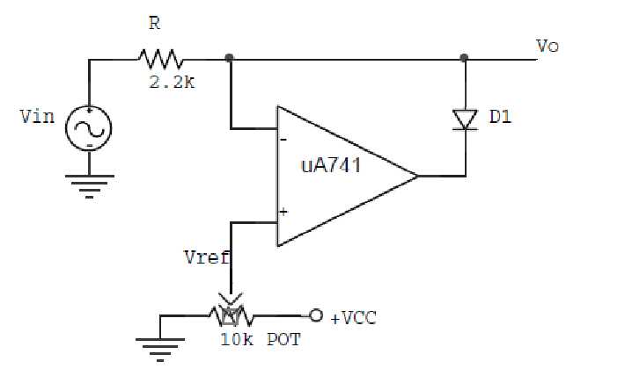

With the wiper all the way to the left, Vref is o and the non-inverting input is grounded. When Vin goes positive, the error voltage drives the op-amp output negative and turns on the diode. This means the final output VO is 0 (same as Vref) for any positive value of Vin.
When Vin goes negative, the op-amp output is positive, which turns off the diode and opens the loop. When this happens, the final output VO is free to follow the negative half cycle of the input voltage. This is why the negative half cycle appears at the output. To change the clipping level, all we do is adjust Vref as needed.

Active clamper:

In clamper circuits, a predetermined dc level is added to the input voltage. In other words, the output is clamped to a desired dc level. If the clamped dc level is positive, the clamper is called a positive clamper. On the other hand, if the clamped dc level is negative, it is called a negative clamper. The other equivalent terms for clamper are dc inserter or dc restorer.
A clamper circuit with a variable dc level is shown in below figure. Here the input wave form is clamped at +Vref and hence the circuit is called a positive clamper.

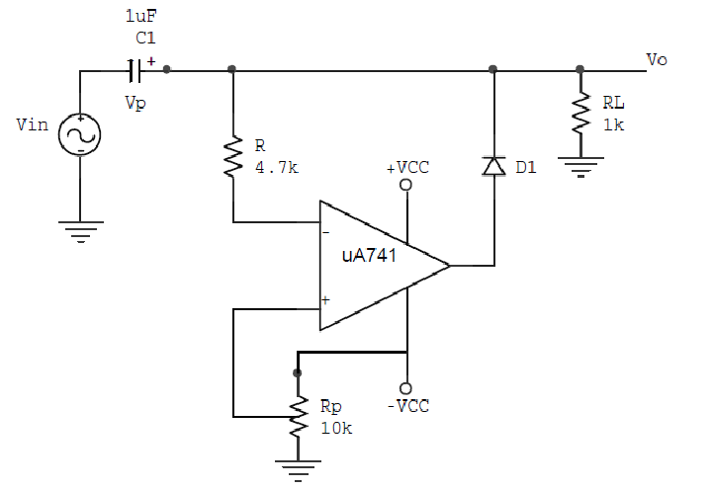


The output voltage of the clamper is a net result of ac and dc input voltages applied to the inverting and non-inverting input terminals respectively. Therefore, to understand the circuit operation, each input must be considered separately. First, consider Vref at the non-inverting input. Since this voltage is positive, is +VO is positive, which forward biases diode D1. This closes the feedback loop and the op-amp operates as a voltage follower. This is possible because C1 is an open circuit for dc voltage. Therefore VO = Vref. As for as voltage Vin at the inverting input is concerned during its negative half-cycle D1 conducts, charging C1 to the negative peak value of the VP. However, during the positive half-cycle of Vin diode D1 is reverse biased and hence the voltage VP across the capacitor acquired during the negative half-cycle is retained. Since this voltage VP is in series with the positive peak voltage VP, the output peak voltage VO=2VP. Thus the net output is Vref+VP, so the negative peak of 2VP is at Vref. For precision clamping C1Rd<<T/2, where Rd is the forward resistance of the diode D1 (100typically) and T is the time period of Vin.

Resistor R is used to protect the op-amp against excessive discharge currents from capacitor C1 especially when the dc supply voltages are switched off. Negative clamping at a negative voltage is accomplished by reversing diode D1 and using the negative reference voltage –Vref.

CIRCUIT DIAGRAM:

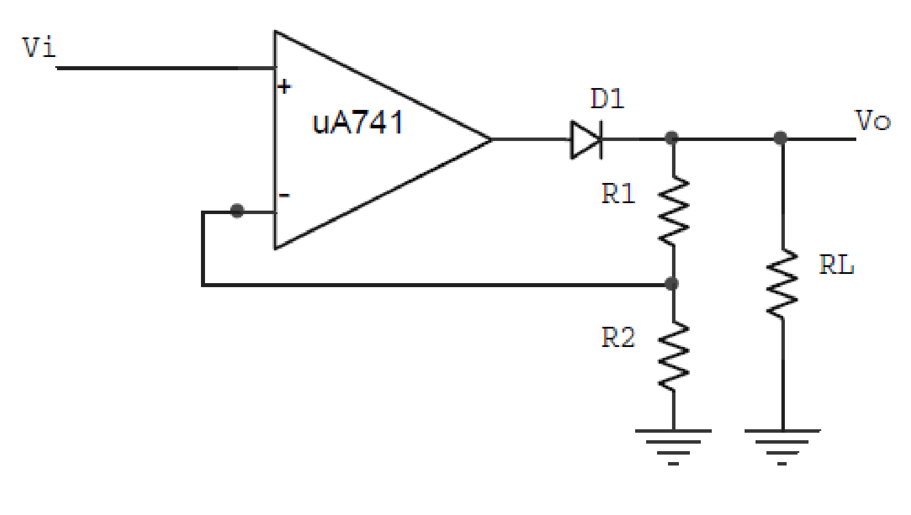
Circuit Diagram1: Circuit for Active Half Wave Rectifier.

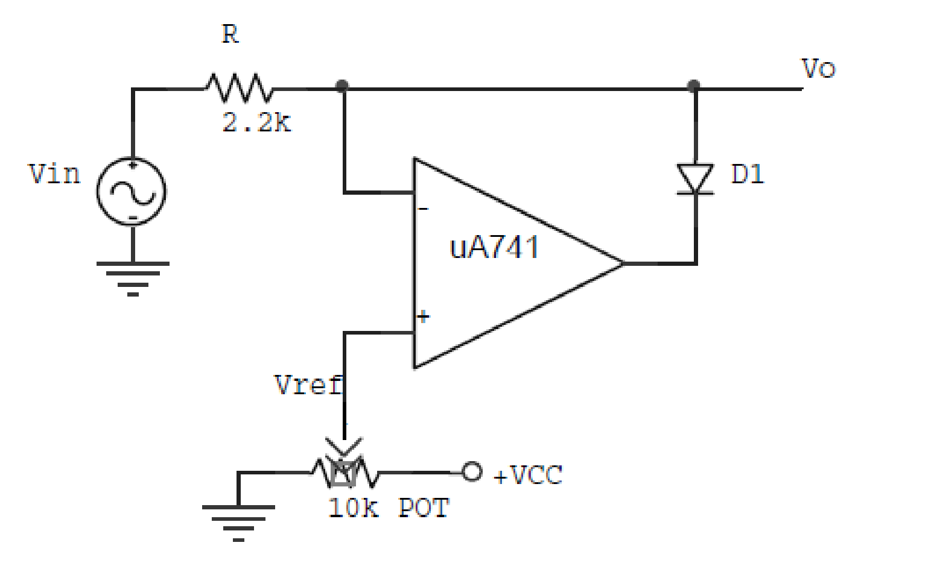
Circuit Diagram 2: Circuit for Active Clipper

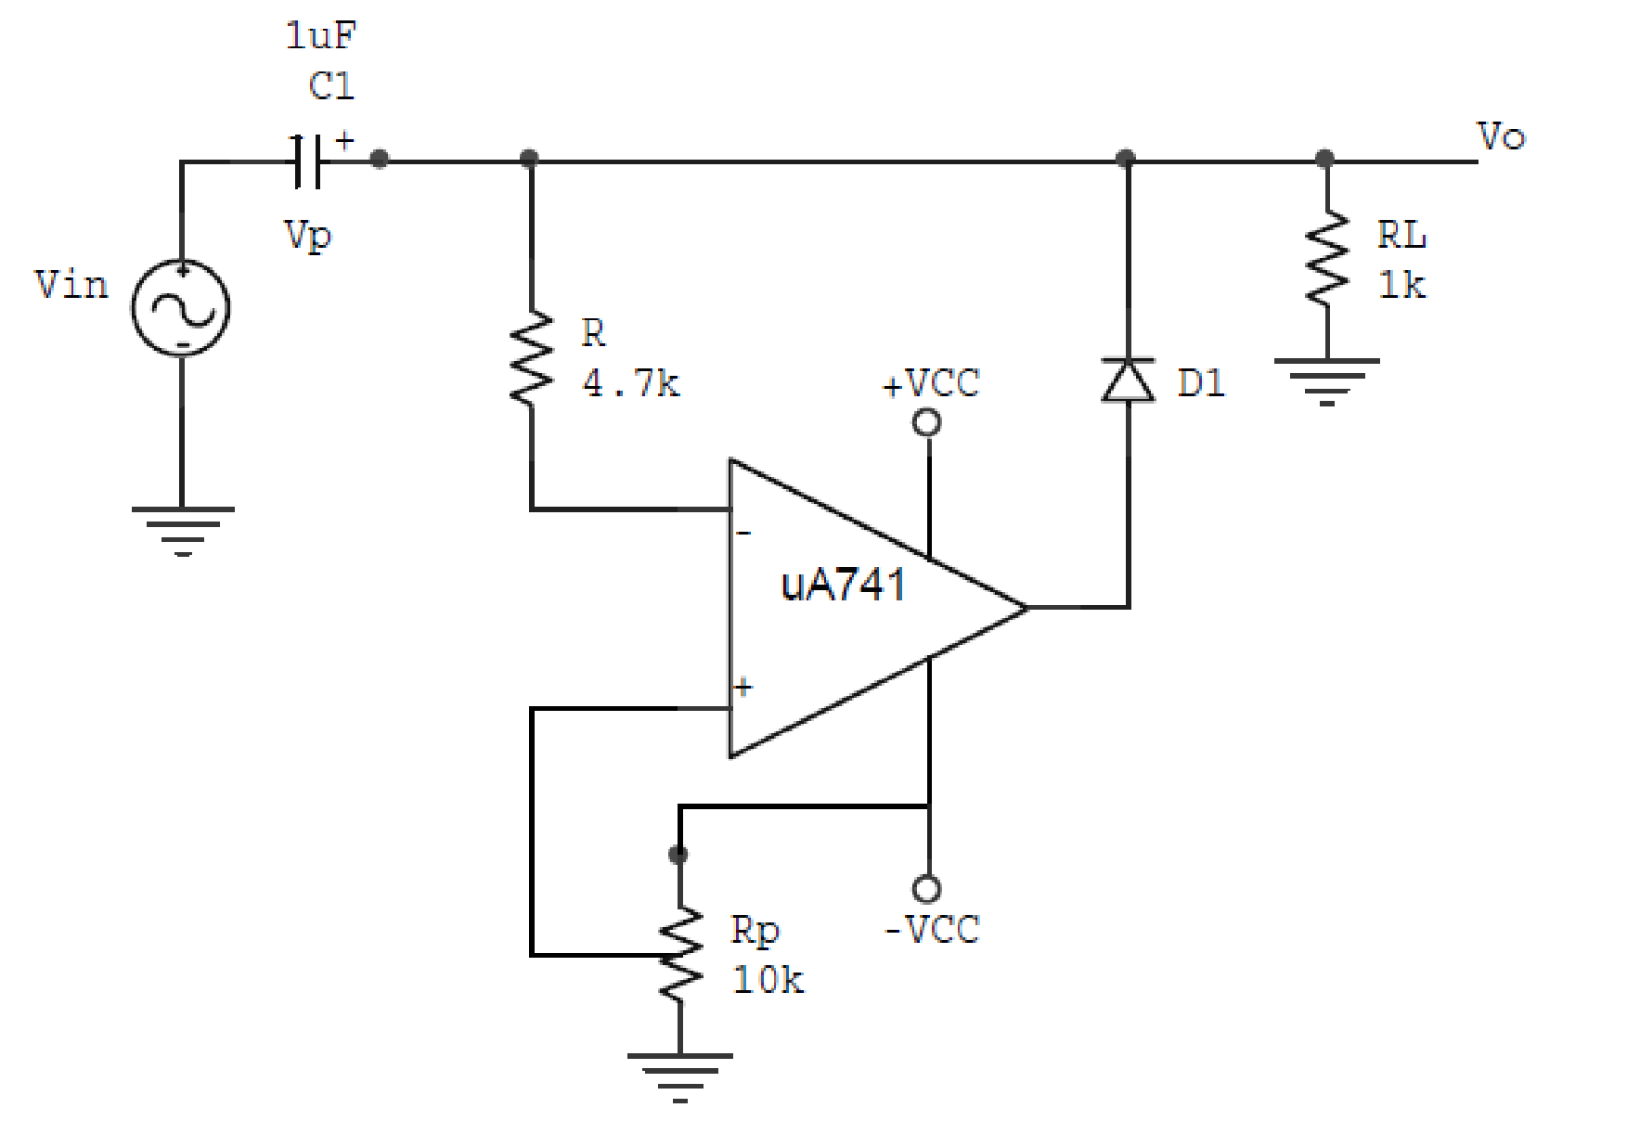
Circuit Diagram 3: Circuit for Active Clamper

PROCEDURE:
1.Initially set +Vcc = 12 volts and -Vcc to -12 volts.
2.Measure all resistors and capacitors that are used in the circuits using the multimeter and record these values.
3.Before turning any power on, double check the wiring to make sure that it is correct. Make sure that the power supply to the op-amp is correctly wired as not to apply the incorrect polarity to the op-amp.
- For Active Half Wave Rectifier:
  - Choose the appropriate resistor values of R1 and R2. Consider RL = 10kΩ.
  - Feed sinusoidal input of amplitude 200mVPP and frequency 100Hz.
  - Using a CRO observe the input and output voltages simultaneously.
  - Determine the amplitude and frequency of the output voltage.
  - Record this values in table shown below.
  - Plot the input and output voltages on the same scale.
- For Active clipper:
  - Feed 3VP, 1 KHz sinusoidal input from function signal generator.
  - Observe the input and output voltages on a CRO.
  - Look at output signal while turning the potentiometer through its entire range.
  - Record your readings in table shown below for a desired clipping level.
5.6 Plot the input and output voltages on the same scale.

- For Active clamper:

  - Assemble a positive clamping circuit with clamping level at zero as shown in fig. Note that Vref = 0V. Use 1N4002 diode.
  - Feed 5VPP, 10 KHz sinusoidal input.
  - Using a CRO observe the input and output voltages simultaneously.
  - Determine the clamping levels of the output voltage.
  - Tabulate your readings in table shown below.
6.4 Plot the input and output voltages on the same scale.

TABULAR COLUMN:

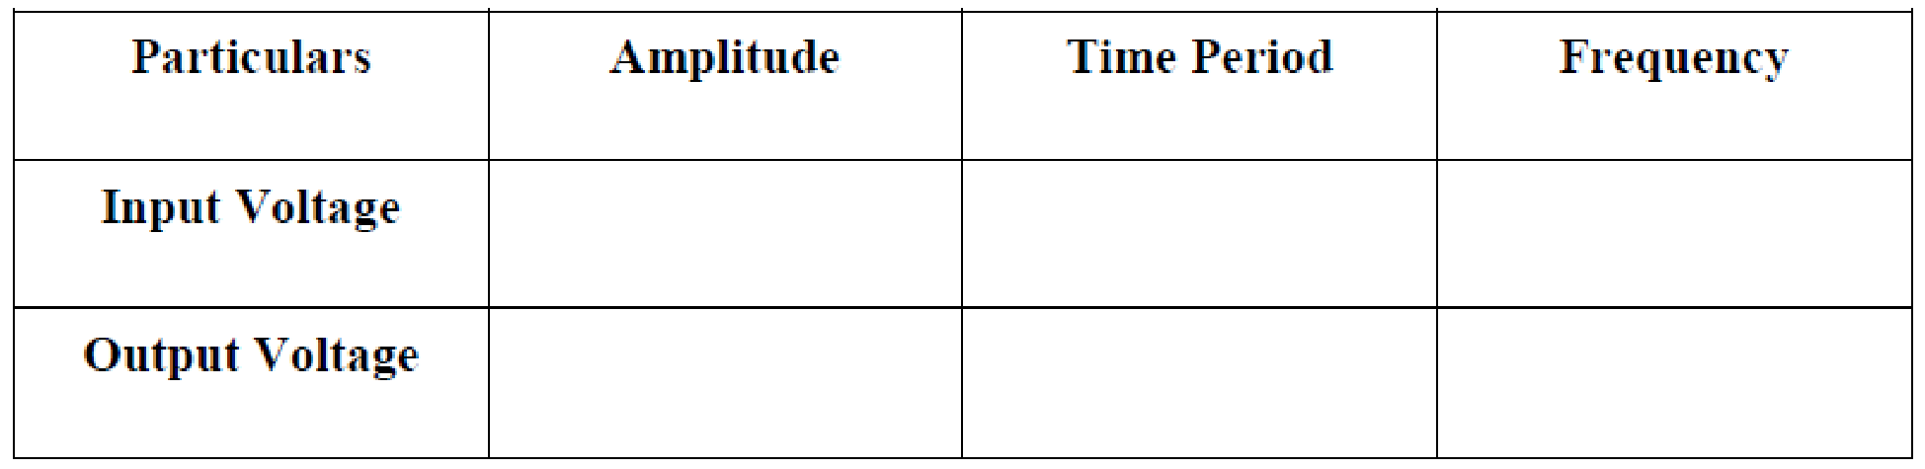
Tabular Column 1: Table for Active Half Wave
Rectifier
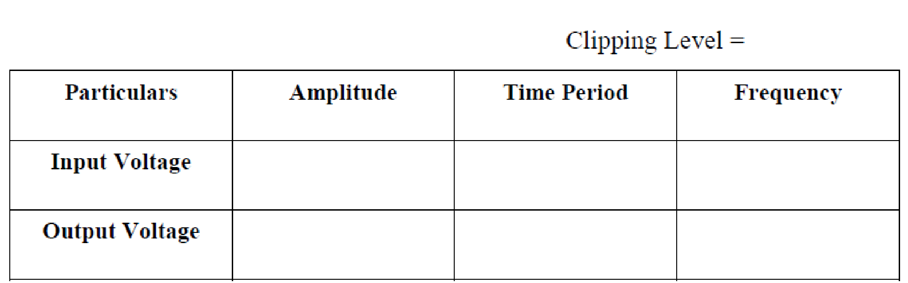
Tabular Column 2: Table for Active Clipper
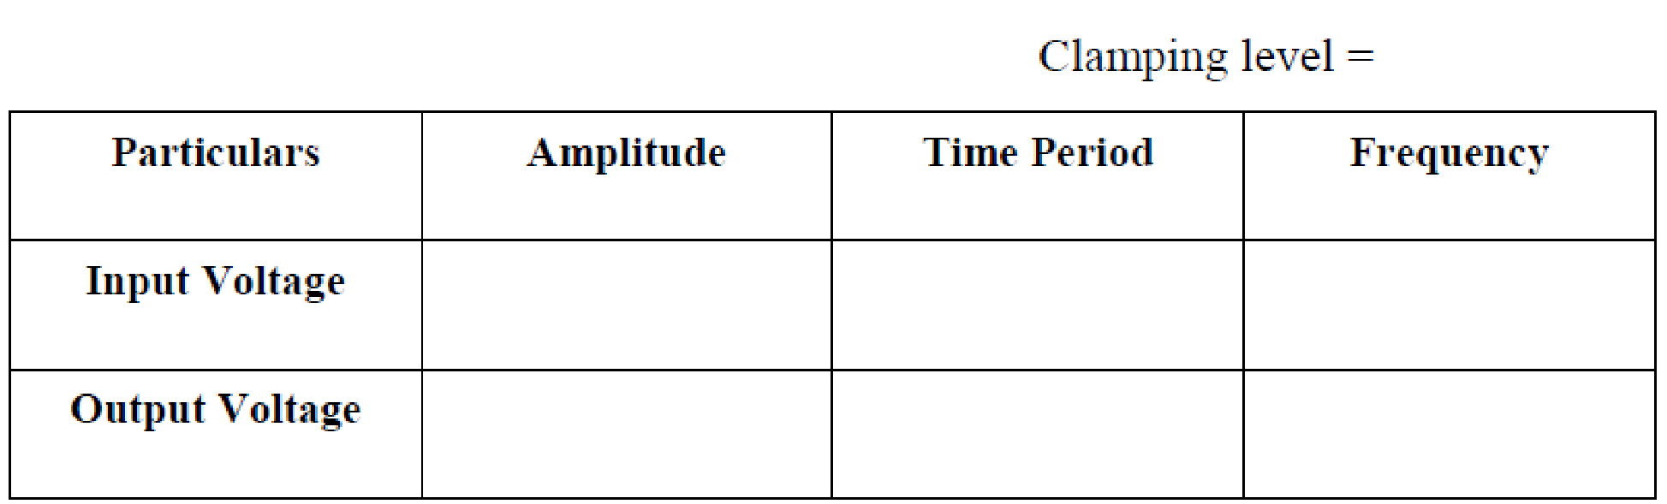
Tabular column 3: Table for Active Clamper
EXPECTED GRAPH:

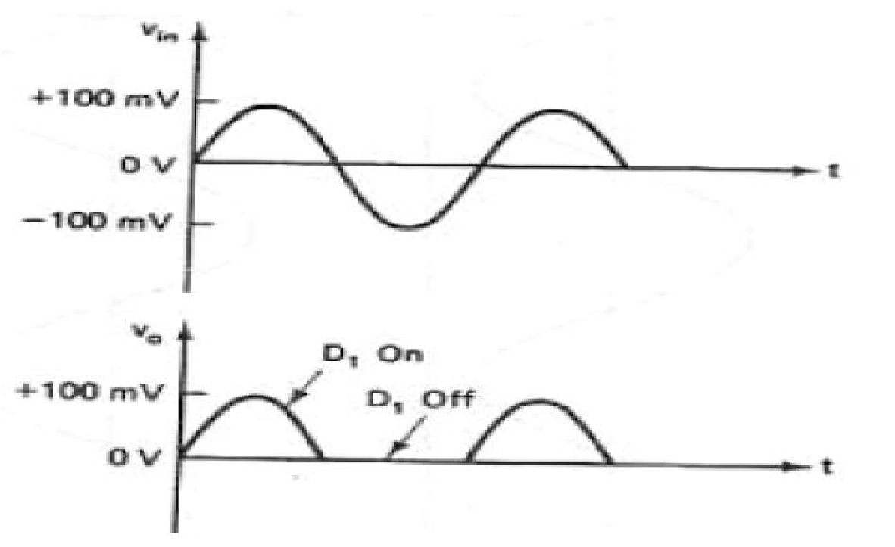

Fig: Input and Output waveforms of Active Half wave Rectifier.

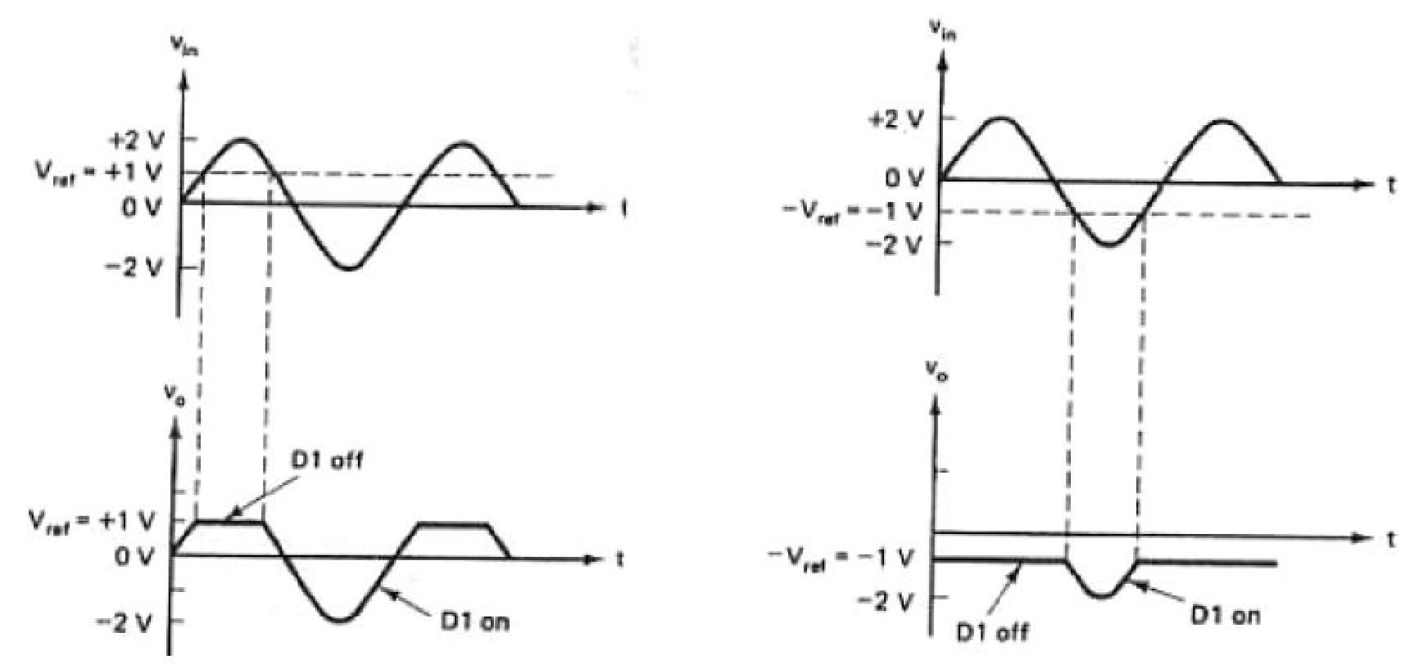

Fig: Input and Output waveforms of Active Clipper with +Vref and with –Vref
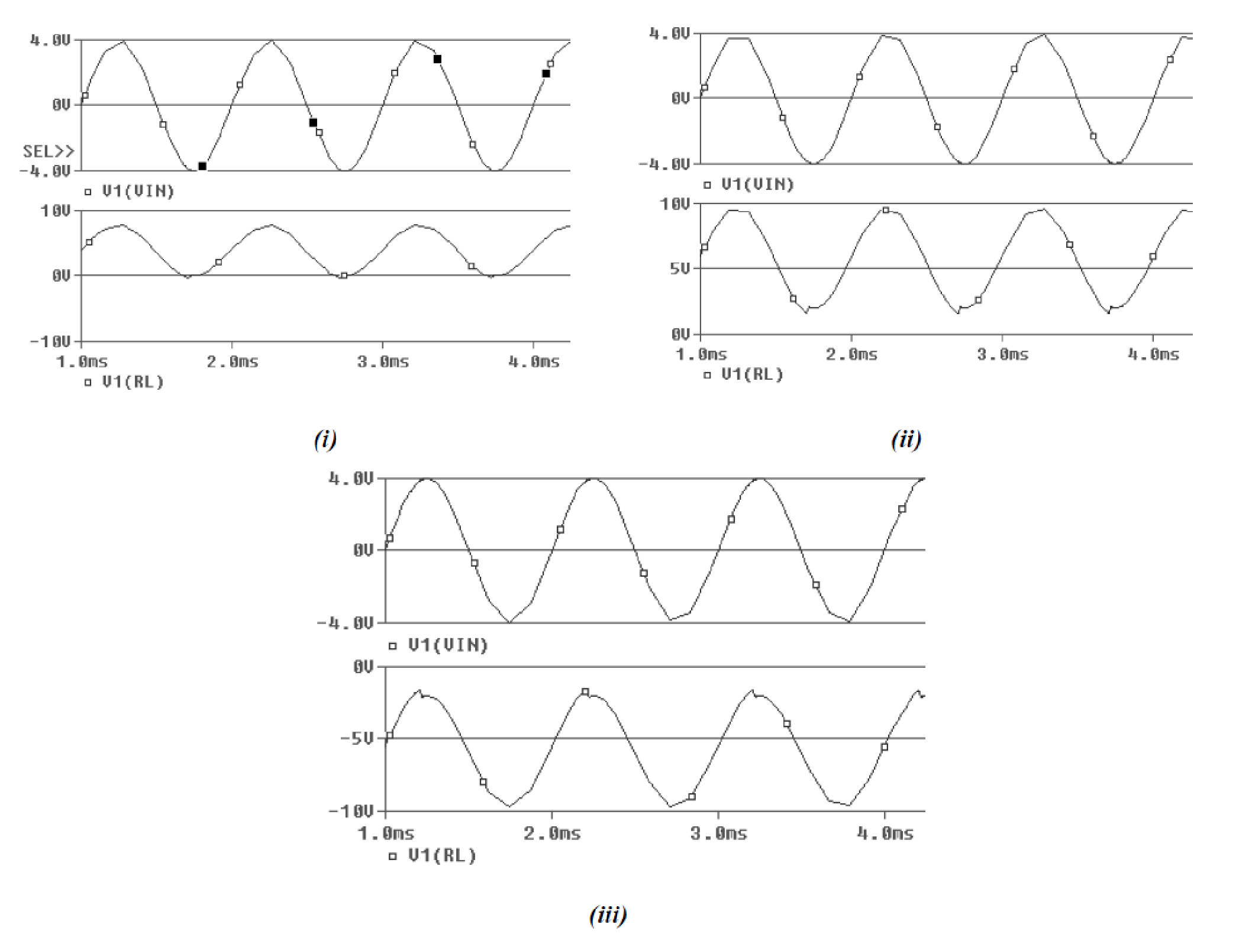

Fig: Input and Output waveforms of Active Clamper (i) with Vref=0V (ii) with +Vref (iii) with –Vref

WORKSHEET:

Input and Output Waveform of Active HWR:



Input and Output Waveform of Active Clipper :



Input and Output Waveform of Active Clamper :



RESULT:

From this we can conclude that the Active HWR, Active Clipper and Active Clamper using IC 741 OPAMP is satisfying its function properly.

